RESEARCH REPORT · RELEASE 2.2
US Car Price Outlook
Prices, technology, demand and the cost of ownership, 1976–2030
Fifty years of what has moved the price, technology and demand for cars in the United States, and a tested forecast of new- and used-vehicle prices through 2030. Release 2.2 adds the cost of owning a gas, hybrid or electric vehicle bought new or at 2–3 years old, statistical tests for used-car prices and demand, and vehicle size and technology as inflation inputs. Every chart and nearly every table in the web edition is reproduced here.

Table 1. Headline forecast
Price outlook, December 2030 | Value
Average new-vehicle transaction price | $53,734
80% forecast range | $50.4k – $63.6k
Quality-adjusted new-car prices (CPI) | +4.8%
Used-vehicle prices (CPI) | +1.8%
Typical new-loan payment | $843/mo
Chance ATP tops $55,000 by Dec 2030 | 51%
Battery-EV share of sales, 2030 | 9.7%
Auto loans entering 90+ day delinquency | 3.00%

Today: $50,089 ATP (Aug 2026, KBB) · new-vehicle CPI +0.6% y/y · used −2.3% y/y
11 October 2026 · Data through August–September 2026 · Research only, not financial advice
Contents
1. Executive summary 3
2. What's new in releases 2.0–2.2 5
3. Buyer's guide 11
4. Price forecast, 2026–2030 14
5. What drives prices and demand 18
6. Total cost of ownership: new vs. used, gas vs. hybrid vs. EV 25
7. Used-car prices and demand 34
8. Vehicle size, technology and safety 43
9. EVs, vehicle classes, credit and luxury 47
10. History and long-run trends 55
11. Statistical appendix and model card 59
12. Sources 69
Figures are reproduced from the interactive web edition, which also shows values on hover. Tables carry the same numbers as the page.

1. Executive summary
EXECUTIVE SUMMARY

Prices keep rising, but slowly. The risks are mostly to the upside.
Adjusted for quality, new cars are among the few goods that got cheaper in real terms over the last half-century. The quality-adjusted new-vehicle price index rose 2.7× since 1976 while overall consumer prices rose 6.0×, a 54% real decline. Sticker prices tell a different story because buyers moved to larger, more powerful, better-equipped trucks and SUVs. The average transaction price (ATP) now sits at $50,089.
Release 2.1's five-model ensemble, tested on 36 rolling forecast origins since 2006, projects quality-adjusted new-vehicle prices rising about 0.9% a year through 2030, below overall inflation. Adding the measured effects of the truck/SUV shift, EVs and content, the central forecast for the average transaction price is $53,734 in December 2030, with an 80% range of $50,417 to $63,613. Used-vehicle prices should be roughly flat in nominal terms (about +0.3% a year), but their uncertainty is three times larger.
Table 2. Key numbers
Measure | Value | Detail
Real change since 1976 | −54% | Quality-adjusted new-vehicle prices vs. all items
Pandemic surge | +21% / +55% | New (Jan 20–Jun 23) / used (Jan 20–Jan 22)
New-car inflation, 2025–30 | +0.9%/yr | Central forecast, quality-adjusted CPI
Avg payment, Q2 2026 | $777 | 70.4-month term · 20.3% pay $1,000+

Key findings
- Used prices lead new prices. Of the 16 inputs in the release 2.1 model, used-vehicle prices explain the largest share of new-car inflation (26% of explained variance), and they Granger-cause it after correcting for multiple tests. A 10% jump in used prices adds about 1.5 points to new-car inflation within a few months.
- Factory input costs matter less than people think. Steel and aluminum show no reliable short-run pass-through to consumer prices. Imported-vehicle prices (the tariff channel) were the strongest cost driver before 2020. Chip costs mattered across the whole sample.
- The pandemic broke the old relationship. A Chow test rejects stable coefficients at March 2020 (F = 27.4, p < 0.001). New-car inflation ran at 8.3% a year from May 2021 to May 2023 and has since returned to a 0.45% regime.
- Demand runs on jobs, income and credit. Sales rise about 1.2% for every 1% rise in real income and fall about 3.4% for each point of unemployment. Each percentage point on loan rates cuts sales about 2%. Price elasticity is negative but imprecise (−0.86, not significant).
- EVs reset, hybrids surge. With the federal credit gone, battery-EV share fell from 8.1% (2024) to about 6%. Our scenarios put it at 7–14% in 2030 (median 9.7%), while hybrids, already 16% of sales, keep gaining. The EV price premium should roughly halve by 2030 as battery costs fall, but sticker parity is unlikely before then.
- Classes diverge. Light-truck prices have outpaced car prices by 0.7 points a year since 1994 (p = 0.04). Luxury SUVs and EVs have been getting cheaper since 2022, while full-size SUVs and pickups climb.
- Credit is the weak link. The saving rate is 4.1%. 3.0% of auto balances moved into serious delinquency in the past year, near the 2009 peak, and subprime delinquency is at a record. Our model expects delinquency to stay elevated rather than spike, with the outcome tied to rates and jobs.
- Quality up front, costs later. Initial quality improved by the most since 1997, but three-year dependability is at its worst since 2022, and repair costs rose 46% since 2019.
- 2026 adds upside risk. The Iran-war oil shock, the Fed's first rate hike in three years, Section 232 tariffs and sticky core inflation all push prices up. An upside scenario adds about 6.4% to prices by 2028. A demand-slump scenario takes about 3.5% off. A credit squeeze barely moves prices but cuts unit sales sharply.
- Don't try to time the market. Used-car prices gave a real early warning of the pandemic surge, but in normal times no combination of indicators predicts 3- to 12-month price moves better than the historical average. The one reliable timing effect is seasonal: December transaction prices run about 0.7% below May's.
- Hybrids win on five-year cost. For a compact SUV, a hybrid costs about $3,300 less than the gas model over five years and the EV about $2,400 more. The EV saves on fuel and maintenance but loses more to depreciation and insurance. It breaks even with gas at $5.32 a gallon.
- Inventories drive used prices. Adding dealer inventories, fleet age and vehicle size to the used-price regression lifts explained variance from 0.50 to 0.74: each 1% rise in real dealer inventories lowers used inflation by about 0.35 points, and Cox's new-car days' supply tracks used prices closely. Used demand rises about 1.4% for each 1% of real income and falls about 3.3% per point of unemployment. The regressions fail out of sample, but the time-series ensemble beats a random walk for used prices.
- Size and technology are priced as quality. Since 1990, new vehicles are 30% heavier and 96% more powerful, and technology adoption rose from 1% to 46%. None of this explains the quality-adjusted CPI (Wald p = 0.67). In sticker prices, years of faster technology adoption show bigger price gains (correlation 0.64, n = 10).
- New variables explain more than they predict. Savings, delinquency, Treasury yields, mix, repair costs, tariffs and EV subsidies together raise explained variance from 0.70 to 0.79, but none of them leads prices. The policy VAR improves forecasts only as part of the ensemble, and not significantly. The sticker-price outlook is lower than in version 1, because the truck shift that drove past drift is nearly complete.

2. What's new in releases 2.0–2.2
WHAT'S NEW IN RELEASE 2.2 · 11 OCT 2026

Ownership cost, used cars, and size and technology
Release 2.2 adds four analyses: gas vs. hybrid vs. EV ownership cost, buying new vs. 2–3 years old, used-car prices and demand (with new vs. used inventories and the age of vehicles on the road), and vehicle size and technology. The 2030 forecast is unchanged, because none of the new inputs improved it in testing. Details are in the ownership cost, new vs. used, used-car and size and technology sections.
Table 3. Five-year cost of a compact SUV by powertrain
Compact SUV, 5 years / 75,000 miles | Gas | Hybrid | Battery EV
Five-year cost | $55,549 | $52,229 | $57,950
Cost per mile | 74¢ | 70¢ | 77¢
Fuel or electricity, per mile | 14.5¢ | 10.9¢ | 7.6¢
Value lost in 5 years | 46% | 40% | 59%
Cheapest in 20,000 simulations | 7% | 90% | 3%

Table 4. Release 2.2 at a glance
Item | Detail
Gas vs. hybrid vs. EV | The hybrid is cheapest, about $3,320 below gas over five years. The EV saves about $1,039 a year on fuel and repays its higher price in 3.5 years. Faster depreciation and higher insurance cancel that out, so it only beats gas above $5.32 a gallon.
New vs. 2–3 years old | Buying a 3-year-old and keeping it five years saves $7,437 on gas, $6,364 on hybrid and $15,722 on EV versus new. A 3-year-old EV is the cheapest option ($42,228, 56¢ a mile), because the first owner absorbs its steep early depreciation.
Used-car prices and demand | Inventories drive used prices: with dealer inventories, fleet age and vehicle size added, the regression explains 0.74 of used-price inflation (baseline 0.50), and each 1% rise in real dealer inventories lowers it 0.35 points. Used demand rises 1.35% per 1% of income and falls 3.3% per point of unemployment. The regressions fail out of sample; the time-series forecast projects used prices +0.35% a year.
Size and technology | Since 1990 cars are 30% heavier and 96% more powerful, and technology adoption rose from 1% to 46%. None of it explains the quality-adjusted price index (p = 0.67), because the index counts it as quality. Sticker prices rose faster in years of faster technology adoption (correlation 0.64, 10 years).

WHAT'S NEW IN VERSION 2.0

Six new variables, tested inside the price model
Version 1 treated savings, credit, vehicle mix, EVs and quality as context. Version 2.0 puts them into the models and tests each one: do they explain past price moves, do they lead prices, and do they improve forecasts made without hindsight? We kept a variable in the forecast only where it did not make the backtest worse.
Table 5. Variables added in version 2.0
Variable | Source & frequency | Enters | What we found
Personal saving rate | BEA, monthly, 1959– | Drivers, demand, VAR+ forecast | Weak on prices; −1.7% sales per point (p = 0.09)
Consumer-loan delinquency | Fed (all banks), quarterly, 1987–; NY Fed auto 90+, 2003– | Drivers, demand, VAR+ forecast | Not a price driver; the strongest new demand predictor (−11% sales per point, p < 0.001)
5-year Treasury yield | Fed H.15, daily → monthly, 1962– | Drivers, payments, scenarios | Only significant new price variable (+0.54 pp per point, p < 0.001); +0.22 pp on auto APRs since August
Truck/SUV share of sales | BEA, monthly, 1976– | Drivers, ATP bridge | Not a CPI driver, because BLS adjusts for mix, but the main source of the sticker-price drift
EV share × EV premium | Cox/KBB, EPA, BNEF; annual | ATP bridge | Small and slightly negative for the average price through 2030
Repair-cost inflation (quality / ownership) | BLS CPI maintenance & repair, monthly | Drivers | Negative association (p = 0.08; pre-2020 p = 0.002)

Version 1 vs. version 2.0
Table 6. Version 1 vs. version 2.0
Measure | Version 1 | 2.0 | 2.1 / 2.2 (current)
New-vehicle CPI, %/yr 2025–2030 | 0.88 | 0.97 | 0.94
Average transaction price, Dec 2030 | $54,765 | $53,833 | $53,734
80% range | $51.0k–$65.1k | $50.5k–$64.0k | $50.4k–$63.6k
P(ATP > $55,000) | 62% | 52% | 51%
Monthly payment, Dec 2030 | $854 | $845 | $843
Used-vehicle CPI, %/yr 2025–2030 | 0.26 | 0.26 | 0.35
Driver regression R² | 0.704 | 0.744 | 0.786
Ensemble RMSE, 12 / 36 months (new) | 2.93 / 6.96 | 2.91 / 6.95 | 2.88 / 6.80
excluding pandemic windows | 1.47 / 3.38 | 1.51 / 3.40 | 1.36 / 3.01
Upside / downside, level vs base by 2028 | +5.5% / -3.0% | +5.6% / -3.4% | +6.4% / -3.5%

Expanded driver ranking
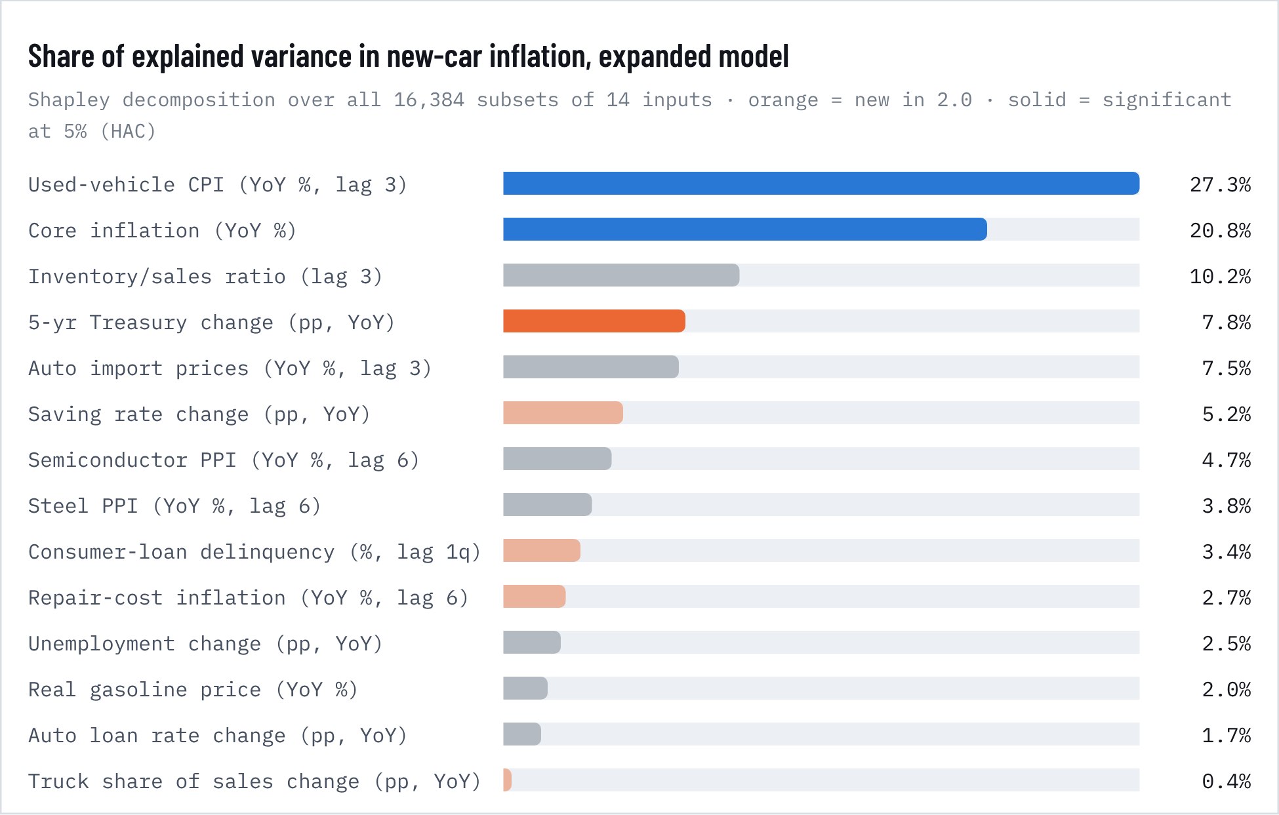
Figure 1. Share of explained variance in new-car inflation, expanded model
Table 7. Expanded driver regression (version 2.0)
Input | Coef. | HAC s.e. | p | Std. β | VIF | Coef. pre-2020 | p pre-2020
Used-vehicle CPI (YoY %, lag 3) | 0.152 | 0.024 | <0.001 | 0.46 | 2.15 | 0.067 | 0.005
Core inflation (YoY %) | 1.102 | 0.330 | <0.001 | 0.44 | 5.26 | 0.006 | 0.988
Inventory/sales ratio (lag 3) | -0.026 | 0.418 | 0.950 | -0.01 | 4.42 | 0.152 | 0.723
NEW · 5-yr Treasury change (pp, YoY) | 0.536 | 0.155 | <0.001 | 0.22 | 1.98 | 0.283 | 0.049
Auto import prices (YoY %, lag 3) | 0.270 | 0.160 | 0.091 | 0.15 | 1.76 | 0.628 | <0.001
NEW · Saving rate change (pp, YoY) | -0.048 | 0.084 | 0.569 | -0.06 | 3.62 | 0.028 | 0.678
Semiconductor PPI (YoY %, lag 6) | 0.079 | 0.058 | 0.171 | 0.08 | 2.11 | 0.198 | 0.005
Steel PPI (YoY %, lag 6) | -0.012 | 0.013 | 0.358 | -0.08 | 1.70 | -0.040 | <0.001
NEW · Consumer-loan delinquency (%, lag 1q) | -0.095 | 0.285 | 0.739 | -0.03 | 2.01 | 0.284 | 0.331
NEW · Repair-cost inflation (YoY %, lag 6) | -0.123 | 0.071 | 0.082 | -0.10 | 3.75 | -0.551 | 0.002
Unemployment change (pp, YoY) | 0.154 | 0.203 | 0.448 | 0.10 | 3.32 | 0.105 | 0.696
Real gasoline price (YoY %) | -0.004 | 0.008 | 0.609 | -0.03 | 1.98 | -0.010 | 0.120
Auto loan rate change (pp, YoY) | -0.240 | 0.250 | 0.338 | -0.07 | 2.54 | 0.027 | 0.904
NEW · Truck share of sales change (pp, YoY) | 0.028 | 0.055 | 0.617 | 0.03 | 1.53 | -0.021 | 0.584
R² / n | 0.744 |  | 389 |  |  | 0.569 | 312
Joint test of the 5 new variables (HAC Wald) |  |  | <0.001

The five new monthly variables are jointly significant (HAC Wald test, p < 0.001). They raise R² from 0.70 to 0.74 and cut the AIC by 45 points. Only one is individually significant: the five-year Treasury yield, at +0.54 points of new-car inflation per point of yield (p < 0.001), and also in the pre-2020 sample (p = 0.05). That sign says the yield is acting as a gauge of inflationary booms, when rates and car prices rise together, rather than as a financing cost. Used-vehicle prices and core inflation remain the two largest drivers. In a 2004–2026 version using the NY Fed's auto-specific delinquency measure (n = 269), delinquency is also insignificant (p = 0.20).
Explaining is not leading. In Granger tests none of the new variables helps predict next months' new-car prices (all q ≥ 0.57). The variables describe the same economic weather that moves car prices, but they don't arrive ahead of it.
Table 8. Do the new variables lead prices? Granger tests
New input (monthly change) | F (6 lags) | p | q (BH) | Leads new prices?
Saving rate | 1.36 | 0.230 | 0.574 | No
5-yr Treasury | 0.62 | 0.714 | 0.732 | No
Consumer-loan delinquency | 1.44 | 0.197 | 0.574 | No
Truck share of sales | 0.92 | 0.477 | 0.732 | No
Repair-cost inflation | 0.60 | 0.732 | 0.732 | No

Do the new variables improve the forecast?
Table 9. Do the new variables improve the forecast?
Model (new-vehicle CPI) | RMSE 12m | RMSE 24m | RMSE 36m | Theil U 36m | DM p 36m | Status
Random walk + drift | 3.05 | 5.28 | 6.95 | 1.000 | – | Benchmark
VAR, version 1 | 3.43 | 5.65 | 7.26 | 1.045 | 0.694 | Kept
Full VAR+ (5 new variables) | 3.13 | 5.87 | 8.30 | 1.194 | <0.001 | Rejected
Ridge direct (all 14 indicators) | 2.71 | 5.26 | 9.14 | 1.315 | 0.023 | Rejected
Selected VAR+ (saving + delinquency), 2.0 | 2.90 | 5.22 | 7.02 | 1.009 | 0.874 | Kept
Policy VAR+ (adds tariffs, EV subsidies), 2.1 | 4.06 | 7.04 | 8.49 | 1.221 | 0.279 | Selected
Ensemble, version 1 | 2.93 | 5.22 | 6.96 | 1.001 | – | Kept
Ensemble, version 2.0 | 2.91 | 5.20 | 6.95 | 0.999 | – | Kept
Ensemble, release 2.1 | 2.88 | 5.16 | 6.80 | 0.978 | – | Selected
Used CPI, 36-month RMSE: random walk 17.48% | full VAR+ 26.47 | ridge 25.36 | selected VAR+ 19.48 |  |  | All rejected

Same 36 rolling origins (2006–2023) for every model; RMSE in % of index level; DM p-value vs. the random walk at 36 months (negative DM = more accurate). Full VAR+ = adds saving, Treasury, delinquency, truck share and repair costs. Selected VAR+ = adds saving and delinquency only, BIC lag choice. Ridge = penalized direct 12/24/36-month regressions on all 14 indicators.
Putting every new variable into the VAR made forecasts significantly worse than the naive benchmark at 24–36 months, for both new and used vehicles: classic overfitting. A penalized regression helped at 12 months but failed at 36. The disciplined version, adding only the saving rate and delinquency, roughly matches the benchmark and beats version 1's VAR at every horizon for new vehicles. Version 2.0 added it as a fifth ensemble member for new-vehicle prices; for used vehicles it made the ensemble slightly worse. Release 2.1 replaces it with a policy VAR that also carries tariffs and EV subsidies. That model is weaker alone but improves both ensembles (see the tariffs and EV subsidies section).

The transaction-price bridge: mix, EVs and content
The sticker price (ATP) rises faster than the quality-adjusted index because of what people buy. Version 1 used one assumed drift for that gap. Version 2.0 splits it into three measured parts:
- the move to trucks and SUVs: change in truck share × the truck–car price gap, about 43% of the average price, from KBB's segment structure;
- EVs: EV share × EV price premium;
- everything else, which is content and features.
From 2013 to 2025, the truck shift accounts for 1.11 points a year of the 1.34-point average gap. EVs account for 0.08 and pure content for just 0.15. Truck share is now 84% and its logit trend points to about 88.6% by 2030, so this engine is slowing. With EV share rising while the EV premium shrinks, the net EV effect on the average price turns slightly negative.
Table 10. Transaction-price bridge, Aug 2026 to Dec 2030
Aug 2026 → Dec 2030 | Contribution
Quality-adjusted price (CPI ensemble) | +4.7%
Truck/SUV mix (84.3% → 88.6%) | +1.9%
EV mix (share 6% → 9.7%, premium → 4.4%) | -0.2%
Residual content drift | +0.6%
Total ATP change → $53,734 | +7.3%

Table 11. Historical ATP–CPI gap decomposition
Span | ATP–CPI gap %/yr | Truck mix | EV mix | Content
2013-2014 | 1.90 | 0.61 | 0.00 | 1.30
2014-2015 | 0.96 | 2.35 | 0.05 | -1.44
2015-2016 | 1.21 | 1.49 | 0.00 | -0.29
2016-2017 | 2.86 | 2.01 | 0.03 | 0.83
2018-2019 | 1.67 | 1.25 | -0.05 | 0.47
2019-2020 | 4.08 | 1.92 | 0.15 | 2.01
2020-2021 | 1.93 | 0.40 | 0.35 | 1.18
2021-2022 | -0.66 | 0.37 | 0.56 | -1.59
2022-2024 | -0.04 | 0.68 | -0.21 | -0.52
2024-2025 | 0.92 | 0.45 | 0.25 | 0.22
Weighted mean | 1.34 | 1.11 | 0.08 | 0.15

Demand with credit and savings
Table 12. Demand with credit and savings
Variable (4-quarter change) | OLS coef. | OLS p | 2SLS coef. | 2SLS p
Real new-vehicle price | 0.277 | 0.758 | -1.037 | 0.645
Real disposable income | 1.666 | 0.041 | 1.155 | 0.241
Unemployment (pp) | -0.006 | 0.537 | -0.004 | 0.809
Auto loan rate (pp) | 0.014 | 0.422 | 0.016 | 0.389
Sentiment (pt) | 0.002 | 0.037 | 0.003 | 0.166
NEW · Saving rate (pp) | -0.017 | 0.090 | -0.014 | 0.166
NEW · Consumer-loan delinquency (pp) | -0.111 | <0.001 | -0.137 | 0.020
Real gasoline price | -0.005 | 0.965 | -0.060 | 0.561
Chip-shortage dummy | -0.071 | 0.481 | -0.000 | 0.998
COVID dummy | -0.199 | 0.056 | -0.231 | 0.038
R² / n / first-stage F / Hausman p | 0.55 | 150 | 8.3 | 0.521

Adding the saving rate and consumer-loan delinquency to the quarterly sales model (1989–2026) raises R² from 0.46 to 0.55 on the same sample. Each point of delinquency is associated with about 11% fewer sales (p < 0.001; IV −14%, p = 0.02), and once it is in the model, the loan-rate effect disappears. Lenders' losses, not posted rates, are what ration credit at the margin. The new credit-squeeze scenario (5-year Treasury +1 pt, saving +2 pts, delinquency +1 pt, used prices −4% in 2027) barely moves prices (-0.5% by 2028) but implies a 15% drop in unit sales in the shock year. Credit stress hits volumes, not prices.

3. Buyer's guide
EXECUTIVE SUMMARY FOR CAR BUYERS

Should you buy now? Time the deal, not the market.
We tested whether any combination of indicators (used-car prices, dealer inventory, core inflation, Treasury yields, tariffs, import prices) can tell a buyer if new-car prices will be higher in 3, 6 or 12 months. The full seven-indicator model loses to simply assuming the historical average: out-of-sample R² is -0.24 at 12 months (Clark-West p = 0.48). One indicator does carry information. Used-car prices on their own beat the average at every horizon (out-of-sample R² 0.15 at 3 months, 0.22 at 12). That edge comes entirely from the 2020–23 price surge, though. Outside it, used prices lose to the average too (-0.03 at 12 months), and none of the 127 indicator combinations we tried beats the average at all three horizons in normal times. So watch used-car prices for a big market turn, but don't wait for small swings. What reliably moves the price you pay is when you buy within the year, the deal conditions for your segment, and your financing. What does reliably move the price you pay is when you buy within the year, the deal conditions for your segment, and your financing.
Table 13. Purchase signals right now
Item | Signal | Detail
Used-vehicle prices | Favors buying now | -1.9% y/y (34th percentile). Used prices are the strongest leading indicator in our tests, and they point to soft new-car pricing, so negotiate.
Dealer inventory | Negotiate harder or wait | Inventory/sales ratio 1.18 (8th percentile); 73 days' supply. Tight overall, especially under $30,000 (54 days). More than 90 days above $60,000.
Incentives | Negotiate harder or wait | 6.5% of transaction price, against 10–11% before COVID. Automakers are protecting margins; expect modest discounts.
Financing | Favors buying now | 5-year Treasury 4.99% (up 0.60 pp y/y, 73th percentile) and the Fed is hiking. Rates are more likely to rise than fall; lock financing sooner.
Season & model year | Favors buying now | October–December is the cheapest stretch of the year, and only 12% of inventory is MY2027, so outgoing 2026 models are being cleared.
EV prices | Favors buying now | EV transaction prices are down 2.7% y/y and the premium over gas vehicles has shrunk to under 10%. No federal credit, but used EVs are a value play.
Tariffs | Mixed | The effective tariff rate eased to 8.2% after the IEEPA ruling (peak 11.3%), but 25% Section 232 auto tariffs remain and November midterms add policy risk.
Fuel prices | Mixed | $4.35 gasoline favors hybrids and efficient models and is pushing down resale values of large SUVs and pickups.

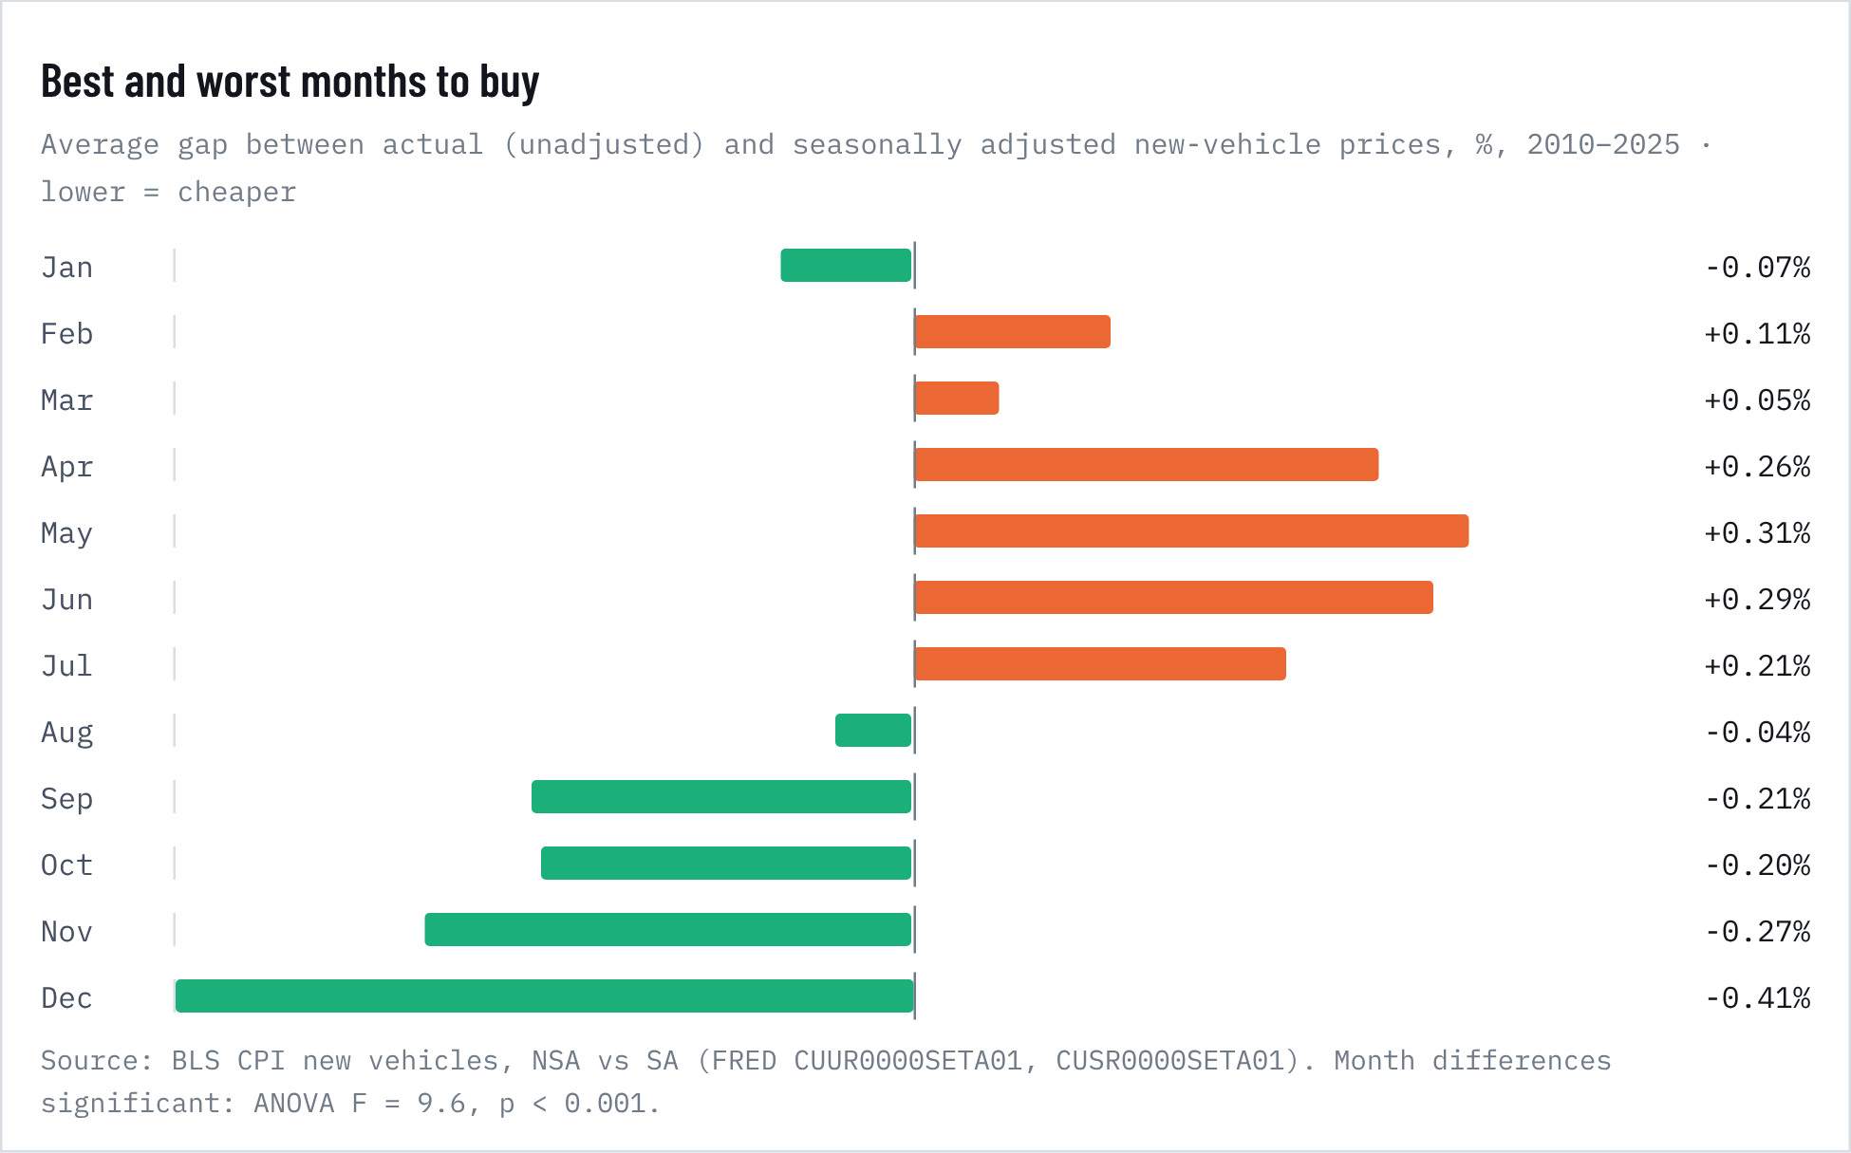
Figure 2. Best and worst months to buy
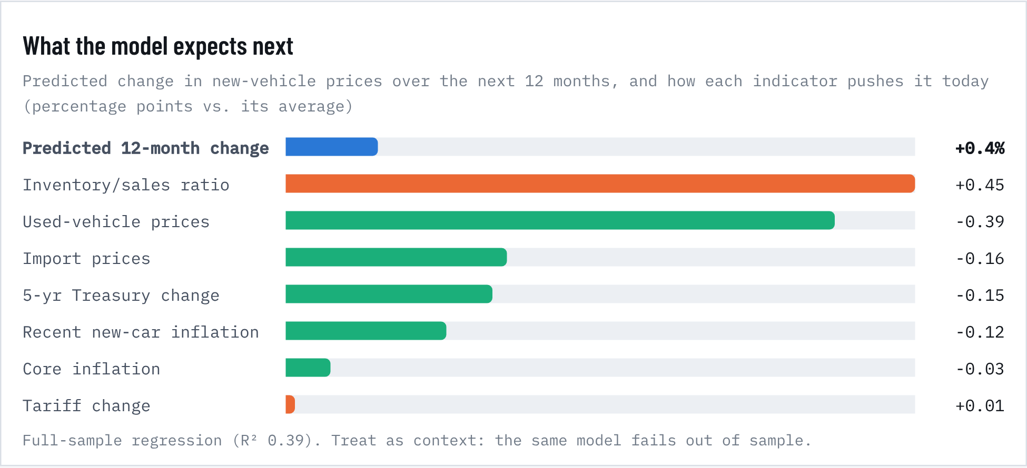
Figure 3. What the model expects next

What to weigh before you buy
Table 14. What to weigh before you buy
Consideration | What the data says | What to do
Timing within the year | Transaction prices run about 0.7% lower in December than in May, roughly $360 on a $50,000 vehicle. September–December are all below trend. | Shop October–December. Outgoing model-year 2026 stock is being cleared now; MY2027 is only 12% of inventory.
Your segment's inventory | Vehicles under $30,000 have just 54 days of supply, the tightest band. Vehicles over $60,000 have more than 90 days. | Expect little discounting on cheap models. On expensive trims, negotiate hard: dealers are carrying stock.
Incentives | Incentives are 6.5% of the price, against 10–11% before COVID. EV incentives run about 12%. | Ask for the incentive sheet. Brands and segments with high days' supply discount the most.
Financing | Banks' 48-month rate is 7.47%. Cox's market-wide average is 9.93%. The 5-year Treasury rose to 4.99%, and the Fed is hiking. Each point of APR is about $22 a month. | Get preapproved before visiting a dealer. If you need a loan within months, locking a rate sooner is likely better than waiting. Keep the term at 60 months or less: 31% of loans now run past 72 months, and Cox reports 57% of loans involve negative equity.
Total cost of ownership | Over five years and 75,000 miles, a compact SUV costs about $55,500 as a gas model, $52,200 as a hybrid and $58,000 as an EV. Depreciation is the biggest cost, then fuel, insurance, maintenance and financing. Repair prices are up 46% since 2019, and 23% of collision claims end in a total loss. | Price insurance before you sign. Favor models with simple, well-rated driver-assist hardware and strong reliability scores.
Powertrain | Charging costs about 7.6¢ a mile against 14.5¢ for gas, saving roughly $1,040 a year at $4.35 gas. That repays the EV's price premium in 3.5 years. But EVs lose about 59% of their value in five years (gas 46%, hybrid 40%), so the EV only beats gas above $5.32 a gallon. The hybrid is cheapest in 90% of simulations. Gas vehicles have the fewest problems (198 PP100), then hybrids (213) and EVs (237). | At today's prices, the hybrid is the best-value new powertrain. Buy a new EV if you drive a lot, can charge at home and plan to keep it long. A used EV sidesteps the steep early depreciation.
Size and safety | The average new vehicle weighs 4,441 lb, up 38% since 1980. Hoods taller than 40 inches raise pedestrian fatality risk by about 45%. 63 models earned 2026 IIHS awards under tougher rules. | Check the IIHS rating for the exact trim, especially rear-seat and pedestrian results. Bigger is not automatically safer for everyone on the road.
Mainstream vs. luxury | A full-size pickup averages $66,386, more than a luxury compact SUV ($52,290). GMC and Ram average more than Lexus or Acura. | Compare across the luxury line. Similar money can buy a well-equipped premium vehicle.
Resale | High fuel prices are pushing down wholesale values of large SUVs and pickups. Compact cars and EVs are gaining. | If you trade often, factor in depreciation by segment, not just today's price.

Overall signal: lean buy, with patience on price. 4 of 8 indicators favor buying now and 2 favor holding out. The model expects new-car prices to change +0.4% over the next 12 months (80% range -2.5% to +3.4%), close to the long-run average of +0.8%. Waiting for a price drop is unlikely to pay. Rising rates argue for arranging financing now, and the November–December window offers the best seasonal pricing. Buy when you need the vehicle and the deal is right; don't hold out for a national price fall.

4. Price forecast, 2026–2030
INPUTS TO TRACK · STATUS OCTOBER 2026

The 2026 shock board
Table 15. The 2026 shock board
Item | Signal | Detail
Oil & gasoline | Pushes prices up | Iran war since late Feb 2026; Brent peaked at $118 on 31 Mar. US regular gasoline $4.35 (5 Oct), WTI $97 (Sep). Shifts demand toward small cars, hybrids and used EVs; pressures large-SUV and pickup values.
Interest rates | Pushes prices up | Fed raised to 3.75–4.00% on 16 Sep, its first hike since 2023; median path 4.1% through 2027. Cox puts the average new-loan rate at 9.93% (Aug). Pass-through to auto APRs ≈ 0.43 per point.
Tariffs | Pushes prices up | Section 232: 25% on vehicles and parts (15% for Japan, EU, Korea deals; UK 10% within quota). IEEPA tariffs were struck down on 20 Feb 2026. The temporary 10% Section 122 tariff that replaced them expired in July, and Section 301 tariffs have taken over; none of that changes the Section 232 auto tariffs. Cox estimated $5,500 per imported vehicle and $1,000 per US-built vehicle.
Core inflation | Pushes prices up | Fed projects 2026 core PCE at 3.4%. Before 2020 core inflation had no independent effect on new-car prices; since 2020 it co-moves strongly.
Used-vehicle market | Pushes prices down | Manheim index 205.9 in Sep, −0.6% y/y, falling since its March peak. Used CPI −2.3% y/y. The strongest leading indicator in our tests points to soft new-car pricing near term.
Inventory | Mixed | 76 days of supply (Sep), down 1% y/y. Model-year 2027 is only 12% of supply against 26% a year ago: automakers are building cautiously, which supports prices.
EV policy | Mixed | Federal EV credit ended 30 Sep 2025; EPA eliminated vehicle GHG standards in Feb 2026. EV share about 6%; EV prices falling (ATP $54,813, −2.7% y/y). Lower compliance costs, less EV discounting.
Credit stress | Mixed | Auto balances 90+ days late: 5.49% (Q2 2026), above the 2010 peak. Fitch subprime 60+ day delinquency hit a record 6.90% in January. Tighter lending would cut demand, but defaults also push repossessed supply into the used market.
Consumer health | Pushes prices down | Sentiment 51.7 (Aug); unemployment 4.2% (Sep); retail sales down 5% YTD while fleet is up 7%. Gains are concentrated among affluent buyers.

PRICE PREDICTION, 2026–2030

The forecast
Five models forecast the new-vehicle index: a random walk with 10-year drift (the benchmark), an AIC-selected ARIMA, a damped-trend exponential smoother, and a VAR that links new prices to used prices, core inflation, inventory and loan rates, and (release 2.1) a VAR that adds the saving rate, consumer-loan delinquency, the effective tariff rate and EV-subsidy intensity. They are combined with weights set by inverse backtest error. Forecast ranges come from re-sampling each model's actual historical forecast errors, so they reflect real surprises such as 2021, not textbook normal errors. Used-vehicle forecasts use the same five models.
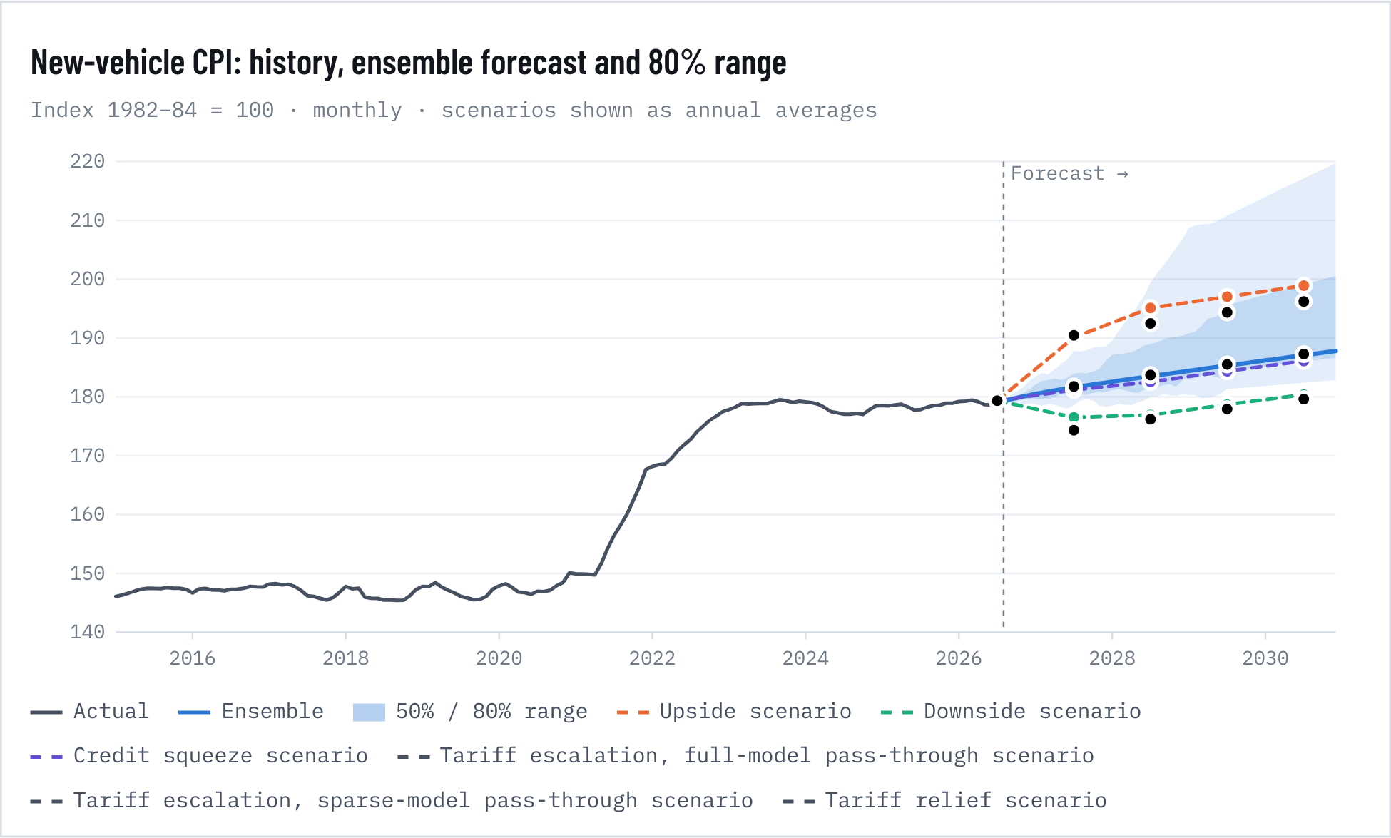
Figure 4. New-vehicle CPI: history, ensemble forecast and 80% range
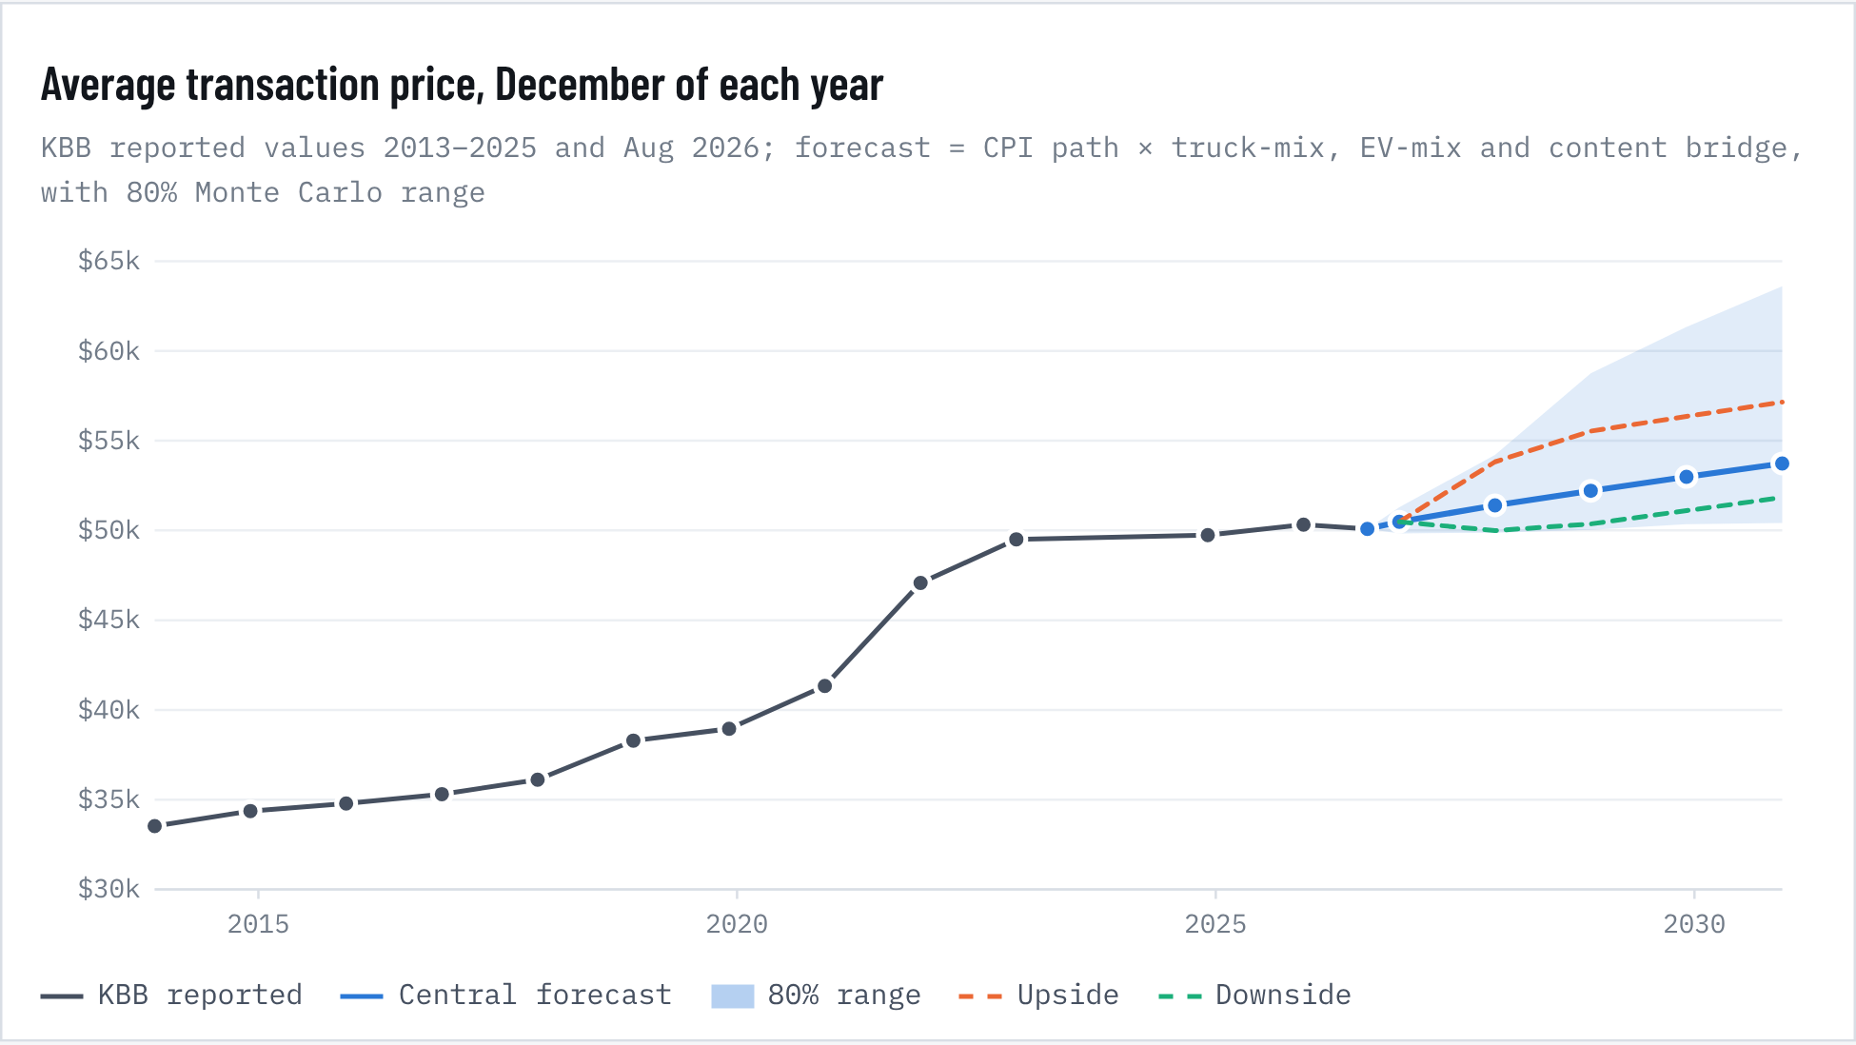
Figure 5. Average transaction price, December of each year

Forecast table
Table 16. Forecast table
Measure | 2026 | 2027 | 2028 | 2029 | 2030
New-vehicle CPI (annual avg) | 179.4 | 181.5 | 183.4 | 185.2 | 187.0
y/y change | +0.5% | +1.2% | +1.1% | +1.0% | +1.0%
80% range | 179.1–179.8 | 178.5–186.3 | 179.8–202.6 | 181.1–215.5 | 181.7–224.5
80% range, ex-pandemic errors | 179.1–179.7 | 179.2–186.1 | 179.8–190.0 | 181.1–194.4 | 181.7–198.8
Average transaction price (Dec) | $50,484 | $51,399 | $52,211 | $52,986 | $53,734
80% range | $49.8k–$51.3k | $49.9k–$54.2k | $50.0k–$58.8k | $50.3k–$61.3k | $50.4k–$63.6k
P(ATP > $55,000) | 0% | 8% | 23% | 40% | 51%
Used-vehicle CPI (annual avg) | 181.0 | 183.9 | 185.2 | 186.6 | 188.2
y/y change | -2.1% | +1.6% | +0.7% | +0.8% | +0.9%
80% range | 179.7–182.7 | 173.9–204.4 | 173.3–237.0 | 170.2–258.0 | 167.0–273.0
80% range, ex-pandemic errors | 179.8–181.7 | 176.1–188.9 | 176.3–200.1 | 172.0–209.4 | 171.0–217.4
Monthly payment, new loan | $797 | $811 | $822 | $832 | $843
range (ATP 80% band, APR ±0.75pp) | $771–$826 | $771–$873 | $772–$945 | $774–$983 | $775–$1,019
assumed APR | 7.42% | 7.42% | 7.34% | 7.21% | 7.21%
ATP in weeks of median income | 28.9 | 28.3 | 27.6 | 26.9 | 26.3

CPI rows are annual averages (2026 includes Jan–Aug actuals). ATP and payments are December values. 80% ranges are the 10th–90th percentiles of 20,000 simulated paths. Payment assumes 88.7% of ATP financed over 70.4 months, with APR following the Fed's September 2026 median rate path at the estimated 0.43 pass-through, plus 0.22 points for the rise in the 5-year Treasury since August.
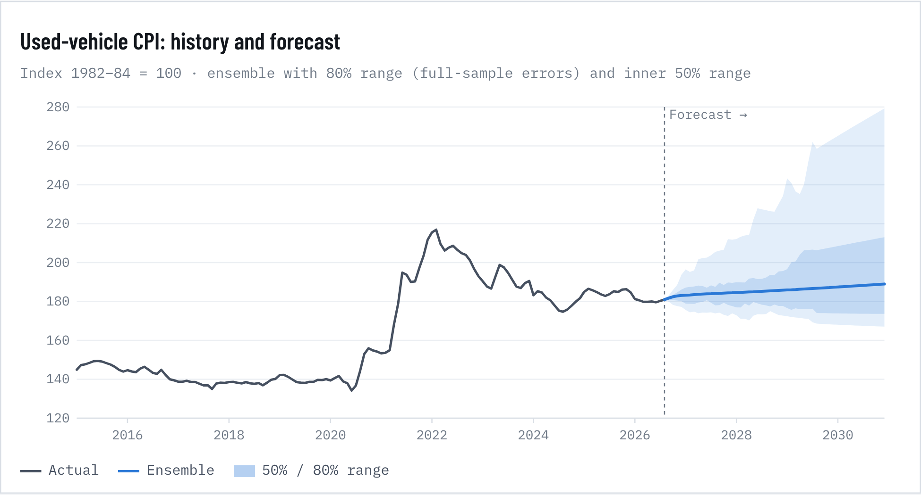
Figure 6. Used-vehicle CPI: history and forecast

Scenarios
Table 17. Scenarios
Scenario | Shocks in 2027 | Shocks in 2028 | Added inflation 2027 | Added 2028 | Level vs. base by 2028 | ATP Dec 2030
Base (ensemble) | – | – | – | – | – | $53,734
Upside: tariff escalation + sticky oil-shock inflation | core +1pp, used +5%, imports +6%, chips +5%, 5-yr Treasury +0.5pp | core +0.5pp, used +2%, imports +2% | +4.7pp | +1.6pp | +6.4% | $57,158
Downside: demand slump + price competition | core -0.5pp, used -6%, imports -3%, inventory ratio +0.3, 5-yr Treasury -0.5pp | core -0.5pp, used -2%, imports 0%, inventory ratio +0.3 | -2.7pp | -0.8pp | -3.5% | $51,834
Credit squeeze: higher rates, more saving, rising defaults | used -4%, 5-yr Treasury +1pp, saving rate +2pp, delinquency +1pp | used -2%, saving rate +0.5pp, delinquency +0.5pp | -0.2pp | -0.3pp | -0.5% | $53,477
Tariff escalation, full-model pass-through: effective rate +5 pp | effective tariff rate +5pp | – | +4.9pp | +0.0pp | +4.9% | $56,385
Tariff escalation, sparse-model pass-through: effective rate +5 pp |  | – | +0.2pp | +0.0pp | +0.2% | $53,816
Tariff relief: effective rate −4 pp | effective tariff rate -4pp | – | -3.9pp | +0.0pp | -3.9% | $51,614

Shocks are deviations from the base path, translated into new-vehicle inflation with the expanded (2.0) driver-regression coefficients: core 1.11, used 0.16, imports 0.35, chips 0.10, inventory 0.17, 5-yr Treasury 0.49, saving -0.08, delinquency 0.12. Shocks fade after 2028.
How to read the range. The distribution is skewed upward. Historically, the big forecast misses were upside surprises: chip shortages and supply shocks raise prices quickly, while price cuts happen slowly through incentives. The simulated median for December 2030 ($55,091) sits above the central forecast for that reason. The chance that the average transaction price is below $50,000 in December 2030 is 8%.
Affordability. Measured as weeks of median household income, the average new vehicle cost 34.6 weeks at the 2021 peak and 29.9 weeks in 2025. If household incomes keep growing about 4% a year, the central forecast brings that to about 26.3 weeks by 2030, since prices are projected to grow slower than incomes. Higher loan rates offset part of that gain in the monthly payment.

5. What drives prices and demand
WHAT CHANGES THE PRICE

Ranking the inputs behind new-car inflation
We regressed 12-month new-vehicle inflation on nine candidate inputs from January 1994 to August 2026 (390 months), with Newey-West standard errors to correct for the overlap in 12-month changes. The model explains 70% of the variation. To rank inputs fairly when they move together, we split the R² among them with a Shapley (LMG) decomposition over all 512 subsets.
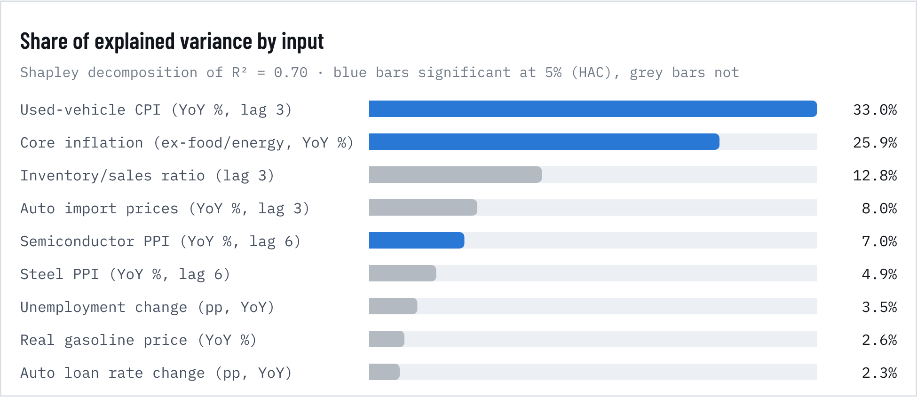
Figure 7. Share of explained variance by input

Coefficients, full sample vs. before 2020
Table 18. Coefficients, full sample vs. before 2020
Input | Coef. | HAC s.e. | p | Std. β | VIF | Coef. pre-2020 | p pre-2020
Used-vehicle CPI (YoY %, lag 3) | 0.159 | 0.028 | <0.001 | 0.48 | 1.70 | 0.071 | 0.004
Core inflation (ex-food/energy, YoY %) | 1.169 | 0.387 | 0.003 | 0.46 | 3.81 | -0.367 | 0.334
Inventory/sales ratio (lag 3) | 0.240 | 0.487 | 0.621 | 0.06 | 3.15 | 0.272 | 0.543
Auto import prices (YoY %, lag 3) | 0.232 | 0.154 | 0.131 | 0.13 | 1.55 | 0.681 | <0.001
Semiconductor PPI (YoY %, lag 6) | 0.151 | 0.072 | 0.035 | 0.16 | 1.63 | 0.194 | 0.011
Steel PPI (YoY %, lag 6) | -0.010 | 0.017 | 0.541 | -0.07 | 1.64 | -0.051 | <0.001
Unemployment change (pp, YoY) | -0.050 | 0.139 | 0.717 | -0.03 | 1.49 | -0.255 | 0.253
Real gasoline price (YoY %) | 0.005 | 0.012 | 0.670 | 0.04 | 1.58 | -0.006 | 0.402
Auto loan rate change (pp, YoY) | -0.131 | 0.265 | 0.620 | -0.04 | 1.55 | 0.066 | 0.752
R² / n | 0.704 |  | 390 |  |  | 0.519 | 312

Dependent variable: 12-month log change in new-vehicle CPI, %. HAC (Newey-West, 12 lags) standard errors. Bold p-values < 0.05. Pre-2020 sample: 1994–2019, n = 312.
The pre-2020 column changes the story. Before the pandemic, import prices were the dominant cost channel (0.68 points of new-car inflation per 1% rise, p < 0.001), and core inflation had no independent effect. Core inflation's large full-sample weight comes mostly from 2021–22, when everything rose at once. For tariff analysis, the import-price channel is the one to watch.

Which inputs lead prices? Granger causality
Table 19. Which inputs lead prices? Granger causality
Input (monthly change) | F (6 lags) | p | q (BH) | Leads new prices?
Used-vehicle prices | 4.97 | <0.001 | <0.001 | Yes
Inventory/sales ratio | 4.33 | <0.001 | 0.002 | Yes
Core CPI | 2.51 | 0.021 | 0.100 | No
Sales (SAAR) | 1.76 | 0.105 | 0.316 | No
Vehicle PPI (factory price) | 1.73 | 0.113 | 0.316 | No
Aluminum PPI | 1.42 | 0.205 | 0.478 | No
Unemployment rate | 1.18 | 0.315 | 0.584 | No
Gasoline prices | 1.14 | 0.337 | 0.584 | No
Auto import prices | 1.08 | 0.375 | 0.584 | No
Real disposable income | 0.87 | 0.519 | 0.727 | No
Steel PPI | 0.75 | 0.612 | 0.779 | No
Auto loan rate | 0.64 | 0.695 | 0.811 | No
Semiconductor PPI | 0.30 | 0.938 | 0.949 | No
Consumer sentiment | 0.27 | 0.949 | 0.949 | No

Bivariate tests on monthly changes, 6 lags, 1994–2026. q = Benjamini-Hochberg false-discovery-rate adjusted p-value across 14 tests.
Only two inputs reliably lead new-car prices once we correct for running 14 tests: used-vehicle prices and the inventory-to-sales ratio. Both are market-tightness signals. Dealer lots and the used market tell you where new prices are heading before factory costs do.
TOP PREDICTOR VARIABLES

The six inputs that explain the most
Each panel plots one predictor against new-car inflation, both converted to standard deviations from their 1994–2026 average so they share one scale. These six inputs carry the largest Shapley shares in the 2.1 driver model, which includes tariffs and EV subsidies. The figure in each title is the correlation over the whole period.
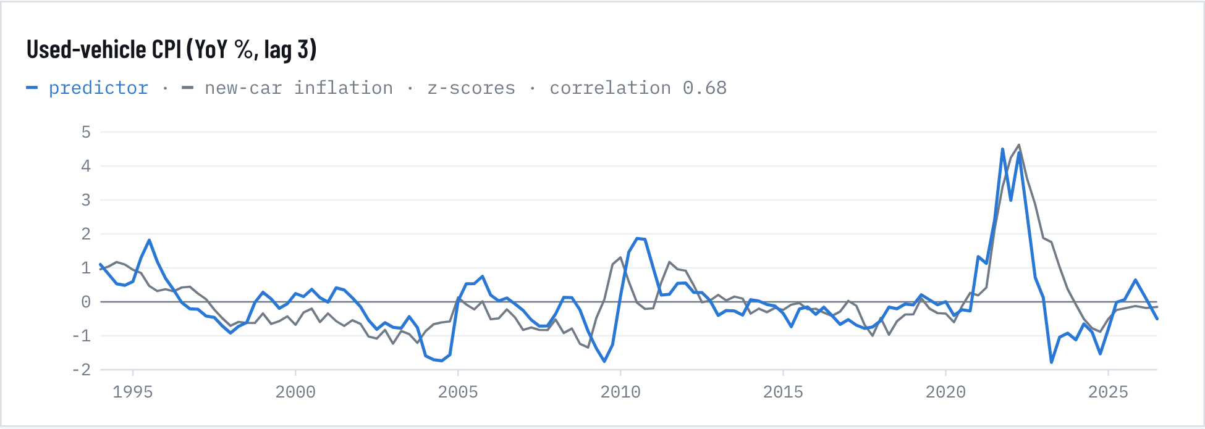
Figure 8. Used-vehicle CPI (YoY %, lag 3)
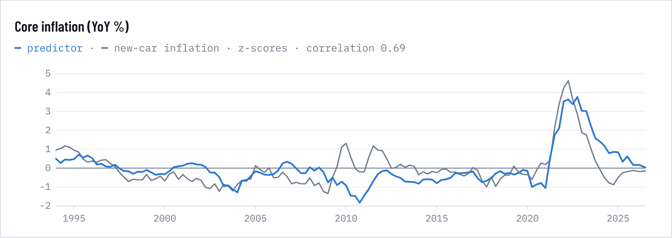
Figure 9. Core inflation (YoY %)
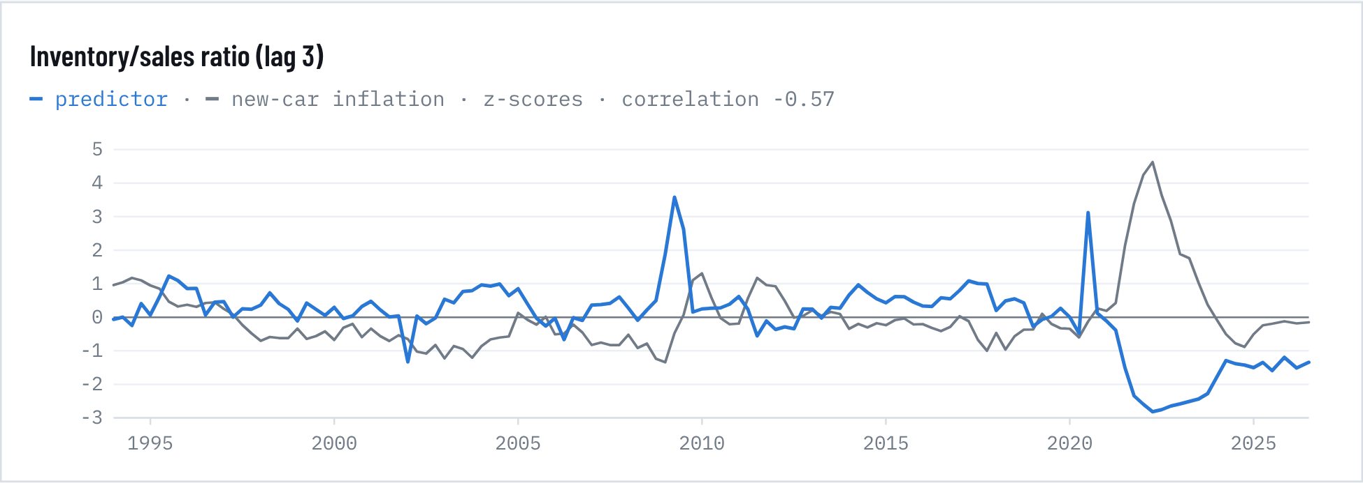
Figure 10. Inventory/sales ratio (lag 3)
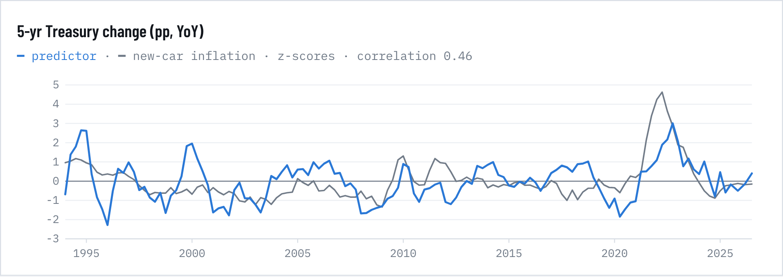
Figure 11. 5-yr Treasury change (pp, YoY)
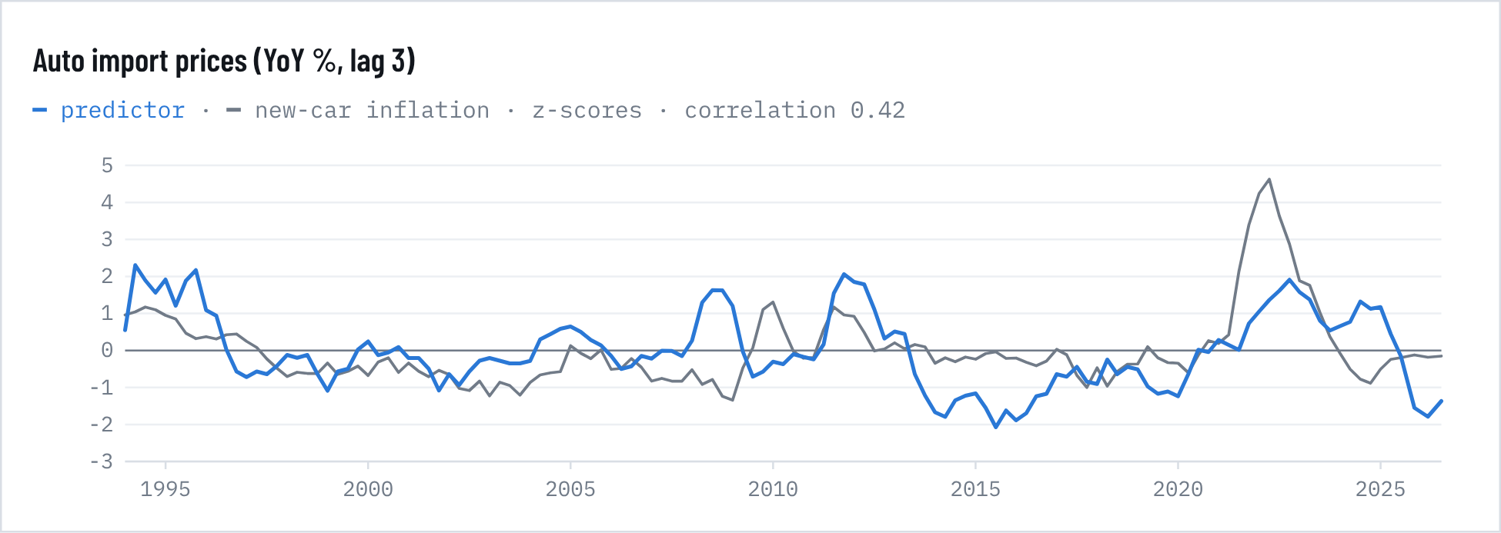
Figure 12. Auto import prices (YoY %, lag 3)
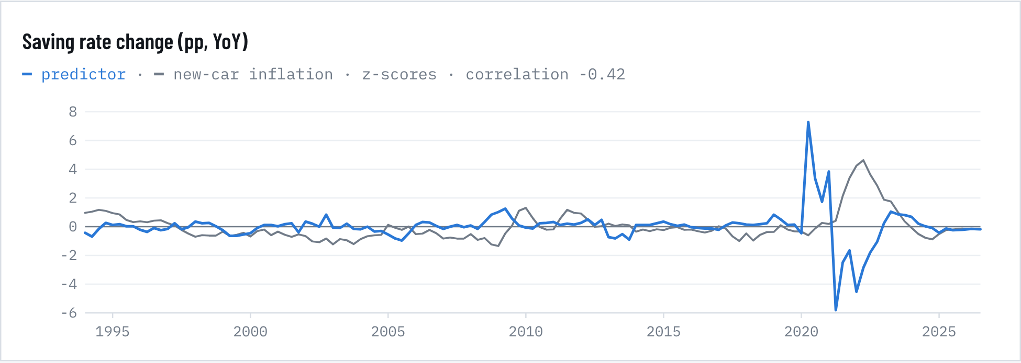
Figure 13. Saving rate change (pp, YoY)
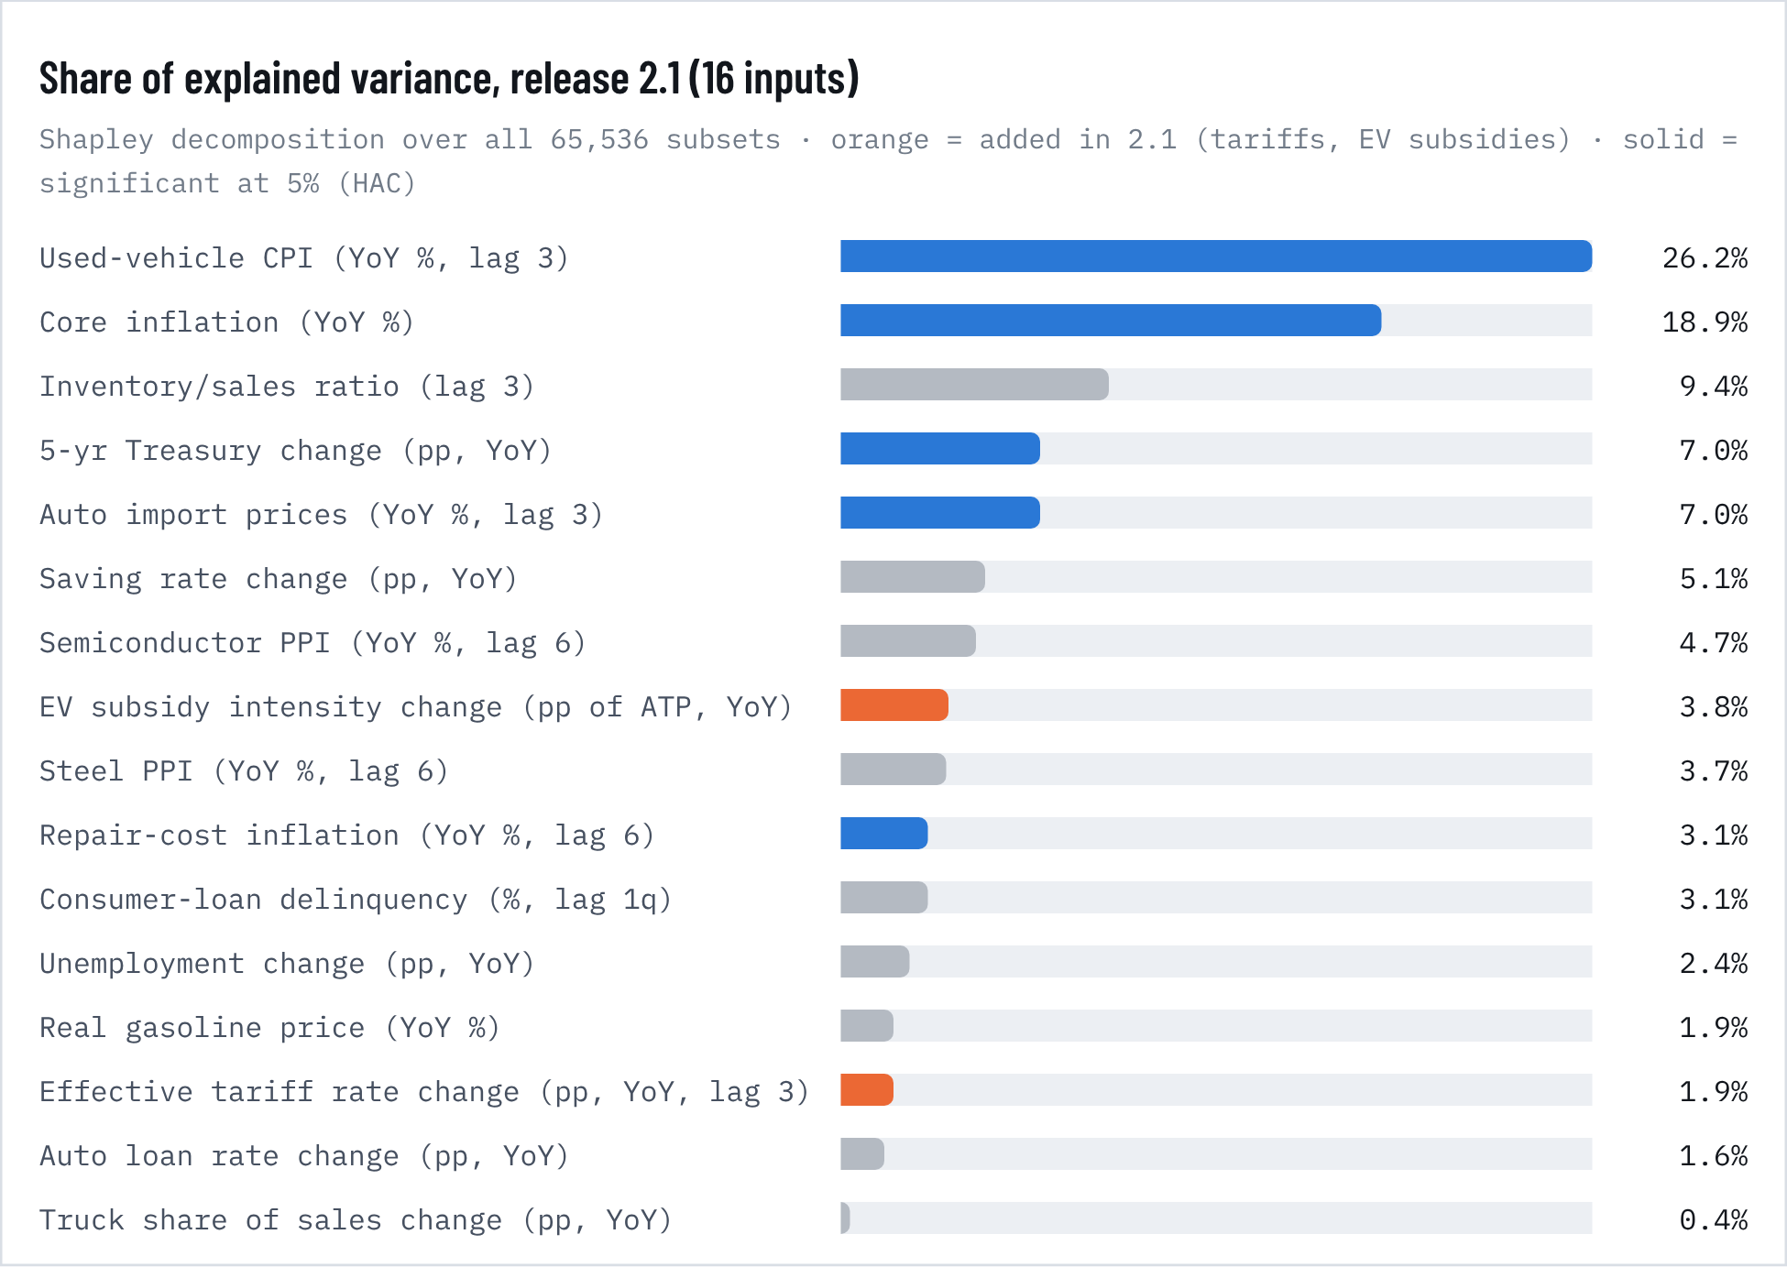
Figure 14. Share of explained variance, release 2.1 (16 inputs)
RELEASE 2.1 · TARIFFS AND EV SUBSIDIES AS PREDICTORS

Policy variables: significant in the past, fragile for the future
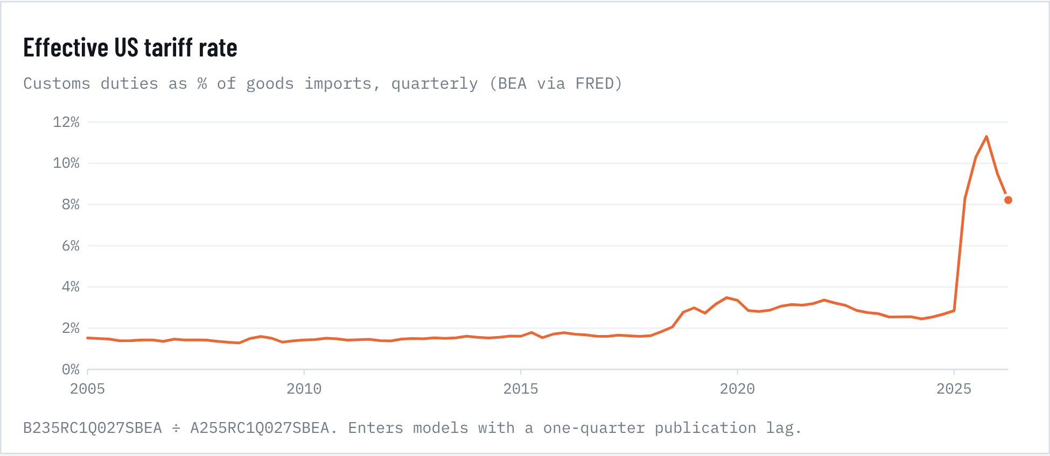
Figure 15. Effective US tariff rate
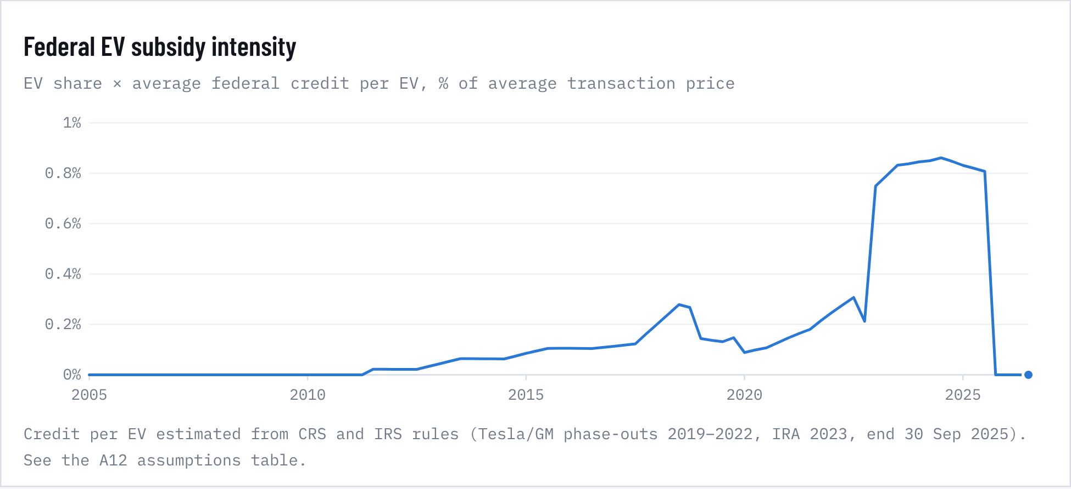
Figure 16. Federal EV subsidy intensity
Table 20. Tariffs and EV subsidies in the driver model
Policy variable | Full model coef. | p | Pre-2020 coef. | p | Shapley share | Granger p
Effective tariff rate change (pp, lag 3) | 0.986 | <0.001 | 1.390 | 0.010 | 1.9% | 0.940
same, sparse model (core, used, imports only) | 0.030 | 0.715 | – | – | – | –
EV subsidy intensity change (pp of ATP) | 7.450 | <0.001 | -2.634 | 0.455 | 3.8% | 0.996
Model R² 2.0 → 2.1 | 0.744 → 0.786 | joint p <0.001

Adding the two policy variables to the driver model lifts R² from 0.74 to 0.79 (adjusted 0.78) and cuts the AIC by 66 points; they are jointly significant (p < 0.001). Each point of effective tariff increase is associated with about 0.99 points of extra new-car inflation a year later (p < 0.001; pre-2020 estimate 1.39, p = 0.01).
That result is fragile. In a sparse model with only core inflation, used prices and import prices as controls, the tariff effect drops to 0.03 (p = 0.72). The 2025 experience also argues for caution: the effective rate jumped from about 2.5% to 11.3%, yet new-car prices rose only 0.6% over the following year, because automakers absorbed much of the cost. The EV-subsidy coefficient is large and positive, but it reverses sign before 2020 and almost certainly picks up the timing of the 2023 IRA credits against post-pandemic price momentum rather than a causal effect. Neither variable Granger-causes prices (p = 0.94 and 1.00).
As forecast inputs: a VAR that adds tariffs and EV subsidies is worse than the random walk on its own (36-month RMSE 8.49% vs 6.95%). As a fifth ensemble member, though, it improves the ensemble at every horizon for both new and used prices (new: 2.91 → 2.88, 5.20 → 5.16, 6.95 → 6.80 at 12/24/36 months; ex-pandemic 1.51 → 1.36 and 3.40 → 3.01). The gain is not statistically significant (DM p = 0.10 at 36 months). We adopt it in release 2.1. Tariff policy is better handled through explicit scenarios, which the table below brackets with the full-model and sparse-model estimates.
Table 21. Tariff scenarios
Tariff scenario | Added inflation 2027 | Level vs base by 2028 | ATP Dec 2030
Base (effective rate held at 8.2%) | – | – | $53,734
Tariff escalation, full-model pass-through: effective rate +5 pp | +4.93 pp | +4.9% | $56,385
Tariff escalation, sparse-model pass-through: effective rate +5 pp | +0.15 pp | +0.2% | $53,816
Tariff relief: effective rate −4 pp | -3.95 pp | -3.9% | $51,614

Tariff scenarios shift the effective tariff rate in 2027 relative to the base path (which holds today's 8.2%) and translate it into new-car inflation using the full-model coefficient or the sparse-model coefficient. Reinstating a $7,500 EV credit would raise EV share by about 2 points (log-odds +0.32, the reverse of the 2025 expiry) and barely move the average price, because the EV premium is shrinking.
WHAT CHANGES DEMAND

Sales follow jobs, income and credit
Quarterly model of the 4-quarter change in light-vehicle sales, 1983–2026 (n = 175). Plain OLS gives a positive price coefficient, a classic sign of simultaneity: prices and sales both rise in booms. We instrument the real new-vehicle price with real auto import prices, a cost shifter (first-stage F = 34). A Wu-Hausman test leans against treating price as exogenous (p = 0.08). Adding steel as a second instrument rejects exogeneity more strongly (p = 0.003), but steel is a weak instrument and that version fails the over-identification test, so the table reports the import-price IV.
Table 22. Light-vehicle demand model, OLS vs. 2SLS
Variable | OLS coef. | OLS p | 2SLS coef. | 2SLS s.e. | 2SLS p
Real new-vehicle price (elasticity) | 0.794 | 0.296 | -0.864 | 0.824 | 0.294
Real disposable income (elasticity) | 1.232 | 0.007 | 1.026 | 0.462 | 0.026
Unemployment rate (per pp) | -0.034 | <0.001 | -0.034 | 0.010 | 0.001
Auto loan rate (per pp) | -0.018 | 0.090 | -0.024 | 0.011 | 0.028
Consumer sentiment (per point) | 0.003 | <0.001 | 0.004 | 0.001 | <0.001
Real gasoline price (elasticity) | 0.107 | 0.334 | 0.029 | 0.109 | 0.787
Chip-shortage dummy | -0.064 | 0.490 | 0.010 | 0.090 | 0.913
COVID dummy | -0.094 | 0.366 | -0.073 | 0.119 | 0.540
Constant | -0.016 | 0.266 | -0.038 | 0.022 | 0.082
Robustness: 2 instruments (imports + steel), price elasticity |  |  | -0.730 | 0.804 | 0.364
Diagnostics | R² 0.48 | n 175 | 1st-stage F 34.5 | Hausman p 0.078 | 2-IV Sargan p <0.001

HAC/kernel standard errors (4 lags). Δ = 4-quarter change. Controls include chip-shortage (2021Q2–2023Q1) and COVID (2020Q2) dummies.
Each extra point of unemployment cuts sales by about 3.4%. A 1% rise in real disposable income adds 1.0–1.2%. One percentage point on loan rates costs about 2% of sales, and each point of consumer sentiment adds 0.3–0.4%. The price elasticity is about −0.9 but its 95% interval spans roughly −2.5 to +0.8, so aggregate data cannot pin it down. That fits a market where buyers respond to the monthly payment more than to the sticker.

6. Total cost of ownership: new vs. used, gas vs. hybrid vs. EV
RELEASE 2.2 · TOTAL COST OF OWNERSHIP

Five years of ownership: the hybrid wins; depreciation eats the EV's fuel savings
We priced five years and 75,000 miles of owning a new compact SUV, the best-selling segment, as a gas model, a hybrid and a battery EV. The gas model is the KBB segment average ($37,722, August 2026). The hybrid adds a typical $2,500 trim premium, and the EV carries Cox's current 9.7% EV price premium. Fuel and electricity are at today's prices: $4.35 a gallon, 19.6¢ a kWh at home and $0.49 at public fast chargers, with 86% of charging at home (J.D. Power).
Table 23. Key numbers
Measure | Value | Detail
Gas, 5-year cost | $55,549 | 74¢ a mile · $681/mo loan
Hybrid, 5-year cost | $52,229 | 70¢ a mile · $726/mo loan
Battery EV, 5-year cost | $57,950 | 77¢ a mile · $747/mo loan
EV break-even gas price | $5.32 | $3.13 if EVs held value like the average car

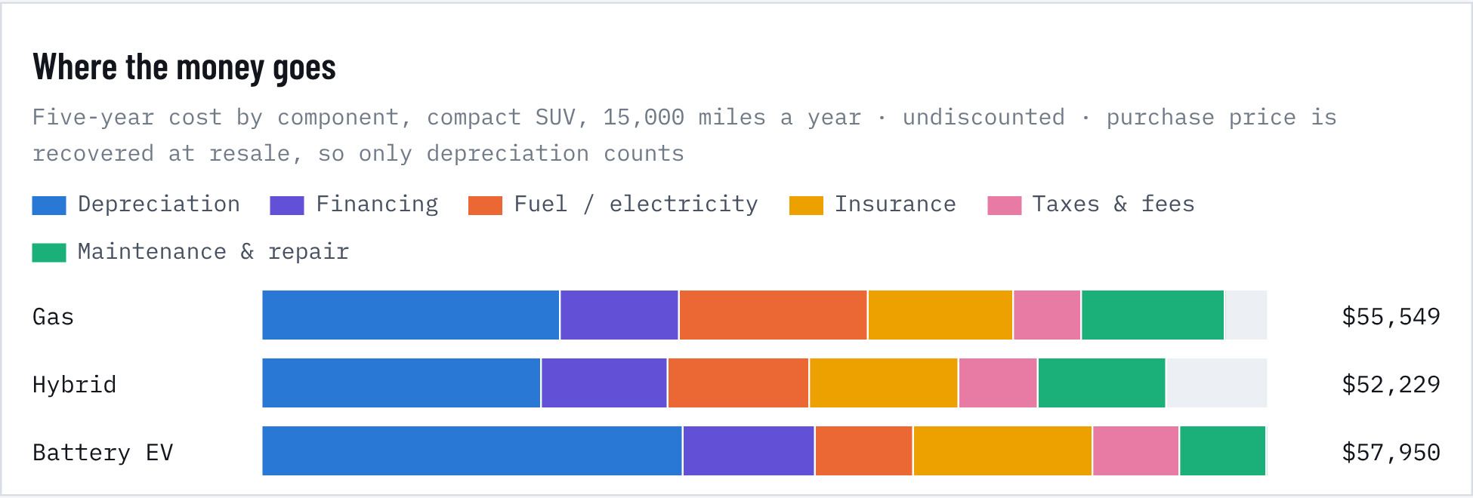
Figure 17. Where the money goes
Table 24. Five-year cost by component, new compact SUV
Five-year cost | Gas | Hybrid | Battery EV | Hybrid vs gas | EV vs gas
Purchase price | $37,722 | $40,222 | $41,381 | +$2,500 | +$3,659
Depreciation | $17,201 | $16,089 | $24,332 | −$1,112 | +$7,131
Financing | $6,906 | $7,364 | $7,576 | +$458 | +$670
Fuel / electricity | $10,887 | $8,165 | $5,692 | −$2,722 | −$5,195
Insurance | $8,337 | $8,609 | $10,298 | +$272 | +$1,962
Taxes & fees | $3,938 | $4,551 | $5,051 | +$613 | +$1,113
Maintenance & repair | $8,280 | $7,452 | $5,001 | −$828 | −$3,279
Total, five years | $55,549 | $52,229 | $57,950 | −$3,320 | +$2,401
Cost per mile | 74¢ | 70¢ | 77¢
Monthly loan payment | $681 | $726 | $747 | +$45 | +$66

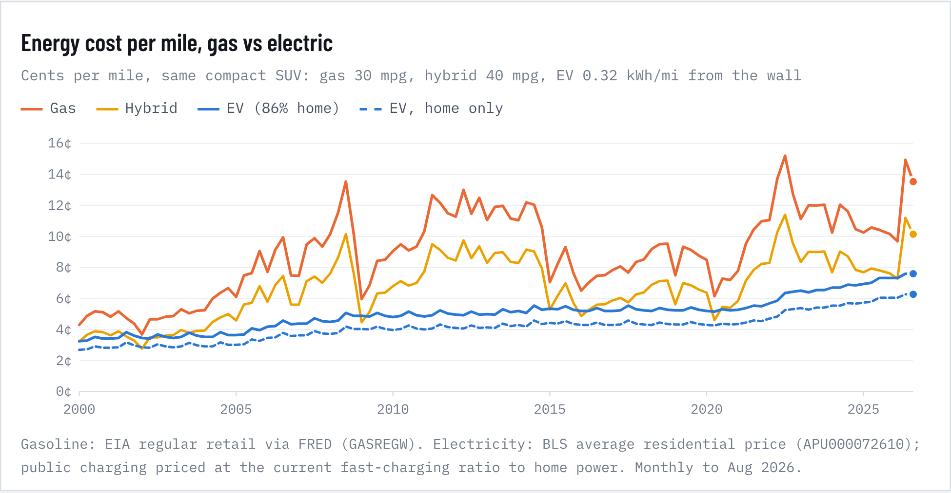
Figure 18. Energy cost per mile, gas vs electric
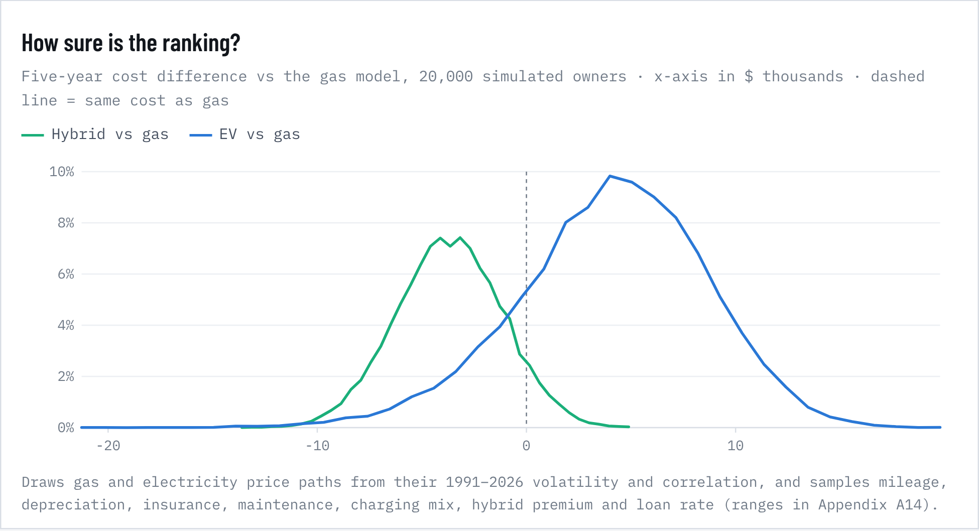
Figure 19. How sure is the ranking?
Fuel vs electricity. At August prices a gas compact SUV costs 13.5¢ a mile to fuel, the hybrid 10.1¢ and the EV 7.6¢ (6.3¢ if it only charges at home). That saves an EV driver about $891 a year against gas. Charging has been cheaper than gasoline in every month since 2000. The gap ranged from almost nothing in late 2001 to $1,535 a year in June 2022. Electricity also beat the hybrid's fuel bill in 91% of months. Electricity prices are also far steadier: 12-month swings average 21% for gasoline against 4% for electricity (Levene test p < 0.001). An EV makes running costs more predictable, not just lower.
The other components decide it. Depreciation is the largest cost for every powertrain. An EV loses about 59% of its value in five years, against 46% for the average vehicle and 40% for hybrids (iSeeCars). EV insurance runs about 18% more for 2024-and-newer models and 42% more across all model years (Insurify). Maintenance is about 40% cheaper for an EV (Argonne National Laboratory). But 41 states now add a special EV registration fee averaging $146 a year, and 30 states charge hybrids about $70. Financing at 7.54% (60 months, 10% down) costs more on the pricier models.
Break-even prices. Fuel savings alone repay the EV's price premium in 3.5 years and the hybrid's in 4.6 years. But the EV's faster depreciation and higher insurance outweigh its fuel savings: it only beats the gas model once gasoline reaches $5.32 a gallon. If EVs held their value like the average car, the break-even would fall to $3.13, below today's price. The hybrid is cheaper than the gas model at any gas price, because it holds value better and costs less to fuel.
How sure is that? Across 20,000 simulated owners the hybrid is cheapest 90% of the time, the gas model 7% and the EV 3%. The EV beats gas in 18% of draws. Its median five-year cost is $4,318 higher (80% range −$1,861 to +$9,608). The hybrid's median saving is $3,680 (80% range $477 to $6,964). The swing factors chart below shows what moves the EV result most. AAA's 2025 Your Driving Costs study ranks the three the same way (hybrid 63.9¢, compact SUV 68.5¢, EV 71.2¢ a mile, at $3.15 gas). Our costs per mile run higher because gas is now $4.35 and loan rates are higher.
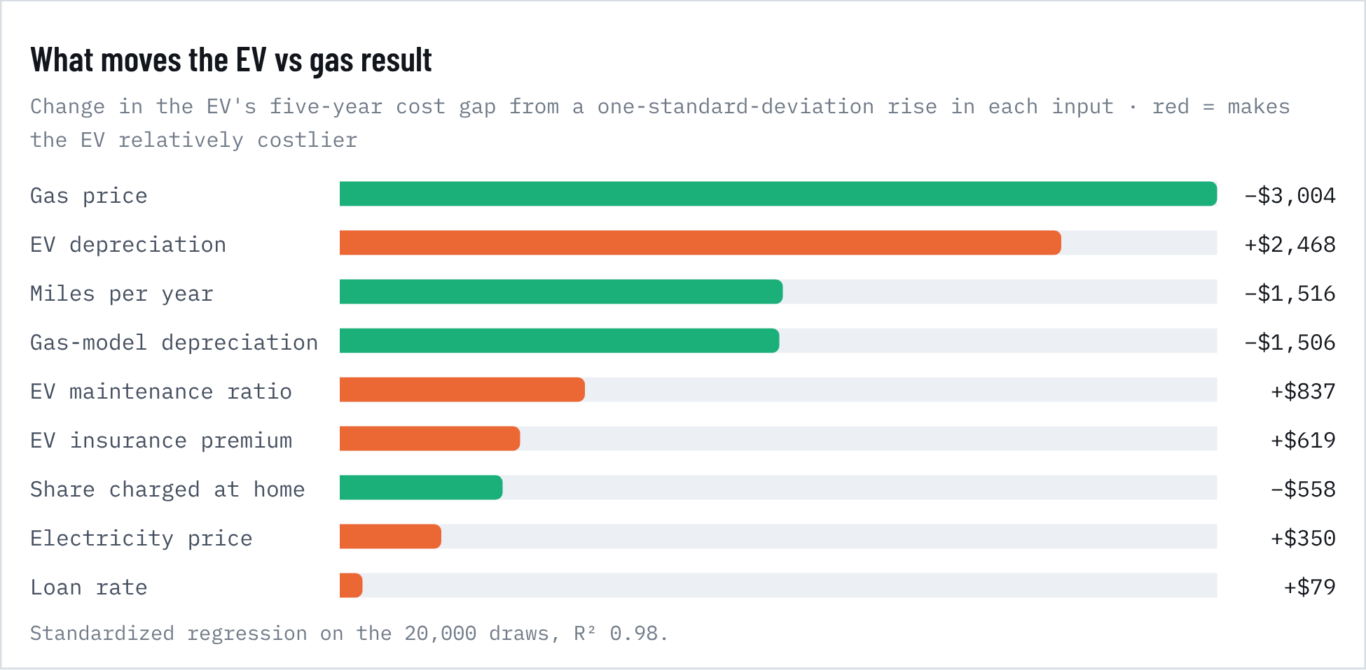
Figure 20. What moves the EV vs gas result
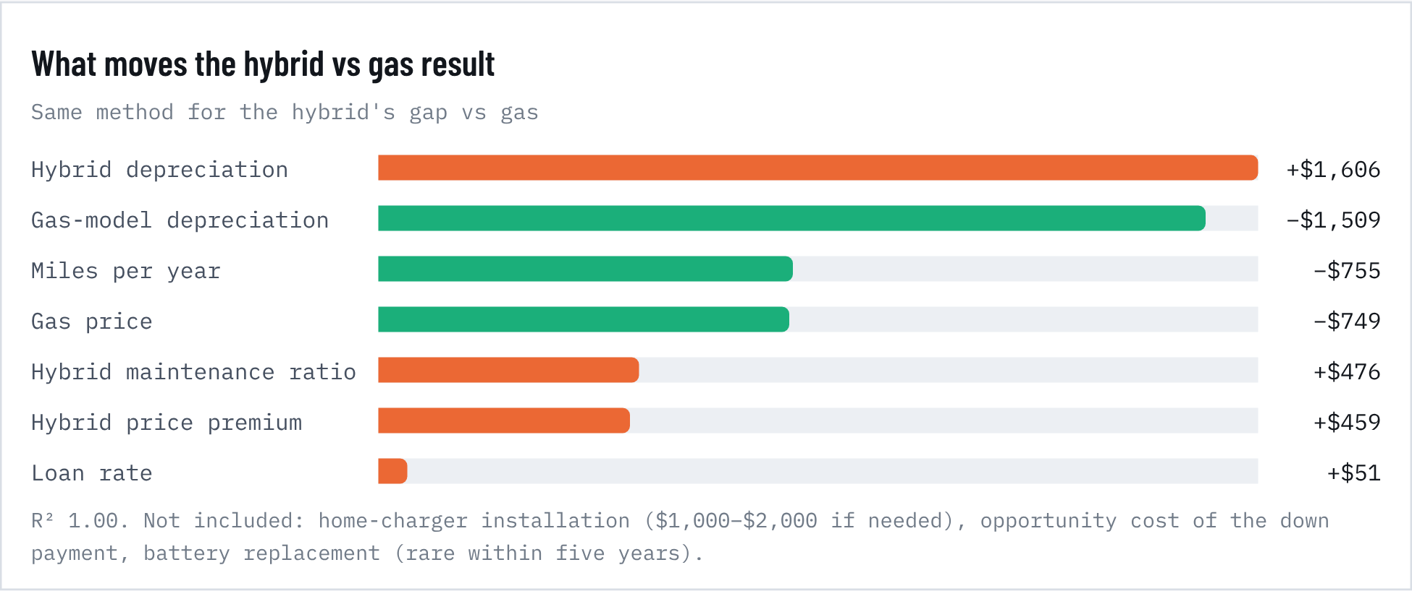
Figure 21. What moves the hybrid vs gas result

New vs. a 2- or 3-year-old car
Buying used shifts the biggest cost, depreciation, onto the first owner. We priced the same compact SUVs bought at 2 and 3 years old and kept five years, at today's used-market values. A vehicle's value follows a curve built from CARFAX's 20% first-year loss and iSeeCars' five-year losses (46% average, 40% hybrid, 59% EV), flattening after year 5. That curve puts a 3-year-old gas model at 66% of today's new price, close to Edmunds' Q2 2026 3-year-old average of $32,461 (65% of the $50,089 new-vehicle average). Used loans cost more (Experian average 11.19%, against 7.54% for new). Insurance falls with age (Insure.com: about 8% less for a 2-year-old and 12% less for a 3-year-old over the five years). Repairs rise about 12% per year of age (Bumper).
Table 25. Key numbers
Measure | Value | Detail
3-year-old gas, 5-year cost | $48,112 | 64¢/mi · $7,437 less than new
3-year-old hybrid | $45,865 | 61¢/mi · $6,364 less than new
3-year-old EV | $42,228 | 56¢/mi · $15,722 less than new
Cheapest in simulations | 3-yr EV 62% | 3-yr hybrid 37% · 3-yr gas 1%

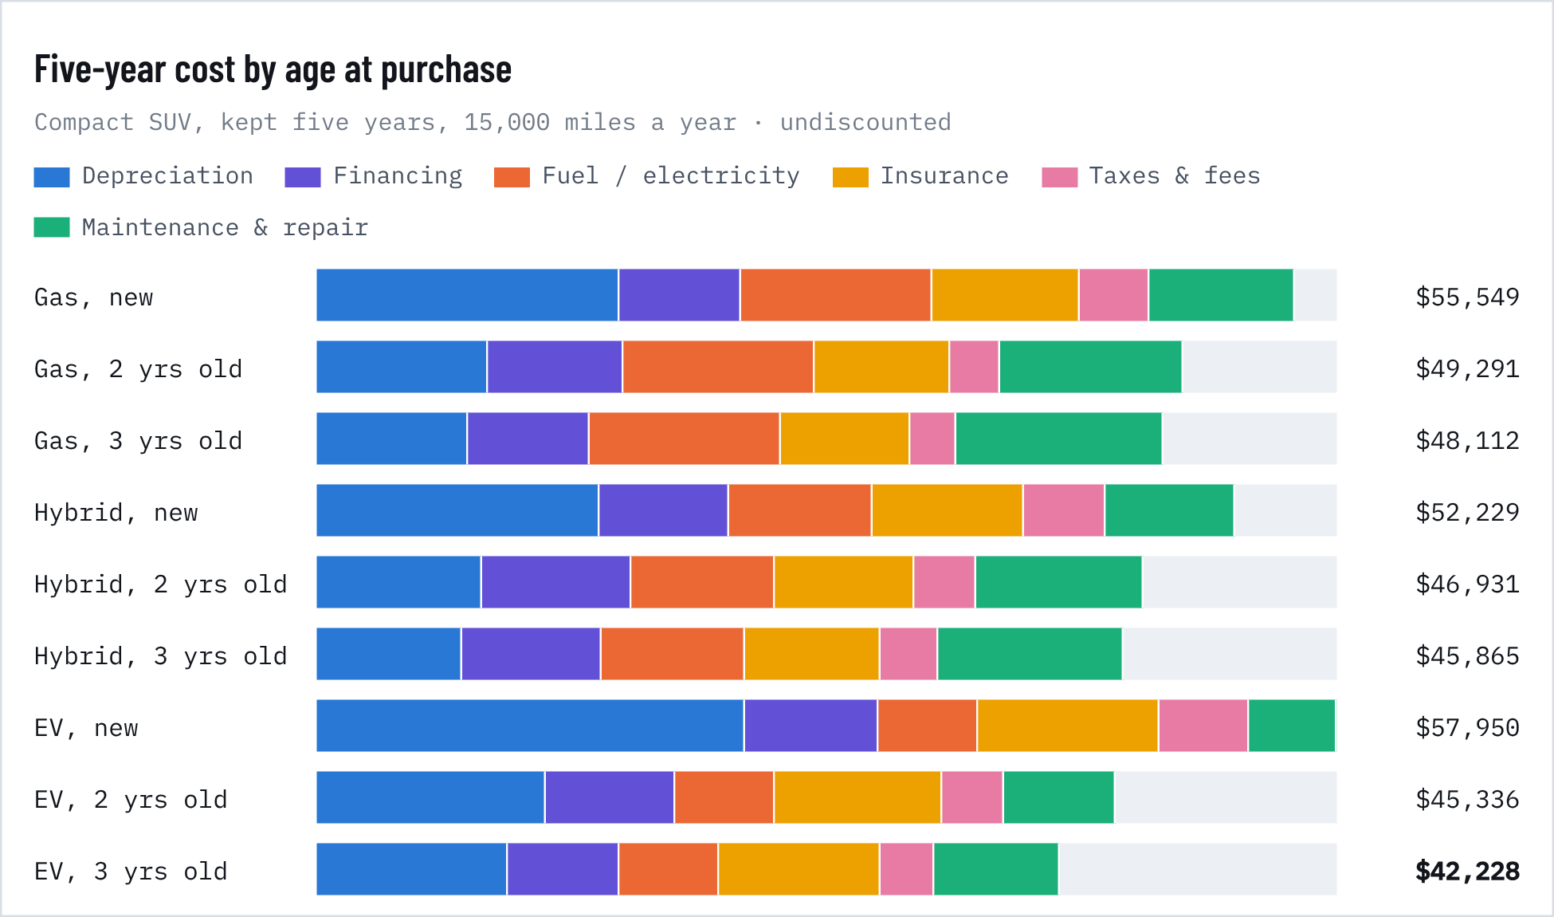
Figure 22. Five-year cost by age at purchase
Table 26. Five-year cost by age at purchase: new, 2 and 3 years old
Option | Price | Depreciation | Financing | Energy | Insurance | Fees | Maint. | 5-yr total | Per mile | vs. new
Gas, new | $37,722 | $17,201 | $6,906 | $10,887 | $8,337 | $3,938 | $8,280 | $55,549 | 74¢ | –
Gas, 2 yrs old | $27,404 | $9,790 | $7,652 | $10,887 | $7,643 | $2,861 | $10,459 | $49,291 | 66¢ | −$6,258
Gas, 3 yrs old | $24,885 | $8,566 | $6,948 | $10,887 | $7,357 | $2,598 | $11,755 | $48,112 | 64¢ | −$7,437
Hybrid, new | $40,222 | $16,089 | $7,364 | $8,165 | $8,609 | $4,551 | $7,452 | $52,229 | 70¢ | –
Hybrid, 2 yrs old | $30,632 | $9,358 | $8,553 | $8,165 | $7,892 | $3,550 | $9,413 | $46,931 | 63¢ | −$5,298
Hybrid, 3 yrs old | $28,291 | $8,318 | $7,899 | $8,165 | $7,597 | $3,305 | $10,580 | $45,865 | 61¢ | −$6,364
EV, new | $41,381 | $24,332 | $7,576 | $5,692 | $10,298 | $5,051 | $5,001 | $57,950 | 77¢ | –
EV, 2 yrs old | $26,508 | $12,987 | $7,401 | $5,692 | $9,441 | $3,498 | $6,317 | $45,336 | 60¢ | −$12,614
EV, 3 yrs old | $22,881 | $10,840 | $6,389 | $5,692 | $9,088 | $3,120 | $7,100 | $42,228 | 56¢ | −$15,722

Buying at 2–3 years saves the most on EVs. A 3-year-old gas model costs $48,112 over five years, $7,437 less than new. A 3-year-old hybrid costs $45,865 ($6,364 less). A 3-year-old EV costs $42,228, $15,722 less than a new EV and the cheapest of the nine options. Because EVs lose value fastest early, the second owner pays a much lower price and absorbs a smaller loss. Bought at 3 years old, an EV beats the gas model of the same age above $2.00 a gallon (new: $5.32).
How sure is that? In 20,000 simulations that also vary the depreciation curve, used-loan rate (8.81–13.93%) and repair growth (6–15% a year), buying at 2–3 years beats buying new in over 99% of draws for every powertrain. The cheapest option is a 3-year-old EV in 62% of draws and a 3-year-old hybrid in 37%. The 3-year-old EV beats the 3-year-old gas model in 85% of draws (median $3,150 cheaper).
Caveats. A 3-year-old bought now and kept five years ends at 8 years and about 120,000 miles, past the typical 8-year/100,000-mile EV battery warranty, so check battery health and remaining warranty. Used EV values are now firming (Manheim EV index +4.3% y/y), which would raise the purchase price and lower the depreciation advantage. Used-car prices also vary far more by model and mileage than new prices.
Table 27. Used-car ownership assumptions and sources
Used-car assumption | Value | Source
Value retained by age (gas / hybrid / EV), 2 yrs | 73% / 76% / 64% | Curve from CARFAX first-year loss (20%) and iSeeCars 5-year losses
… 3 yrs | 66% / 70% / 55% | Edmunds Q2 2026 3-year-old $32,461 = 65% of new ATP
… 7 / 8 yrs (end of hold) | 47% / 43% gas; 29% EV at 8 | After year 5 annual loss slows to 80% of the year 2–5 rate (range 60–100%)
Used-loan rate | 11.19% (range 8.81–13.93%) | Experian, State of the Automotive Finance Market, Q2 2026
Insurance vs. a new car, five-year average | 2 yrs ×0.92 · 3 yrs ×0.88 | Insure.com premiums by vehicle age (ages 0–1 extrapolated)
Maintenance & repair vs. a new car | 2 yrs ×1.26 · 3 yrs ×1.42 (12.4%/yr of age) | Bumper via ConsumerAffairs: $760 at year 5, $1,079 at year 8
Everything else | same as the new-car model | Energy use and prices, mileage, special registration fees, 10% down, 60 months

VEHICLE QUALITY, RELIABILITY AND COST OF OWNERSHIP

Better built at the start, more trouble with tech, costlier to keep
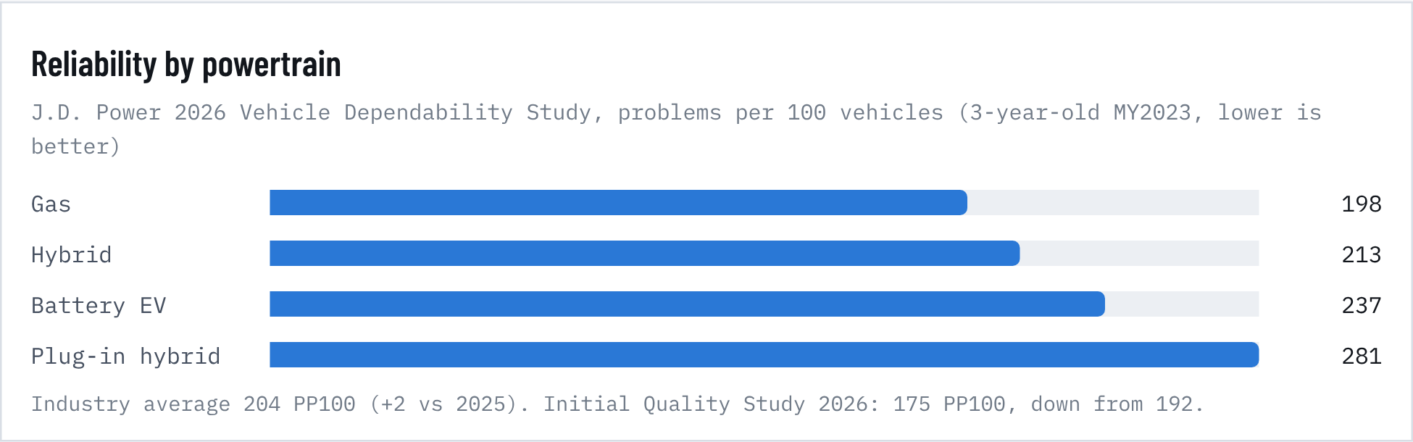
Figure 23. Reliability by powertrain
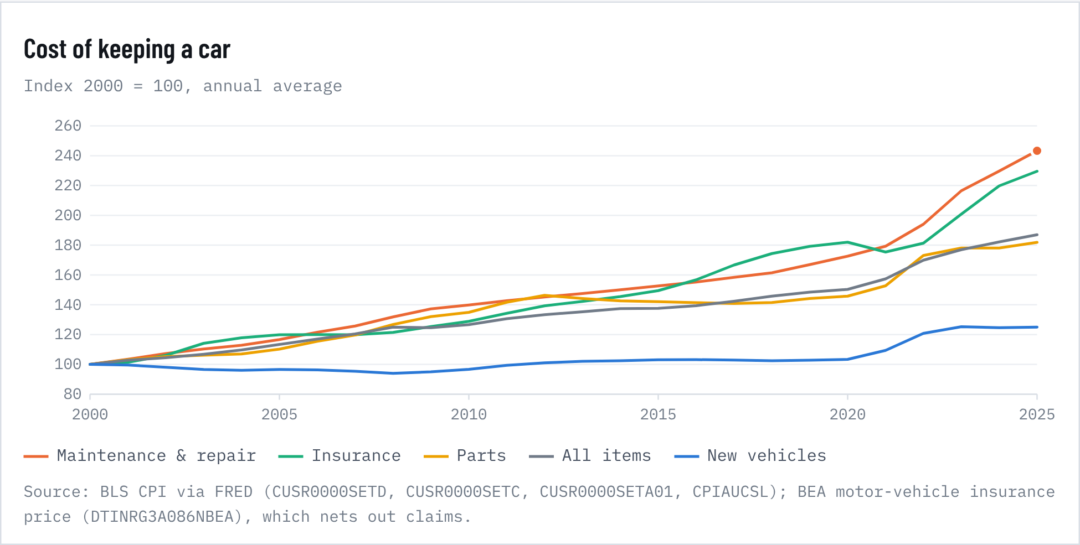
Figure 24. Cost of keeping a car
Table 28. Cost of keeping a car: price growth by component
Measure | 2000–2019 %/yr | 2019–2025 %/yr | Cumulative 2019–2025
Maintenance & repair (CPI) | 2.73 | 6.48 | +45.8%
Parts & equipment (CPI) | 1.95 | 3.95 | +26.1%
Motor vehicle insurance (PCE price) | 3.12 | 4.21 | +28.1%
New vehicles (CPI) | 0.15 | 3.30 | +21.5%
All items (CPI) | 2.10 | 3.92 | +25.9%
NHTSA recalls 2021 | 987 campaigns |  | 28.9M vehicles · 1.9 per new sale
NHTSA recalls 2022 | 932 campaigns |  | 31.0M vehicles · 2.2 per new sale
NHTSA recalls 2023 | 894 campaigns |  | 34.8M vehicles · 2.2 per new sale
NHTSA recalls 2024 | 950 campaigns |  | 29.4M vehicles · 1.8 per new sale
NHTSA recalls 2025 | 891 campaigns |  | 29.3M vehicles · 1.8 per new sale

Quality is improving at delivery. J.D. Power's 2026 Initial Quality Study recorded 175 problems per 100 vehicles in the first 90 days, down from 192. That is the best year-over-year improvement since 1997, with gains in fit and finish, road noise and EV range. Infotainment was the only category that got worse.
Dependability is slipping with age and complexity. The 2026 Vehicle Dependability Study found 204 problems per 100 three-year-old vehicles, the most since the study was redesigned in 2022. Phone-integration glitches (Android Auto and Apple CarPlay) were the top single complaint for a third year. Gasoline vehicles had the fewest problems (198); plug-in hybrids had the most (281), and battery EVs sat at 237.
Recalls are steady at a high level. NHTSA logged 891 vehicle recall campaigns covering 29.3 million vehicles in 2025, in line with 29–35 million a year since 2021. That is about 1.8 vehicles recalled for every new vehicle sold.
Ownership costs are outrunning prices. From 2019 to 2025, maintenance and repair prices rose 46% (6.5% a year), against 26% for all consumer prices and 22% for new vehicles. That is consistent with costlier repairs on sensor-laden, electrified vehicles and an older fleet (12.8 years on average) that needs more of them. Running costs are rising faster than the purchase price, so the payment-centric affordability measures understate the strain.
COST TO REPAIR

Repairs are the fastest-rising cost of owning a car
Table 29. Key numbers
Measure | Value | Detail
Average collision repair | $4,818 | CCC total cost of repair
Newer vs older cars | $5,721 vs $3,682 | ≤6 years vs 7+ years old (+55%)
ADAS calibration | $486 | 28.3% of repairable claims
Total-loss frequency | 23.1% | record; about 20% in 2020

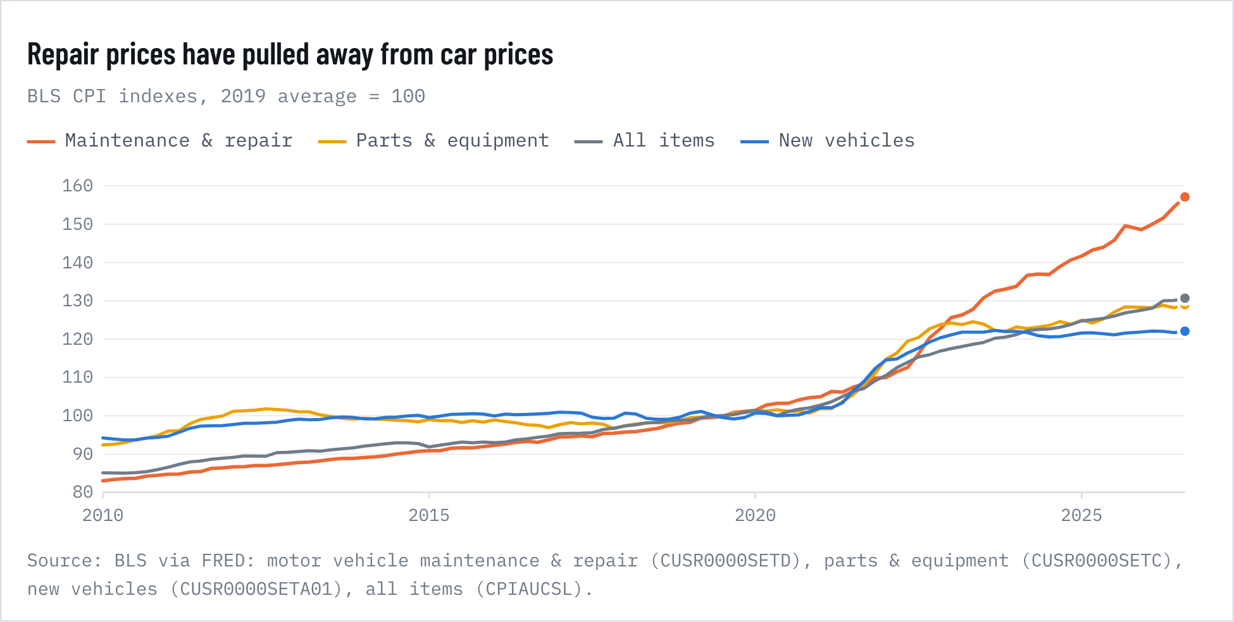
Figure 25. Repair prices have pulled away from car prices
BLS's maintenance and repair price index rose 46% from 2019 to 2025, about 6.5% a year, against 26% for all consumer prices and 22% for new vehicles (chart above). CCC Intelligent Solutions puts the average collision repair at $4,818. Newer cars cost far more: $5,721 for vehicles six years old or newer, against $3,682 for older ones, a 55% premium. The driver is technology. More than 28% of repairable claims now include an ADAS sensor calibration, averaging $486, and 80% include a diagnostic scan ($149). Because repairs cost so much relative to vehicle value, a record 23.1% of claims end in a total loss, up from about 20% in 2020.
Collision costs specifically have slowed, even as the broader BLS index keeps climbing: CCC's headline repair cost rose just 1.7%, the slowest since 2017, partly because older, cheaper-to-fix cars make up more of the claims mix. In our 2.1 driver model, faster repair-cost inflation is associated with slower new-car inflation (−0.32 pp per point, p < 0.001). That is consistent with households keeping and fixing older cars, now 12.8 years old on average, instead of buying new when prices rise. Repair costs are a demand-side brake on new-car pricing as well as a running cost for owners.

7. Used-car prices and demand
RELEASE 2.2 · USED-CAR PRICES AND DEMAND

Used cars: inventories drive prices; income and jobs drive demand
Table 30. Key numbers
Measure | Value | Detail
Used-vehicle CPI | -2.3% | 12 months to Aug 2026
Manheim wholesale index | −0.6% | Sep 2026 y/y · used EVs +4.3%
Used-dealer sales | +5.3% | Jan–Jul 2026 vs 2025, dollars (≈ +7% real)
Release forecast, used CPI | +0.35%/yr | 2025–2030, time-series ensemble

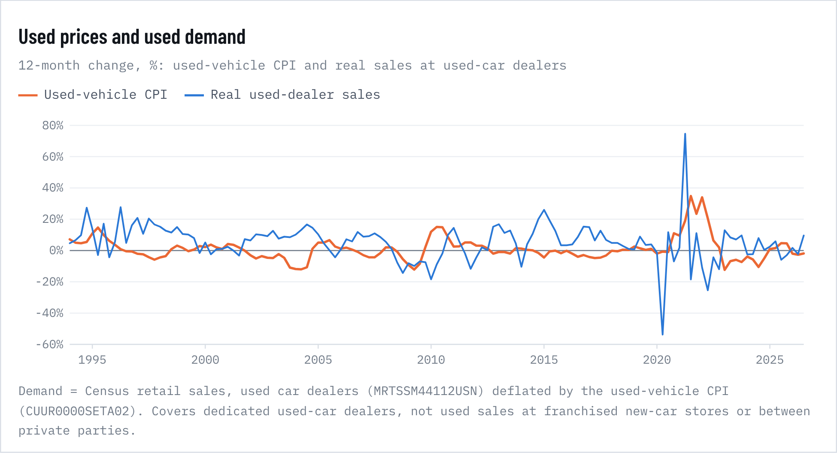
Figure 26. Used prices and used demand
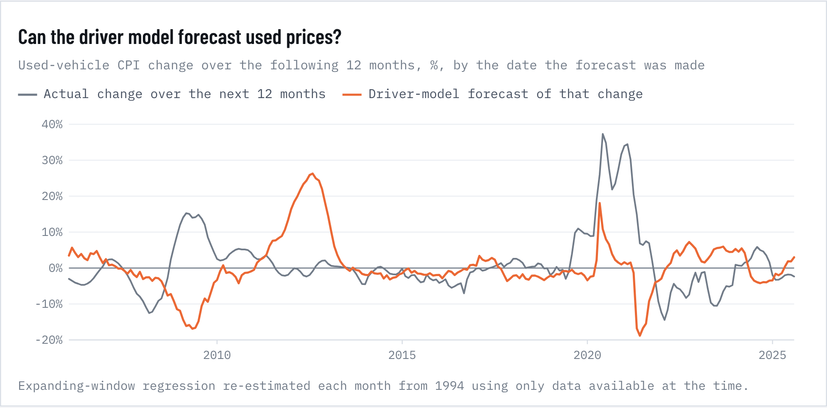
Figure 27. Can the driver model forecast used prices?

Inventories: new vs. used
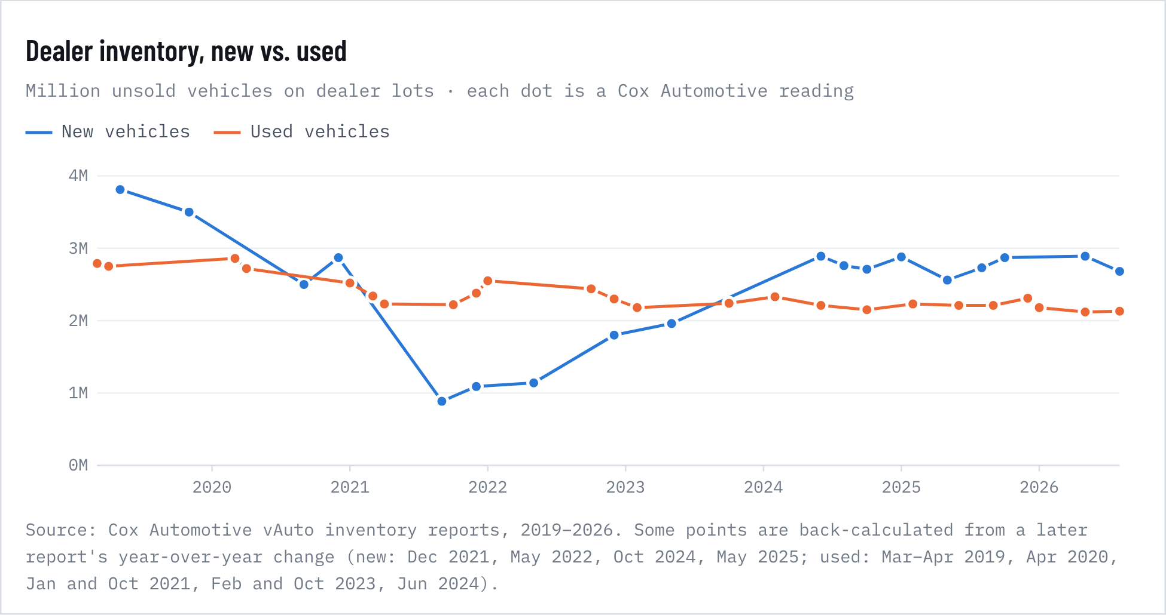
Figure 28. Dealer inventory, new vs. used
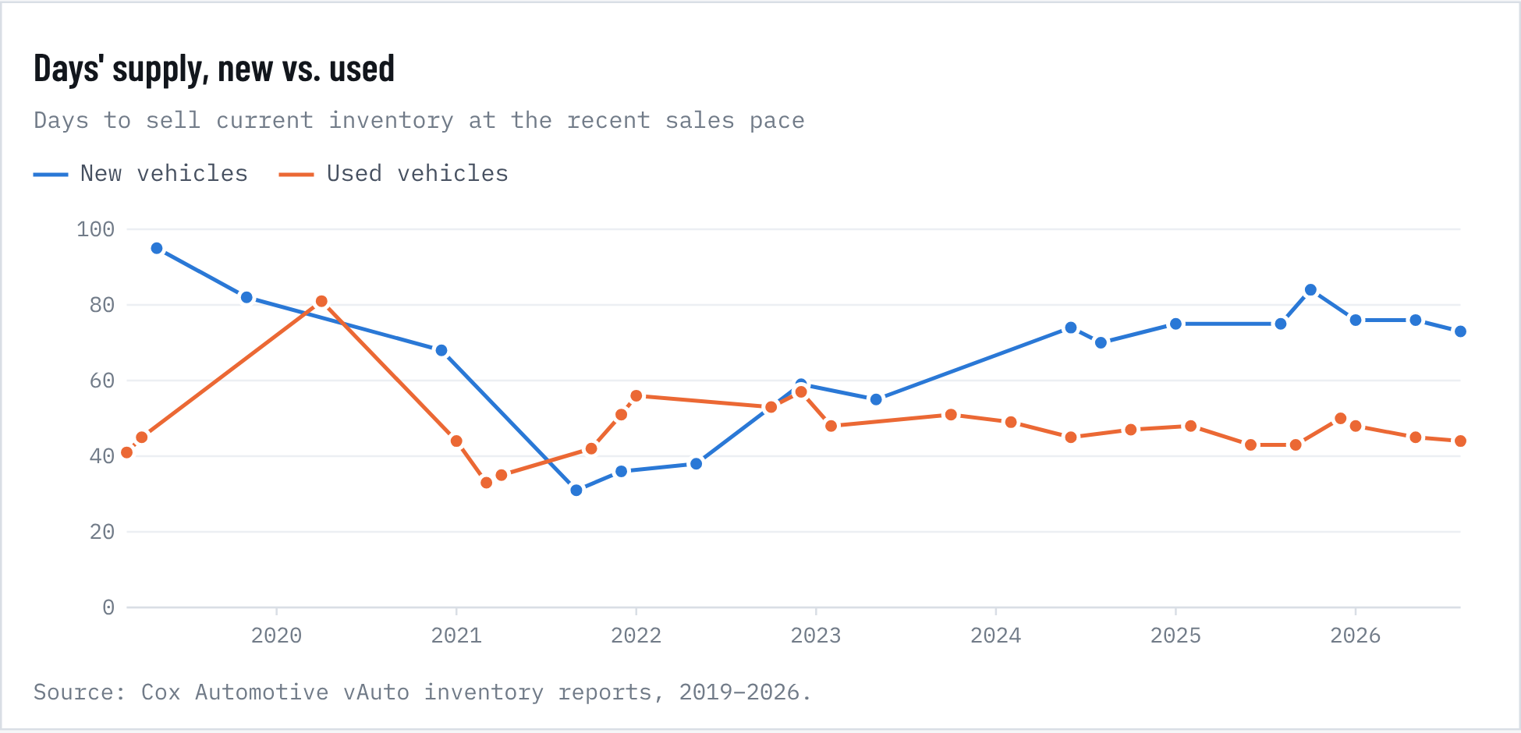
Figure 29. Days' supply, new vs. used
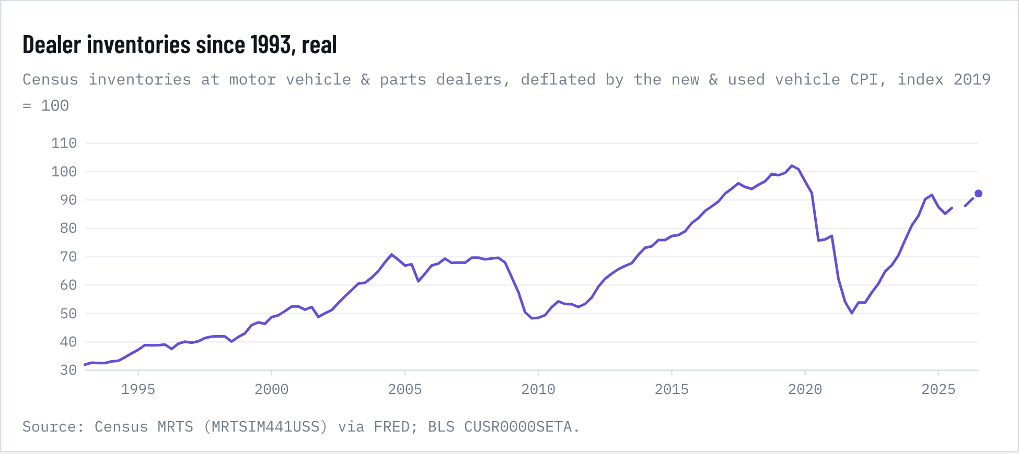
Figure 30. Dealer inventories since 1993, real
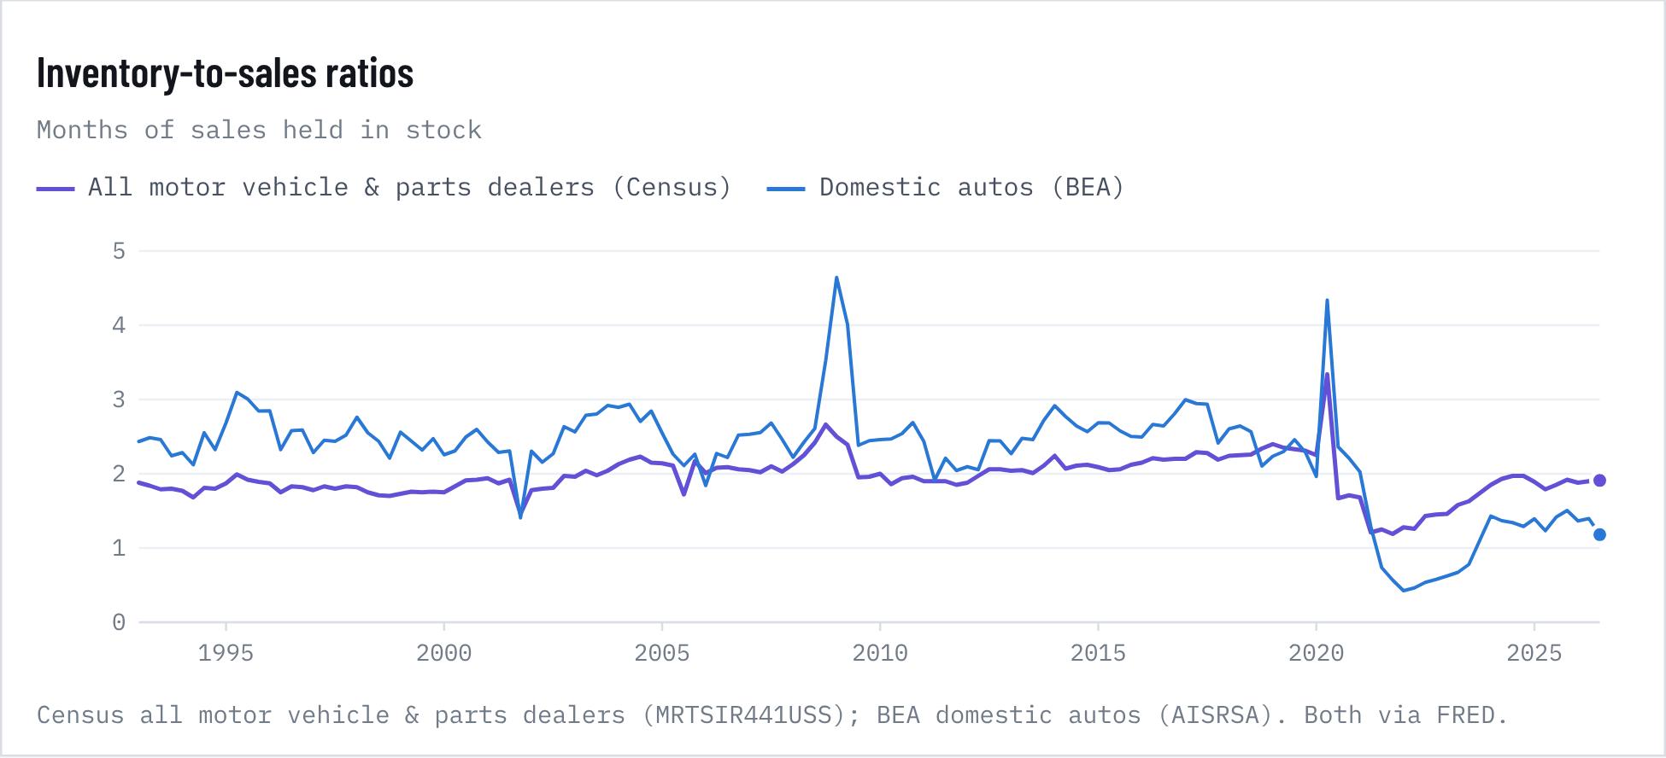
Figure 31. Inventory-to-sales ratios

How old are the vehicles on the road?
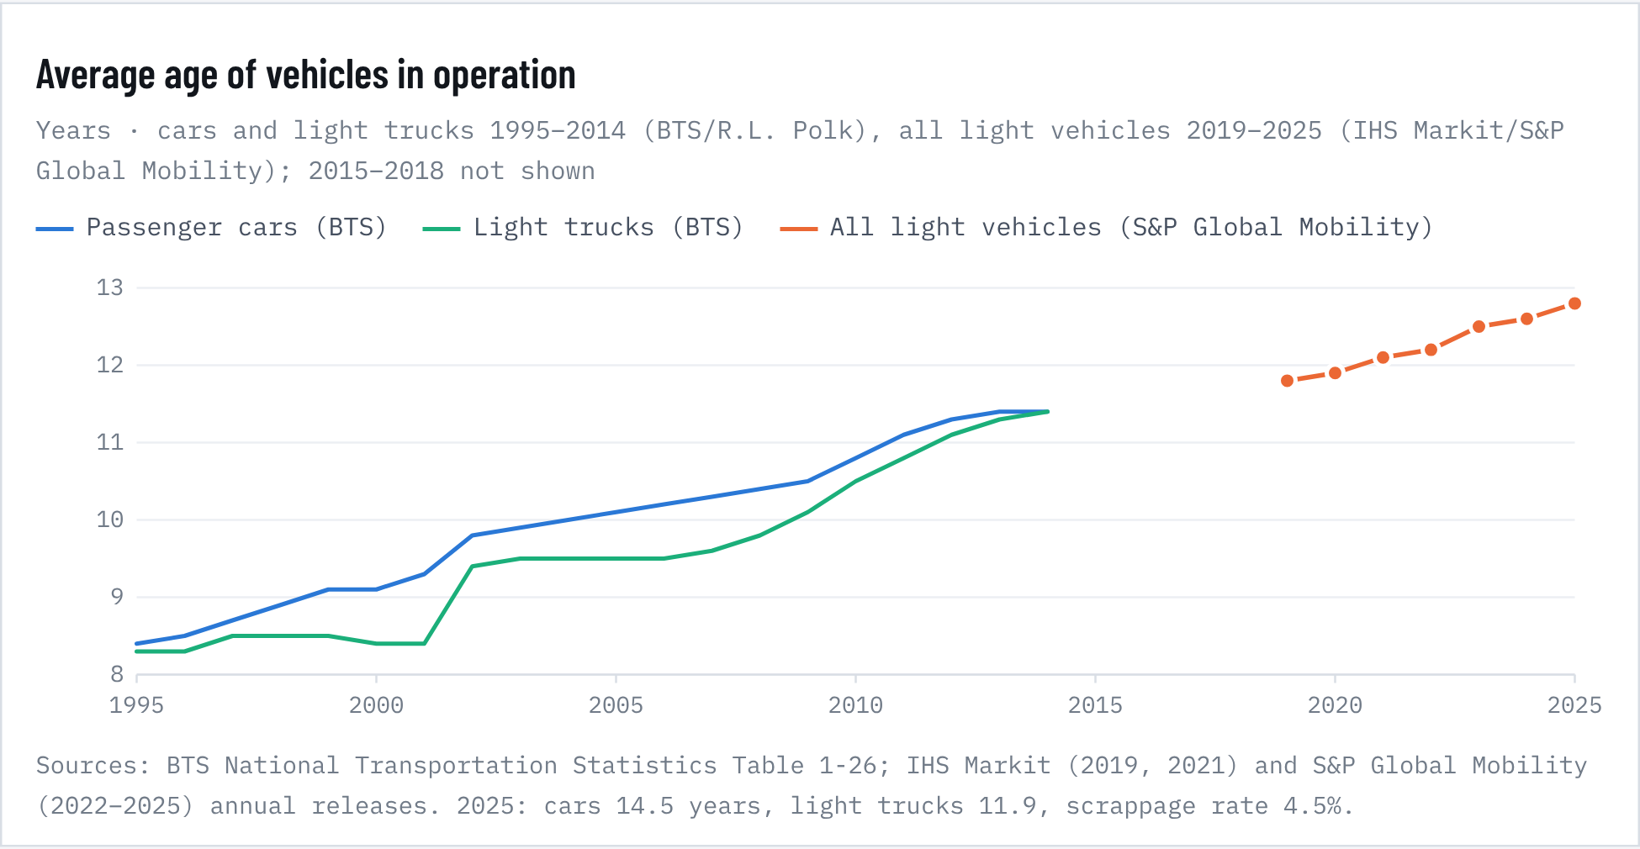
Figure 32. Average age of vehicles in operation
Inventories. Cox's dealer counts show the pandemic squeeze and an uneven recovery. New-vehicle inventory fell from 3.81 million units (95 days' supply) in May 2019 to 0.89 million (31 days) in September 2021, and has since recovered to 2.68 million (73 days, August 2026). Used inventory fell less, from about 2.8 million to 2.2 million, but it has not recovered: it is 2.13 million (44 days) today. Fewer new sales in 2020–2022 mean fewer 3- to 5-year-old cars now reaching the used market. Across all motor vehicle dealers, Census inventories cover 1.91 months of sales, against 2.31 in 2019 and a low of 1.17 in May 2021.
Vehicle age. The average light vehicle on US roads was 12.8 years old in 2025, up from about 8.4 in 1995: passenger cars 14.5 years and light trucks 11.9. Older fleets mean more repair spending, and they show how long buyers are holding on. In the regressions below, a faster-aging fleet goes with slower used-price inflation, consistent with households keeping cars rather than trading into the used market.

Regression 1: used-vehicle prices
Δ12 ln(used-vehicle CPI)t = α + β1·New-vehicle CPI + β2·New-vehicle inventory/sales ratio + β3·Off-lease supply: new sales growth 3 years earlier + β4·Semiconductor PPI + β5·Unemployment change + β6·Real disposable income + β7·Auto loan rate change + β8·Real gasoline price + β9·Consumer-loan delinquency + β10·Saving rate change + β11·Core inflation + β12·Dealer inventory/sales ratio, all dealers + β13·Real dealer inventories + β14·Vehicle size: new-vehicle weight 3 years earlier + β15·Fleet average age + εt · OLS with Newey-West (HAC, 12 lags) errors, monthly, 1996-07 to 2025-01, n = 343
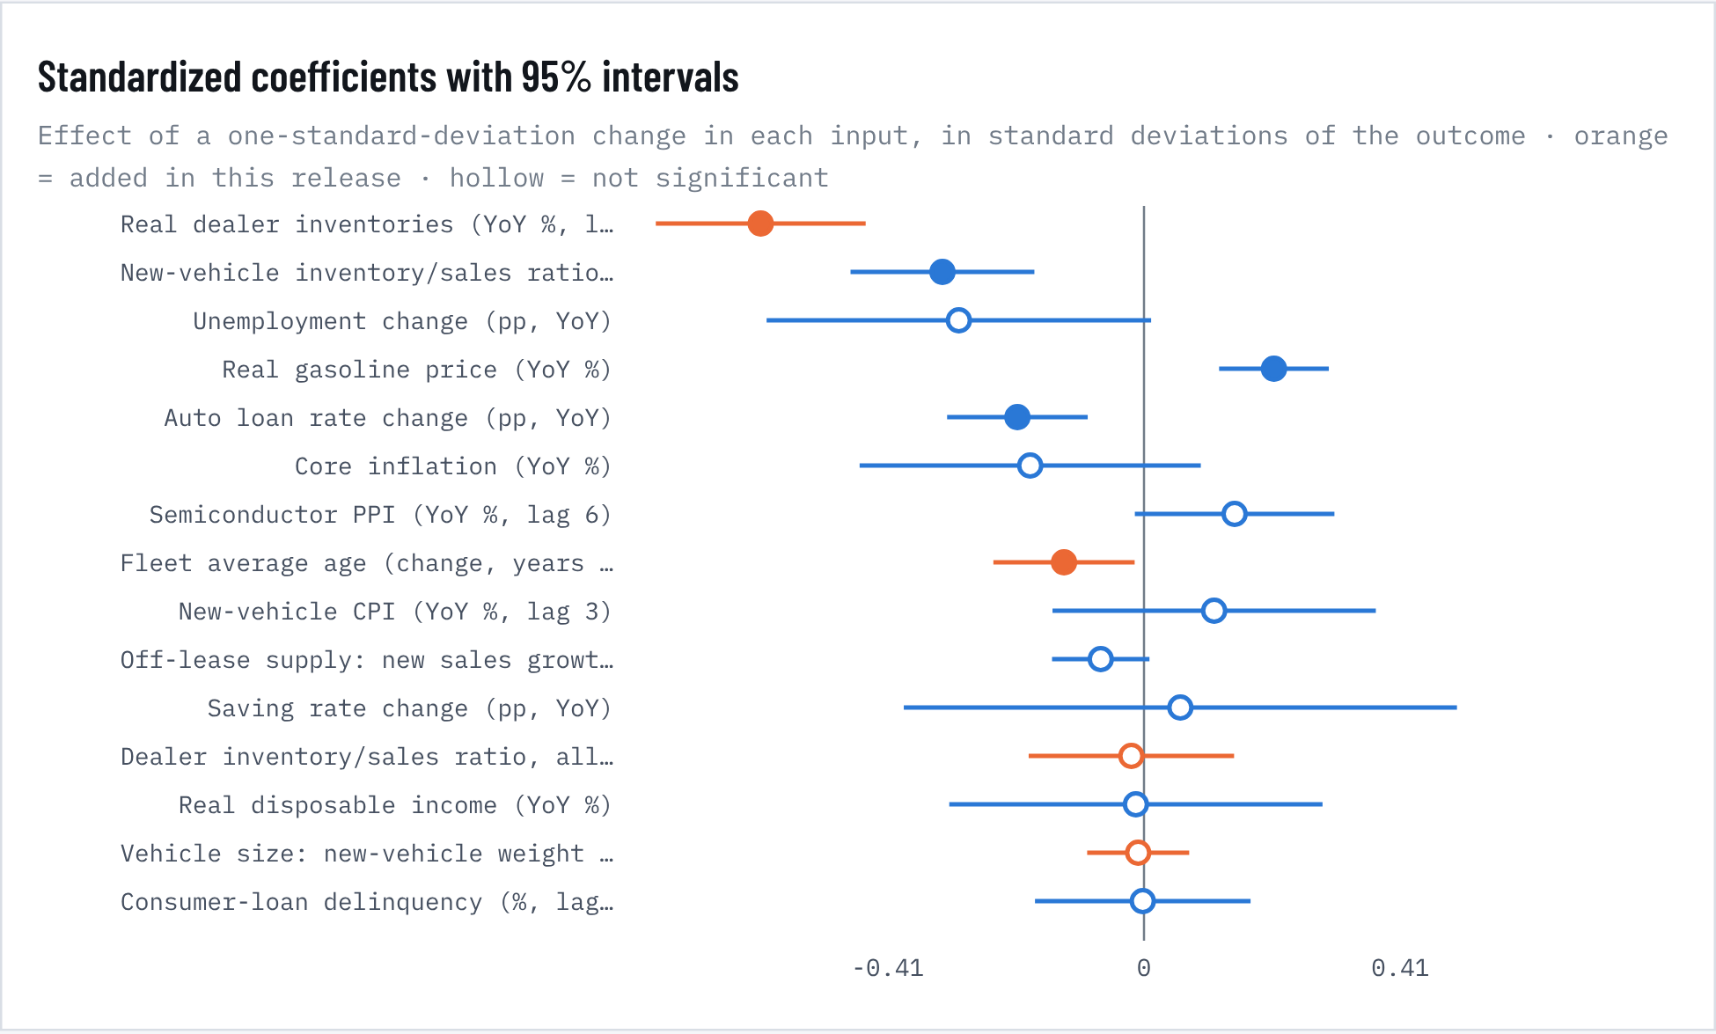
Figure 33. Standardized coefficients with 95% intervals
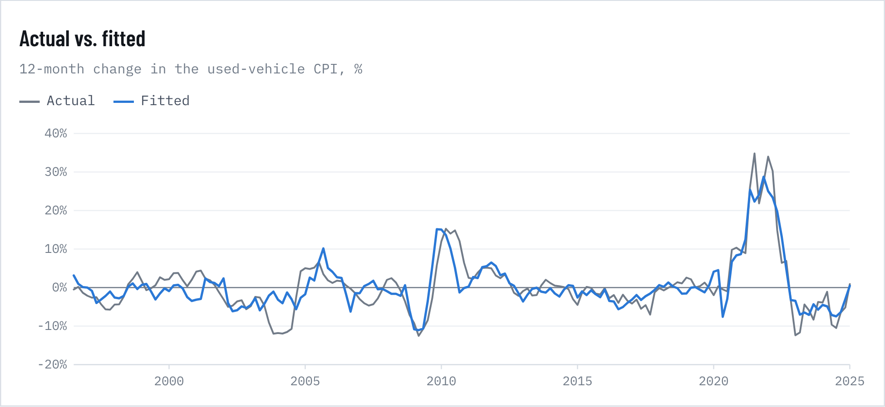
Figure 34. Actual vs. fitted
Table 31. Regression 1: used-vehicle prices, full results
Input | Coef. | HAC s.e. | t | p | 95% interval | Std. coef. | Shapley share | VIF
NEW · Real dealer inventories (YoY %, lag 1) | -0.348 | 0.049 | -7.16 | <0.001 | -0.44 to -0.25 | -0.61 | 38.4% | 1.9
Real gasoline price (YoY %) | 0.083 | 0.018 | 4.64 | <0.001 | 0.05 to 0.12 | 0.21 | 11.5% | 1.8
New-vehicle CPI (YoY %, lag 3) | 0.335 | 0.394 | 0.85 | 0.395 | -0.44 to 1.11 | 0.11 | 8.4% | 4.6
NEW · Dealer inventory/sales ratio, all dealers (lag 1) | -0.545 | 2.266 | -0.24 | 0.810 | -4.99 to 3.90 | -0.02 | 8.4% | 4.0
Saving rate change (pp, YoY) | 0.127 | 0.491 | 0.26 | 0.797 | -0.84 to 1.09 | 0.06 | 6.2% | 18.5
New-vehicle inventory/sales ratio (lag 3) | -3.735 | 0.869 | -4.30 | <0.001 | -5.44 to -2.03 | -0.32 | 5.6% | 4.5
Unemployment change (pp, YoY) | -1.366 | 0.724 | -1.89 | 0.059 | -2.78 to 0.05 | -0.30 | 5.3% | 7.3
Auto loan rate change (pp, YoY) | -2.132 | 0.604 | -3.53 | <0.001 | -3.32 to -0.95 | -0.20 | 4.3% | 2.5
Real disposable income (YoY %) | -0.032 | 0.375 | -0.09 | 0.932 | -0.77 to 0.70 | -0.01 | 2.9% | 8.8
Core inflation (YoY %) | -1.353 | 1.035 | -1.31 | 0.191 | -3.38 to 0.68 | -0.18 | 2.8% | 5.8
Consumer-loan delinquency (%, lag 1q) | -0.019 | 0.871 | -0.02 | 0.982 | -1.73 to 1.69 | -0.00 | 2.0% | 2.3
Semiconductor PPI (YoY %, lag 6) | 0.454 | 0.255 | 1.78 | 0.075 | -0.05 to 0.95 | 0.15 | 1.1% | 2.3
NEW · Fleet average age (change, years YoY) | -8.244 | 3.715 | -2.22 | 0.026 | -15.52 to -0.96 | -0.13 | 1.1% | 1.7
NEW · Vehicle size: new-vehicle weight 3 years earlier (YoY %) | -0.078 | 0.347 | -0.22 | 0.823 | -0.76 to 0.60 | -0.01 | 1.0% | 1.6
Off-lease supply: new sales growth 3 years earlier (%) | -0.062 | 0.036 | -1.74 | 0.082 | -0.13 to 0.01 | -0.07 | 0.9% | 1.4
Constant | 16.212 | 6.941 |  | 0.020
R² / adj. R² / n | 0.743 | 0.731 |  | 343 | Wald (all) p <0.001 |  | 100%

Regression 2: used-car demand
Δ12 ln(real used-dealer sales)t = α + β1·Relative price, used vs new + β2·Real disposable income + β3·Unemployment change + β4·Auto loan rate change + β5·Consumer sentiment change + β6·Real gasoline price + β7·Consumer-loan delinquency change + β8·New-vehicle sales growth + β9·Dealer inventory/sales ratio, all dealers + β10·Real dealer inventories + β11·Vehicle size: new-vehicle weight + β12·Fleet average age + εt · OLS with Newey-West (HAC, 12 lags) errors, monthly, 1996-07 to 2025-01, n = 343
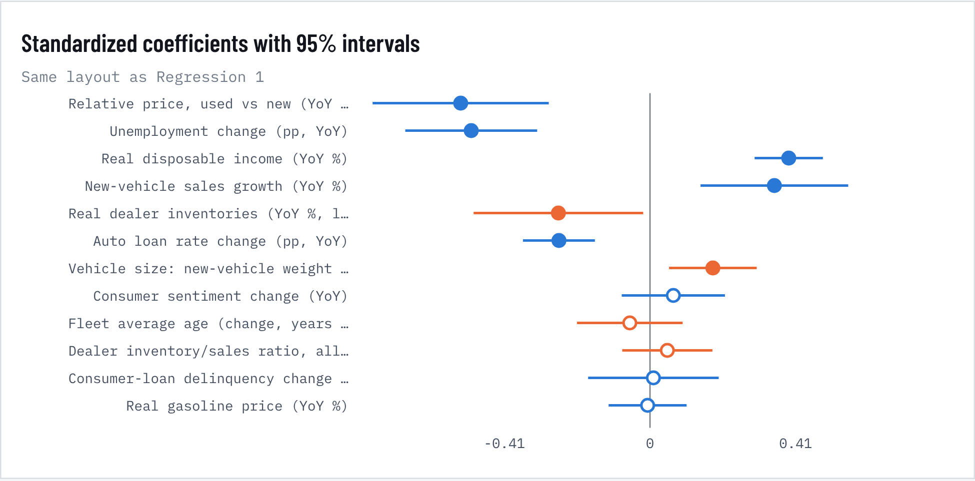
Figure 35. Standardized coefficients with 95% intervals
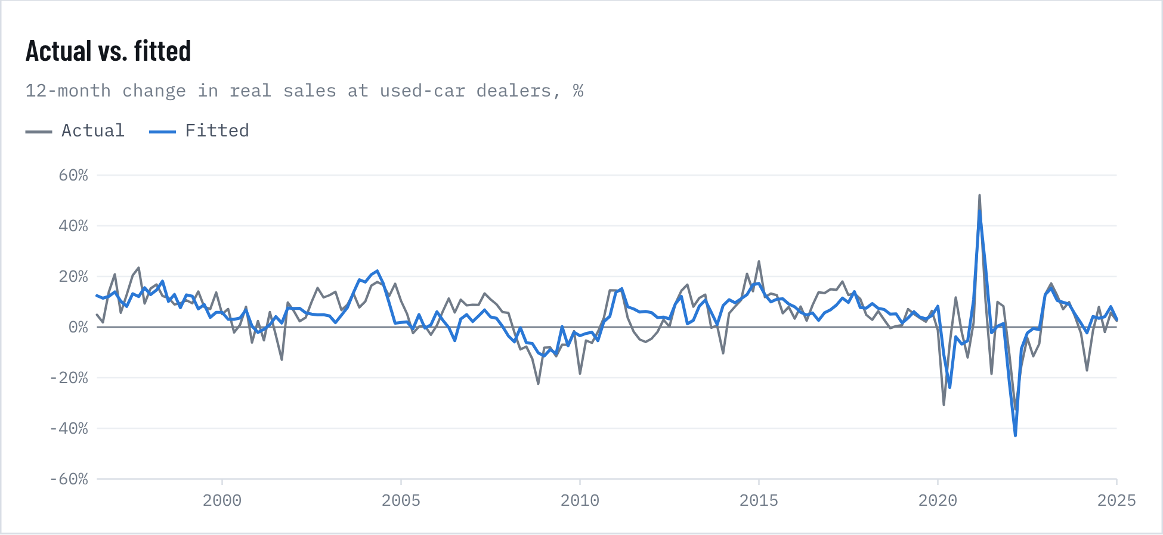
Figure 36. Actual vs. fitted
Table 32. Regression 2: used-car demand, full results
Input | Coef. | HAC s.e. | t | p | 95% interval | Std. coef. | Shapley share | VIF
New-vehicle sales growth (YoY %) | 0.284 | 0.086 | 3.30 | <0.001 | 0.12 to 0.45 | 0.35 | 23.7% | 2.1
Real disposable income (YoY %) | 1.355 | 0.170 | 7.96 | <0.001 | 1.02 to 1.69 | 0.39 | 16.6% | 1.6
Unemployment change (pp, YoY) | -3.266 | 0.615 | -5.31 | <0.001 | -4.47 to -2.06 | -0.50 | 15.5% | 2.9
Relative price, used vs new (YoY %) | -0.902 | 0.214 | -4.21 | <0.001 | -1.32 to -0.48 | -0.53 | 13.1% | 2.8
Consumer sentiment change (YoY) | 0.067 | 0.075 | 0.89 | 0.375 | -0.08 to 0.21 | 0.07 | 11.5% | 1.6
NEW · Vehicle size: new-vehicle weight (YoY %) | 2.064 | 0.734 | 2.81 | 0.005 | 0.63 to 3.50 | 0.18 | 6.3% | 1.2
NEW · Real dealer inventories (YoY %, lag 1) | -0.206 | 0.097 | -2.12 | 0.034 | -0.40 to -0.02 | -0.26 | 4.6% | 2.5
Auto loan rate change (pp, YoY) | -3.798 | 0.766 | -4.96 | <0.001 | -5.30 to -2.30 | -0.26 | 3.4% | 1.6
Consumer-loan delinquency change (pp, YoY) | 0.253 | 2.465 | 0.10 | 0.918 | -4.58 to 5.08 | 0.01 | 2.4% | 1.9
NEW · Dealer inventory/sales ratio, all dealers (lag 1) | 1.856 | 2.465 | 0.75 | 0.451 | -2.98 to 6.69 | 0.05 | 1.3% | 1.9
Real gasoline price (YoY %) | -0.004 | 0.032 | -0.12 | 0.904 | -0.07 to 0.06 | -0.01 | 0.8% | 1.6
NEW · Fleet average age (change, years YoY) | -5.155 | 6.882 | -0.75 | 0.454 | -18.64 to 8.33 | -0.06 | 0.7% | 1.5
Constant | -2.776 | 5.271 |  | 0.598
R² / adj. R² / n | 0.594 | 0.580 |  | 343 | Wald (all) p <0.001 |  | 100%

Model fit and diagnostics
Table 33. Model fit and diagnostics
Statistic | Regression 1: used prices | Regression 2: used demand
Sample | 1996-07 to 2025-01 | 1996-07 to 2025-01
Observations | 343 | 343
R², with new inputs | 0.743 | 0.594
R², baseline on same sample | 0.501 | 0.535
Adjusted R², new vs. baseline | 0.731 vs 0.485 | 0.580 vs 0.524
AIC change (negative = better) | -219.6 | -38.6
Wald test, the four new inputs (p) | <0.001 | 0.002
Std. error of regression | 3.97 pp | 7.01 pp
Durbin-Watson | 0.39 | 0.99
Breusch-Godfrey, 12 lags (p) | <0.001 | <0.001
Breusch-Pagan (p) | 0.033 | <0.001
Jarque-Bera (p) | <0.001 | <0.001
Ramsey RESET (p) | <0.001 | 0.027
Chow break, March 2020 (p) | <0.001 | <0.001
Largest VIF | 18.5 | 2.9

Prices. Adding dealer inventories, fleet age and vehicle size lifts the share of used-price inflation the model explains from 0.50 to 0.74 on the same 1996–2025 sample (the four new inputs are jointly significant, p <0.001). Inventories are now the dominant driver: each 1% rise in real dealer inventories lowers used inflation by 0.35 points (p <0.001; 38% of explained variance), and each extra point on the new-car inventory/sales ratio lowers it 3.7 points. Higher loan rates (-2.1 per point) and cheaper gasoline also cool used prices, and a faster-aging fleet goes with slower used inflation (-8.2 per year of added age, p = 0.03). Once inventories are in, new-car inflation itself is no longer significant (p = 0.39): shortages drove both.
Demand. The demand model explains 0.59 of the variation in real used-dealer sales growth (baseline 0.54; new inputs jointly p = 0.002). Sales rise 1.35% for each 1% of real income and fall 3.3% per point of unemployment and 3.8% per point on loan rates (all p < 0.001). A 10% rise in used prices relative to new cuts volume 9.0%. Used and new sales move together (0.28 per point of new-sales growth), because trade-ins feed used supply. Faster growth in dealer inventories goes with slower used-dealer sales (-0.21, p = 0.03), consistent with stock building up when demand softens.
Vehicle size in the regressions. Vehicle size (average new-vehicle weight from the EPA) now enters all three price and demand regressions. In the used-price model, the weight of new vehicles three years earlier, roughly the cars now arriving on the used market, is not significant (-0.08, p = 0.82). In the demand model, faster upsizing goes with faster used-dealer sales growth (2.06 per point of weight growth, p = 0.005, 6.3% of explained variance), as buyers priced out of larger new vehicles turn to used ones. In the new-car inflation model (size and technology section), weight is not significant over the full sample (-0.57, p = 0.24), because the CPI adjusts for size.
Reading the diagnostics. Both models use overlapping 12-month changes, so residuals are strongly autocorrelated (Durbin-Watson 0.39 and 0.99, Breusch-Godfrey p < 0.001). That is why every standard error is Newey-West HAC with 12 lags. Residuals are also heteroskedastic and fat-tailed (2021 is an outlier), and a Chow test rejects stable coefficients at March 2020. The saving-rate term is collinear with income (VIF 18.5), so read those two jointly. Coefficients describe association, not cause, and the Shapley shares in the tables are the most robust guide to what matters.
Forecast tests. Better fit does not mean better forecasts. Forecasting 12 months ahead with only the data available at the time, the baseline price model has an error of 11.9 points against 8.6 for assuming no change; adding inventories, size and age makes it worse (15.5), while an inventories-only model comes closest (9.3). The demand models also fail (baseline 9.3, augmented 11.0, no-change 7.6). The time-series ensemble behind the release forecast does beat a random walk for used prices: RMSE 9.7 / 13.8 / 16.1 vs 10.3 / 14.8 / 17.5 at 12/24/36 months (DM p = 0.03 at 24 months). Cox's days'-supply readings tell the same story over a shorter sample: across 21 readings since 2020, new-vehicle days' supply explains most of the swing in used-price inflation (-0.64 points per extra day, p < 0.001, R² 0.52), while used days' supply adds nothing (p = 0.83).
Where things stand. Used prices are -2.3% on the year in the CPI. Manheim wholesale values are −0.6% (September), but used EV values are up 4.3% while non-EVs fell 1.6%. Dollar sales at used-car dealers were up 5.3% in January–July versus a year earlier, about 7% after lower prices. Across all dealers, Cox forecasts 20.3 million used retail sales in 2026, 0.7% below 2025. The baseline driver model points to used prices -4.1% (80% range -12.9% to +4.7%) over the next 12 months and used-dealer volume +5.2% (-3.2% to +13.6%). Both models fail out of sample, so treat these as context. The forecast keeps the ensemble path of about +0.35% a year to 2030.

8. Vehicle size, technology and safety
RELEASE 2.2 · VEHICLE SIZE AND TECHNOLOGY AS INFLATION INPUTS

Cars got bigger and smarter, but the price index adjusts that away
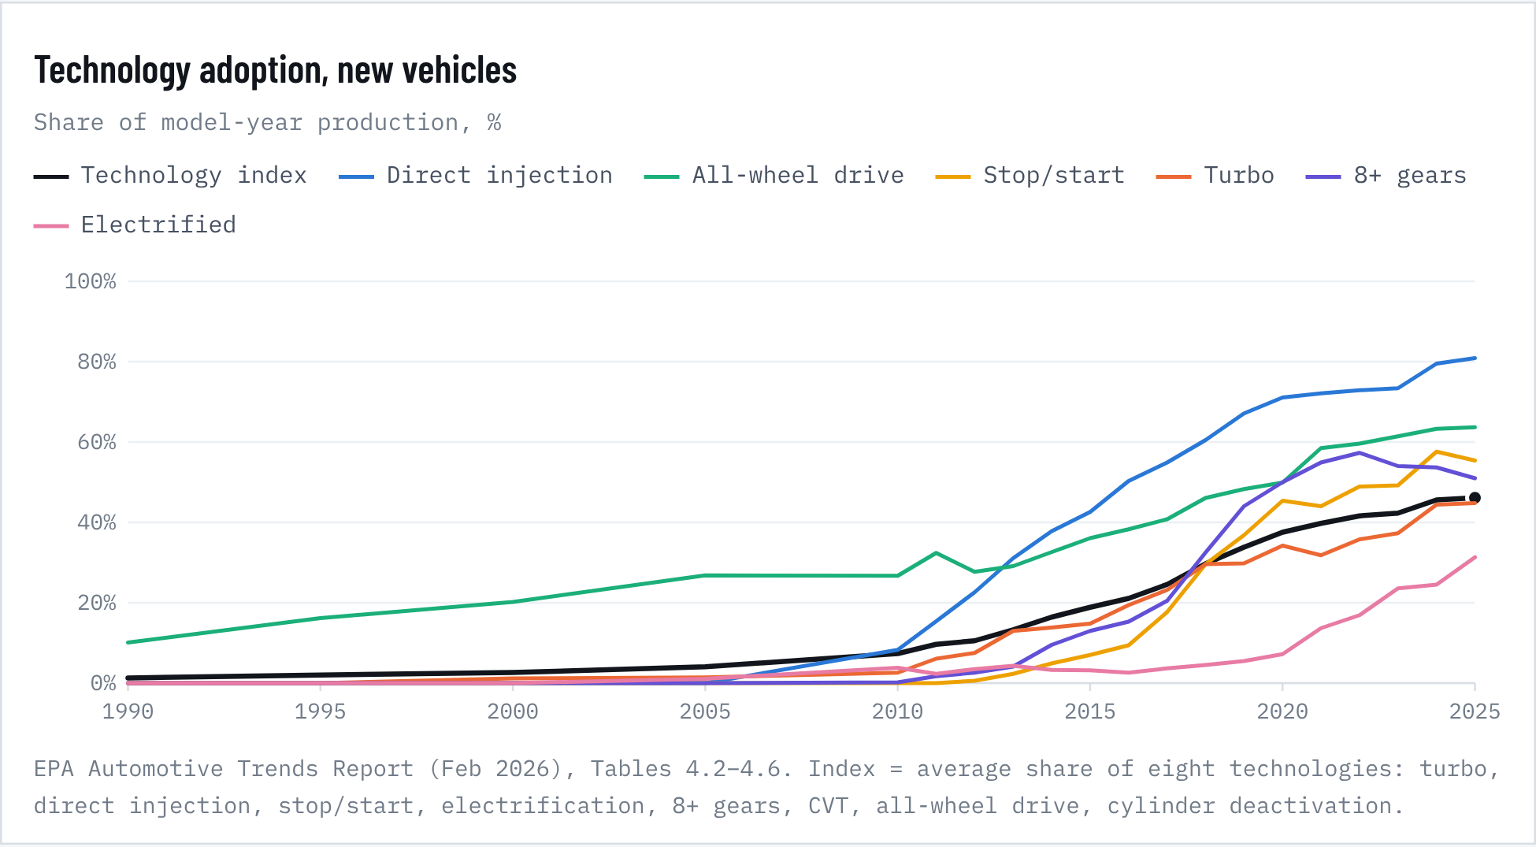
Figure 37. Technology adoption, new vehicles
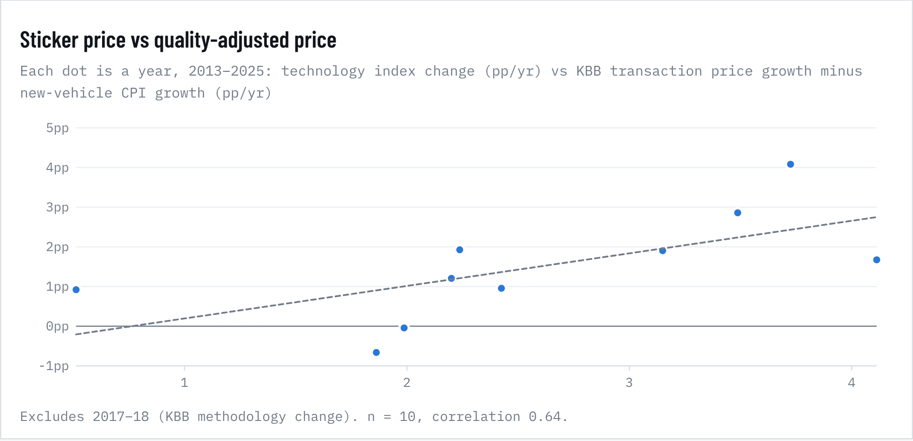
Figure 38. Sticker price vs quality-adjusted price
Table 34. Size and technology added to the release 2.1 inflation model
Input added to the 2.1 inflation model | Coef. | HAC s.e. | p | Shapley share | Coef. pre-2020 | p pre-2020
Vehicle weight (YoY %) | -0.567 | 0.482 | 0.240 | 1.3% | -1.746 | 0.004
Horsepower (YoY %) | 0.377 | 0.337 | 0.263 | 2.2% | 0.985 | 0.019
Technology adoption index (pp, YoY) | 0.108 | 0.259 | 0.677 | 0.6% | 0.200 | 0.243
All three (average-share index): R² vs 2.1 same sample | 0.800 vs 0.796 | Wald p | 0.666 | ΔAIC | -2.4 | n = 376
All three (principal-component index): R² vs 2.1 same sample | 0.803 vs 0.796 | Wald p | 0.600 | ΔAIC | -8.0 | n = 376
Weight only: R² vs 2.1 same sample | 0.796 vs 0.796 | Wald p | 0.807 | ΔAIC | 1.7 | n = 376
Technology index only: R² vs 2.1 same sample | 0.796 vs 0.796 | Wald p | 0.876 | ΔAIC | 1.8 | n = 376

Full release 2.2 new-car inflation model, all 19 inputs
Table 35. Full release 2.2 new-car inflation model, all 19 inputs
Input | Coef. | HAC s.e. | p | Shapley share | Coef. pre-2020 | p pre-2020
Used-vehicle CPI (YoY %, lag 3) | 0.154 | 0.023 | <0.001 | 24.2% | 0.050 | 0.036
Core inflation (YoY %) | 1.050 | 0.302 | <0.001 | 17.6% | 0.495 | 0.115
Inventory/sales ratio (lag 3) | 0.226 | 0.339 | 0.504 | 9.8% | 0.868 | 0.017
Auto import prices (YoY %, lag 3) | 0.360 | 0.141 | 0.010 | 6.8% | 0.449 | <0.001
5-yr Treasury change (pp, YoY) | 0.502 | 0.133 | <0.001 | 6.5% | 0.462 | <0.001
Semiconductor PPI (YoY %, lag 6) | 0.109 | 0.071 | 0.127 | 5.8% | 0.189 | <0.001
Saving rate change (pp, YoY) | -0.080 | 0.065 | 0.215 | 5.0% | -0.067 | 0.350
Steel PPI (YoY %, lag 6) | -0.021 | 0.011 | 0.061 | 3.5% | -0.041 | <0.001
EV subsidy intensity change (pp of ATP, YoY) | 5.227 | 1.631 | 0.001 | 3.4% | -11.369 | 0.017
Consumer-loan delinquency (%, lag 1q) | -0.013 | 0.398 | 0.974 | 3.3% | 0.469 | 0.142
Repair-cost inflation (YoY %, lag 6) | -0.106 | 0.123 | 0.389 | 2.3% | -0.742 | <0.001
Unemployment change (pp, YoY) | 0.118 | 0.148 | 0.427 | 2.2% | 0.128 | 0.593
Horsepower (YoY %) | 0.377 | 0.337 | 0.263 | 2.2% | 0.985 | 0.019
Real gasoline price (YoY %) | -0.005 | 0.007 | 0.522 | 1.8% | -0.006 | 0.246
Effective tariff rate change (pp, YoY, lag 3) | 1.266 | 0.608 | 0.037 | 1.7% | 0.151 | 0.822
Auto loan rate change (pp, YoY) | -0.430 | 0.229 | 0.060 | 1.5% | -0.032 | 0.872
Vehicle weight (YoY %) | -0.567 | 0.482 | 0.240 | 1.3% | -1.746 | 0.004
Technology adoption index (pp, YoY) | 0.108 | 0.259 | 0.677 | 0.6% | 0.200 | 0.243
Truck share of sales change (pp, YoY) | 0.005 | 0.049 | 0.913 | 0.3% | -0.021 | 0.526
R² / adj. R² / n | 0.800 | 0.790 | 376 | Wald (size & tech) p 0.666 | 1994-01 to 2025-04

What we added. Three model-year series from the EPA enter the release 2.1 inflation model: average vehicle weight, horsepower, and a technology adoption index. Each model year is placed at April, the middle of its sales year, and interpolated to months. A principal-components version of the index (the first component explains 89% of the variation in the eight shares) gives the same answer.
Result: no added explanatory power for the CPI. Together the three raise R² from 0.796 to 0.800 on the same sample (1994 to April 2025, n = 376). They are not jointly significant (Wald p = 0.67), and their combined Shapley share is 4.2%. Before 2020, weight (−1.75, p = 0.004) and horsepower (+0.99, p = 0.02) were individually significant but with opposite signs. They largely cancel, because heavier vehicles are also more powerful, and the effect does not survive the full sample.
Why: the CPI is built to ignore them. When a new model gains size, power or features, the Bureau of Labor Statistics counts the value of the improvement as quality rather than price. Since 1990 the average new vehicle has become 30% heavier and 96% more powerful. Its 0–60 mph time fell from 11.5 to 7.3 seconds and real-world fuel economy rose from 21.2 to 28.1 mpg, while the technology index climbed from 1% to 46%. Yet the quality-adjusted new-vehicle CPI rose only 47%, against 146% for all consumer prices.
Sticker prices are another matter. In the years when technology adoption sped up, KBB transaction prices outran the CPI by more (correlation 0.64; slope 0.82 pp per point of adoption, p = 0.17, R² 0.41). That is the expected sign: buyers pay for the content the index adjusts out. With ten observations it is not statistically significant. Size and technology are therefore not added to the forecast models. The forecast's ATP bridge already carries a content-drift term (+0.15 pp a year) that covers this effect.
VEHICLE SIZE AND SAFETY

Bigger vehicles, safer occupants, new risks for everyone else
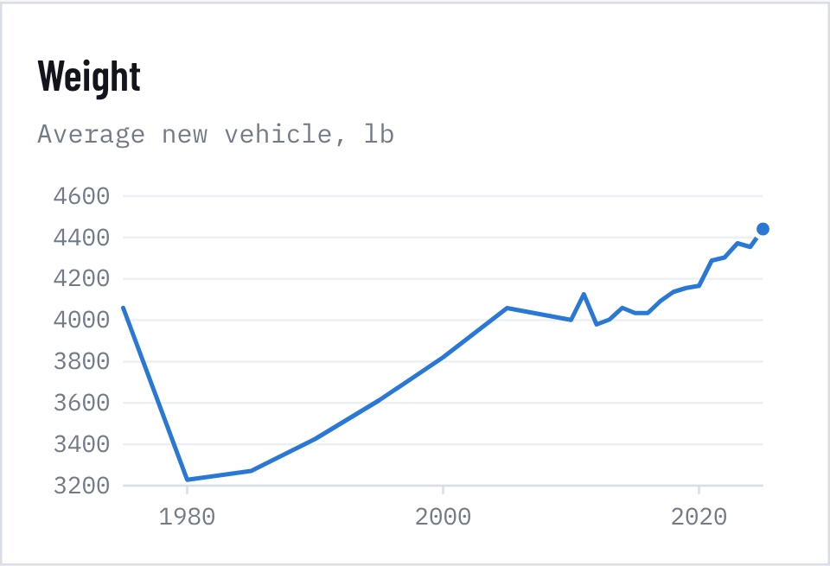  Figure 39. Weight | 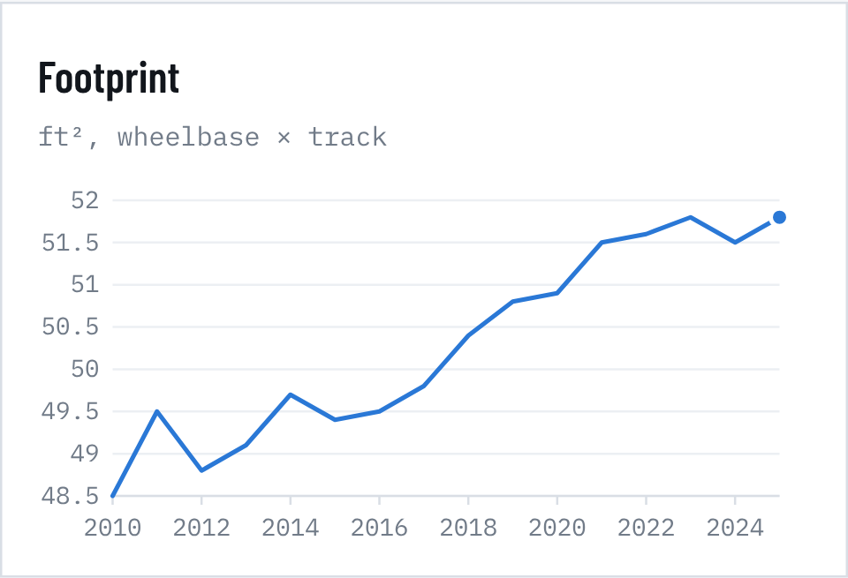  Figure 40. Footprint

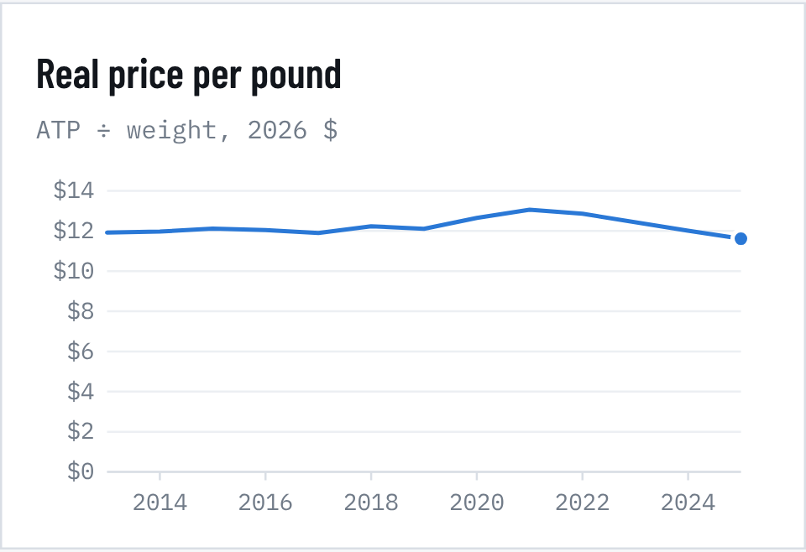  Figure 41. Real price per pound | 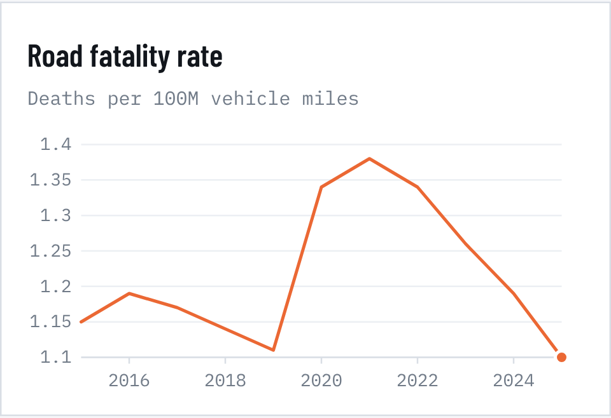  Figure 42. Road fatality rate

Sources: EPA Automotive Trends Report (Feb 2026), Tables 3.1; KBB December ATP; NHTSA, Early Estimate of Motor Vehicle Traffic Fatalities in 2025 (DOT HS 813 800; 2025 is a projection).
Size. The average new vehicle weighs 4,441 lb, up from 3,228 lb in 1980, and its footprint grew from 48.5 to 51.8 ft² between 2010 and 2025. Buyers are paying for that size, but not more per unit of it. Measured in 2026 dollars, the price per pound has held near $11.6–$13.1 since 2013 and is now $11.61, and the real price per horsepower has fallen 7%. The rise in sticker prices is mostly people buying more car, which matches the transaction-price bridge in section 2.0.
Occupant safety keeps improving. The road fatality rate fell from its 2021 pandemic peak of 1.38 deaths per 100 million miles to an estimated 1.10 in 2025, back to the 2019 level. IIHS named 63 models to its 2026 Top Safety Pick lists (45 TSP+, 18 TSP), up from 48 at the same point last year. That came despite tougher criteria: a good rear-seat score for both awards, standard front-crash prevention, and a new high-speed vehicle-to-vehicle test for TSP+. Rearview cameras have been mandatory since May 2018, and automatic emergency braking becomes mandatory by September 2029, so features once sold as luxury options are now baseline.
Size has a cost for pedestrians. IIHS found that vehicles with hoods more than 40 inches high are about 45% more likely to kill a pedestrian in a crash than low, sloped vehicles. Flat, blunt fronts add risk at every height. Pedestrian deaths rose 80% from their 2009 low to nearly 7,400 in 2021. With trucks and SUVs now 84% of sales, the fleet's size trend works against road users outside the vehicle.

9. EVs, vehicle classes, credit and luxury
ELECTRIC VEHICLE OUTLOOK, 2026–2030

EVs: a policy reset, then slow recovery
Battery-electric vehicles went from 0.1% of the market in 2011 to 8.1% of sales in 2024. Growth in the odds of buying an EV ran at about 0.35–0.41 log points a year through 2023, then stopped: the 2023–2025 slope is 0.01 (s.e. 0.03), statistically flat. The federal credit ended on 30 September 2025; after a pull-forward to a record 10.5% in Q3 2025, share fell to 5.8% in Q4 and has held near 6% in 2026.
We model EV share in logit form (the standard shape for technology adoption) starting from today's ~6%. Each path combines an underlying adoption trend, drawn from one of three scenarios, with a price effect: the price premium over gasoline vehicles shrinks as battery costs fall. The price sensitivity is calibrated from the credit expiry itself. Losing a benefit worth about 15% of an average gas vehicle's price lowered the log-odds of buying an EV by 0.32, about −0.021 per percentage point of premium. That is an upper-bound estimate, since not every EV qualified for the credit.
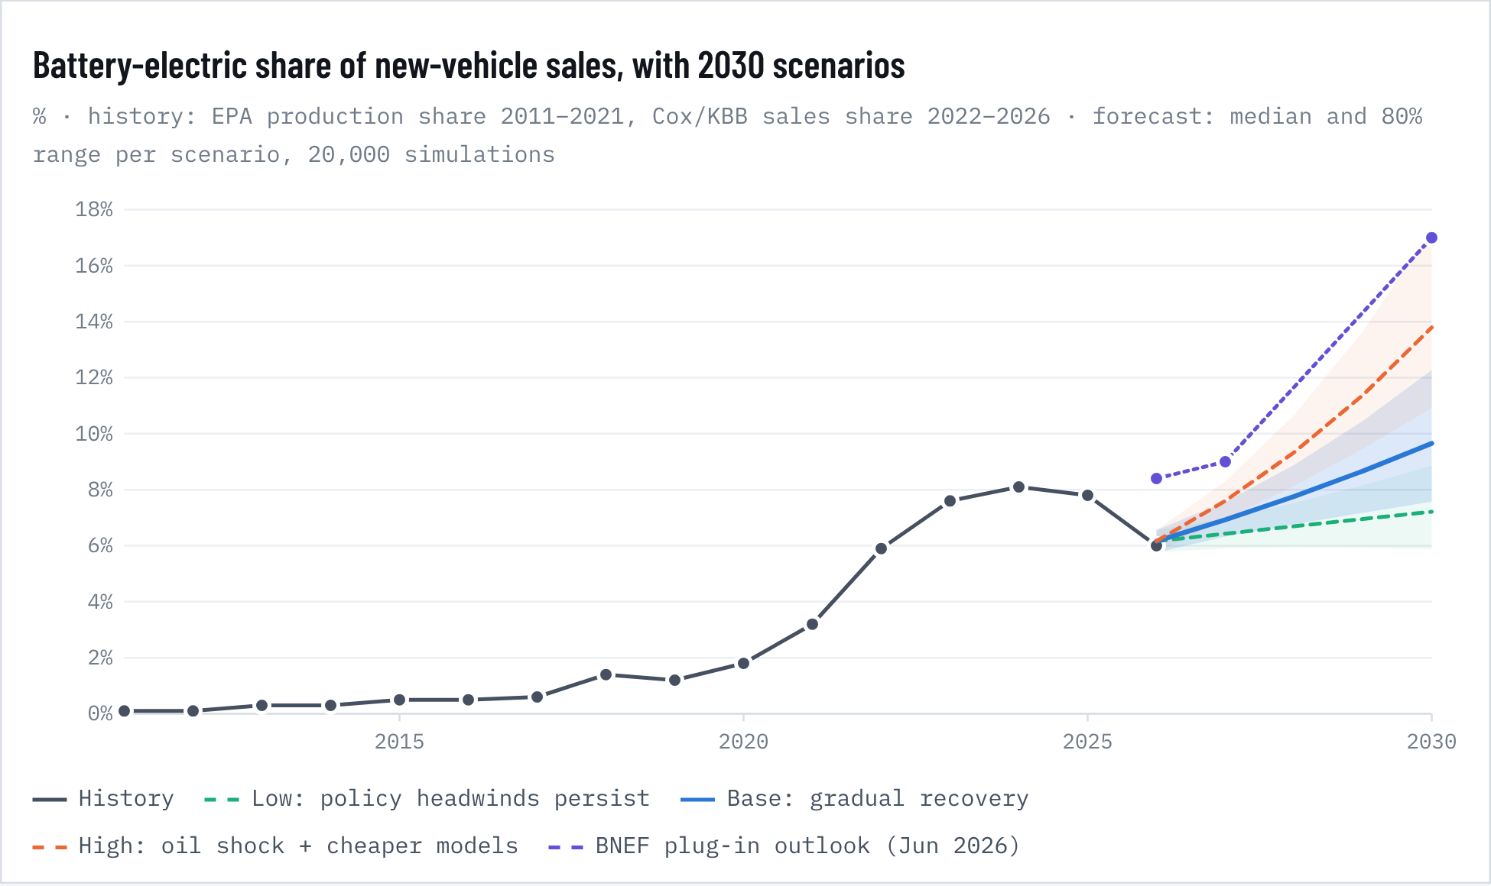
Figure 43. Battery-electric share of new-vehicle sales, with 2030 scenarios
Table 36. Battery-EV share of new-vehicle sales by scenario, %
Scenario | 2026 | 2027 | 2028 | 2029 | 2030 median | 2030 80% range
Low: policy headwinds persist | 6.2% | 6.4% | 6.7% | 7.0% | 7.2% | 5.9–8.9%
Base: gradual recovery | 6.2% | 6.9% | 7.8% | 8.7% | 9.7% | 7.6–12.3%
High: oil shock + cheaper models | 6.2% | 7.6% | 9.3% | 11.4% | 13.8% | 10.9–17.3%
Pooled (equal weight) |  |  |  |  | 9.7% | 6.6–15.2%
BNEF Jun 2026, plug-in incl. PHEV | 8.4% | 9.0% | – | – | 17.0% | (2024 outlook: 47.5%)

Scenario trend (annual change in log-odds, mean ± sd): low 0.02 ± 0.04, base 0.10 ± 0.05, high 0.20 ± 0.05. For reference, 2011–2023 ran at 0.35–0.41. Price effect = −0.021 × change in premium (pp). BNEF figures are plug-in vehicles (battery EVs plus plug-in hybrids), so they sit above a battery-EV-only forecast by about 2–3 points.
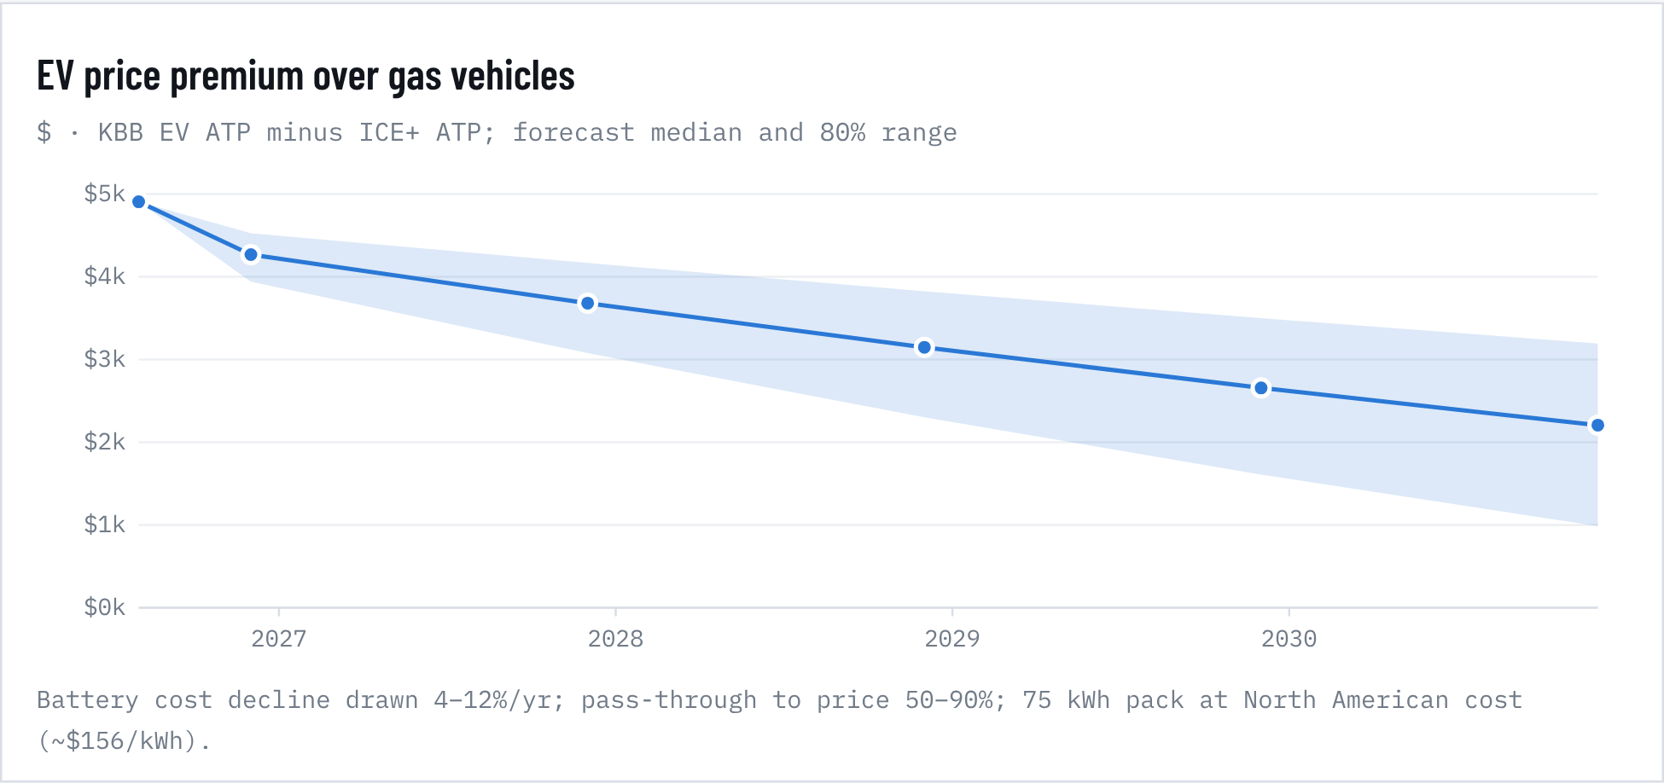
Figure 44. EV price premium over gas vehicles
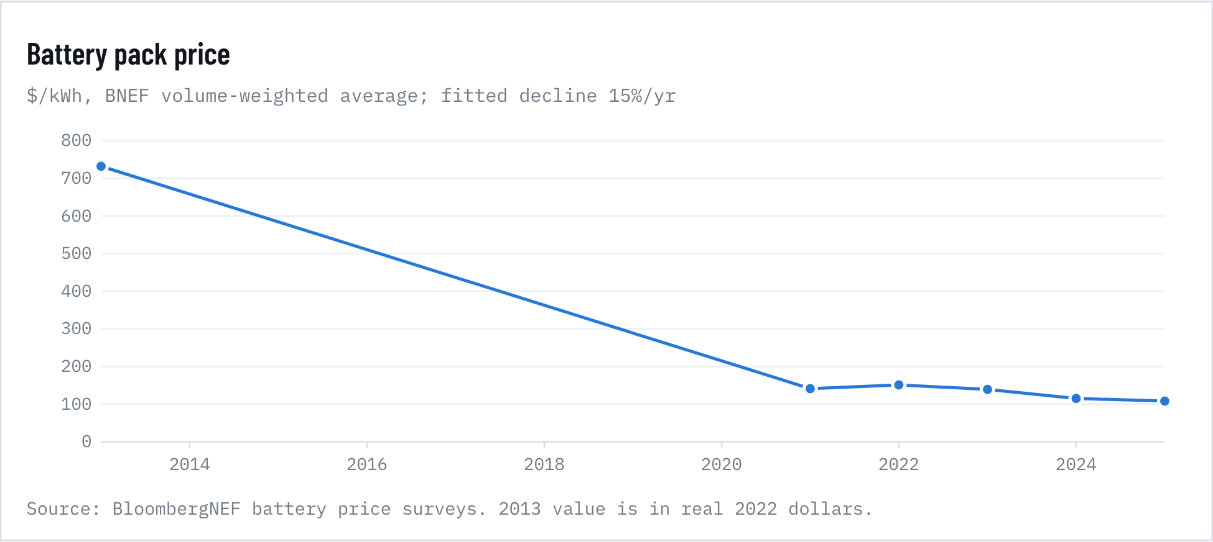
Figure 45. Battery pack price
Price. In August 2026 the average EV sold for $54,813, about $4,906 (9.8%) more than the average gasoline vehicle (ICE+). Battery packs have fallen 15% a year since 2013 (R² 0.96), slowing to about 8% a year since 2021. If that continues and most of the saving reaches buyers, the median premium shrinks to about $2,207 (4%) by 2030. That is smaller, but still a premium, so sticker-price parity is unlikely before 2030 in our median case. We forecast the average EV transaction price at about $55,746 (80% range $48.8k–$63.7k) in December 2030.
Running costs. At today's $4.35 gasoline and 19.6¢/kWh electricity, an EV saves about $1,050 a year in fuel for a 13,500-mile driver: 28.1 mpg against 3.3 miles/kWh, with 80% home charging and public charging at 2.5× the home rate. That pays back today's premium in about 4.7 years. At gasoline of about $5.57 a gallon, payback falls to three years. The oil shock is the main reason our high scenario is plausible, and used EVs are already selling at a record pace (about 124,000 retail sales in Q3 2026, +11.4% y/y; average listing $37,441, +8.2% y/y).
Hybrids are the real growth story. Strong hybrids went from 2.5% of production in MY2019 to 14.0% in MY2025 and reached a record 16.3% of sales in Q2 2026. Their log-odds have grown 0.29 a year (s.e. 0.02). Extending that trend mechanically gives about 40% of production by 2030, which we treat as an upper bound because adoption curves bend.
The pooled median battery-EV share in 2030 is 9.7% (80% range 6.6–15.2%), with a 47% chance of exceeding 10%. BloombergNEF's June 2026 outlook puts plug-in vehicles at 17% in 2030, down from the 47.5% it projected in 2024. Cox expected about 8% EV share for 2026 in January; the year is tracking nearer 6%.
DIFFERENCES ACROSS VEHICLE CLASSES

Trucks and SUVs got pricier; cars, luxury SUVs and EVs got cheaper
Producer prices, which BLS adjusts for quality just as it does the CPI, split cleanly by class. Since 1994 light-truck prices (pickups, SUVs, vans) have risen 0.90% a year and passenger-car prices 0.17% a year. The gap averages 0.72 points a year (HAC s.e. 0.35, p = 0.036) and widened after 2010. Buyers paid up for trucks while sedans became the value end of the market: sedans and wagons fell from 81% of production in 1975 to 23% in MY2025.
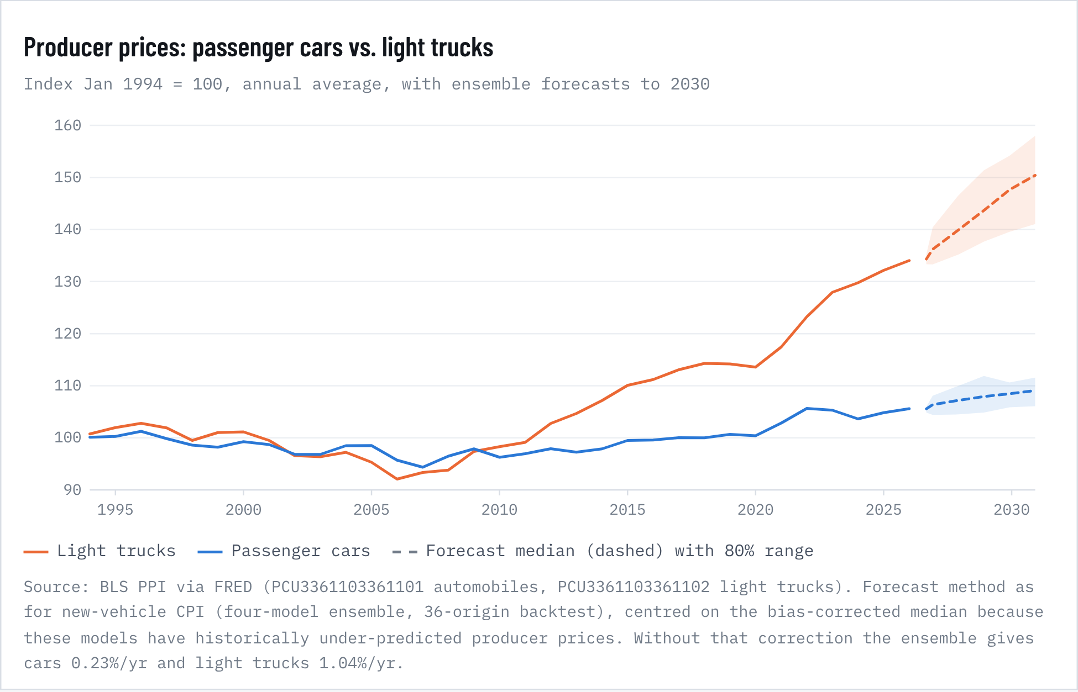
Figure 46. Producer prices: passenger cars vs. light trucks
Table 37. Car vs. light-truck producer prices by period
Period | Cars %/yr | Light trucks %/yr | Gap (pp/yr)
1994–1999 | 0.24 | 0.28 | 0.04
2000–2009 | -0.29 | -0.22 | 0.07
2010–2019 | 0.29 | 1.40 | 1.11
2020–2026 | 0.86 | 2.50 | 1.64
1994–2026 | 0.17 | 0.90 | 0.73
Forecast Aug 2026 → Dec 2030 | 0.75 | 2.69 | 1.95

Segment prices now and in 2030
Table 38. Segment prices now and in 2030
Segment | Class | Dec 2022 | Latest | %/yr 2022–25 | vs industry (pp/yr) | Dec 2030 forecast | 80% range
Luxury Full-size SUV/Crossover | Light truck | $110,089 | $98,865 (Dec 25) | -3.5% | -3.84 | $106,185 | $92.9k–$121.3k
Full-size SUV/Crossover | Light truck | $74,467 | $79,739 (Dec 25) | +2.3% | +2.02 | $85,643 | $75.0k–$97.9k
Luxury Mid-size SUV/Crossover | Light truck | $75,586 | $73,473 (Dec 25) | -0.9% | -1.20 | $78,913 | $69.1k–$90.2k
Full-size Pickup Truck | Light truck | $64,532 | $67,446 (Aug 26) | +0.9% | +0.69 | $72,725 | $63.6k–$83.1k
Entry-level Luxury Car | Car | $55,714 | $57,649 (Dec 25) | +1.1% | +0.88 | $59,718 | $52.3k–$68.2k
Luxury Compact SUV/Crossover | Light truck | $58,015 | $52,290 (Dec 25) | -3.4% | -3.72 | $56,162 | $49.2k–$64.2k
Electric Vehicle | EV | $61,448 | $54,813 (Aug 26) | -1.9% | -2.16 | $55,746 | $48.8k–$63.7k
Mid-size SUV/Crossover | Light truck | $47,931 | $50,315 (Aug 26) | +0.8% | +0.58 | $54,253 | $47.5k–$62.0k
Sports Car | Car | $47,713 | $51,540 (Dec 25) | +2.6% | +2.31 | $53,389 | $46.7k–$61.0k
Minivan | Light truck | $47,386 | $47,723 (Dec 25) | +0.2% | -0.02 | $51,256 | $44.9k–$58.6k
Small/Mid-size Pickup Truck | Light truck | $42,297 | $43,144 (Dec 25) | +0.7% | +0.40 | $46,338 | $40.6k–$52.9k
Compact SUV/Crossover | Light truck | $36,326 | $37,722 (Aug 26) | +0.1% | -0.17 | $40,675 | $35.6k–$46.5k
Mid-size Car | Car | $31,643 | $33,557 (Dec 25) | +2.0% | +1.70 | $34,761 | $30.4k–$39.7k
Subcompact SUV/Crossover | Light truck | $30,513 | $31,149 (Aug 26) | +0.4% | +0.15 | $33,587 | $29.4k–$38.4k
Compact Car | Car | $26,736 | $27,997 (Aug 26) | +0.3% | +0.00 | $29,257 | $25.6k–$33.4k
Subcompact Car | Car | $24,945 | $24,660 (Dec 25) | -0.4% | -0.64 | $25,545 | $22.4k–$29.2k
Industry | All | $49,939 | $50,089 (Aug 26) | +0.3% | – | $53,734 | $50.4k–$63.6k

KBB average transaction prices (Dec 2022 from the year-ago column of the Dec 2023 tables). 2030 forecast = latest segment price × the industry ATP forecast × class drift (light trucks +0.12, cars −0.61 pp/yr relative to industry, from the PPI gap weighted by the 84% truck share). EVs use ICE+ price plus the projected EV premium. 80% ranges combine industry forecast uncertainty with segment-level noise.
Recent segment moves are mostly noise, statistically. Between December 2022 and December 2025, full-size SUVs (+2.3%/yr), sports cars (+2.6%/yr) and mid-size cars (+2.0%/yr) outpaced the industry (+0.25%/yr), while luxury compact SUVs (−3.4%/yr), luxury full-size SUVs (−3.5%/yr) and EVs (−1.9%/yr) fell. A homogeneity test cannot separate these 3-year differences from normal year-to-year segment volatility (χ² = 5.69, df = 16, p = 0.99). Our segment forecasts therefore lean on the long-run, statistically significant truck-vs-car gap rather than extrapolating the latest three years.
Gas prices and the mix. Over 1977–2026, a 10% rise in real gasoline prices cut the truck share of sales by about 0.5 points within a year (p < 0.001). Since 2010 the effect is a third as large and not significant (p = 0.37). Buyers of today's crossovers, many of them hybrids, are much less fuel-sensitive than 1970s or 2008 buyers. With real gasoline up 21% over the past year, the models imply a 0.3–1.0 point dip in truck share. The data so far show trucks steady at 84% of sales, while Manheim reports large SUVs and pickups losing wholesale value and compact cars gaining (+4.3% mid-September).
SAVINGS, CREDIT, DEFAULTS AND INTEREST RATES

The financing side is the weakest link
Table 39. Key numbers
Measure | Value | Detail
Personal saving rate | 4.1% | Aug 2026 · 2015–19 avg 6.1%
Entering 90+ delinquency | 3.00% | Auto balances, year to Q2 2026 · 2019: 2.35%
Auto debt 90+ days late | 5.49% | of $1.71 trillion · 2010 peak 5.27%
5-year Treasury | 4.99% | 8 Oct 2026 · Aug avg 4.38%

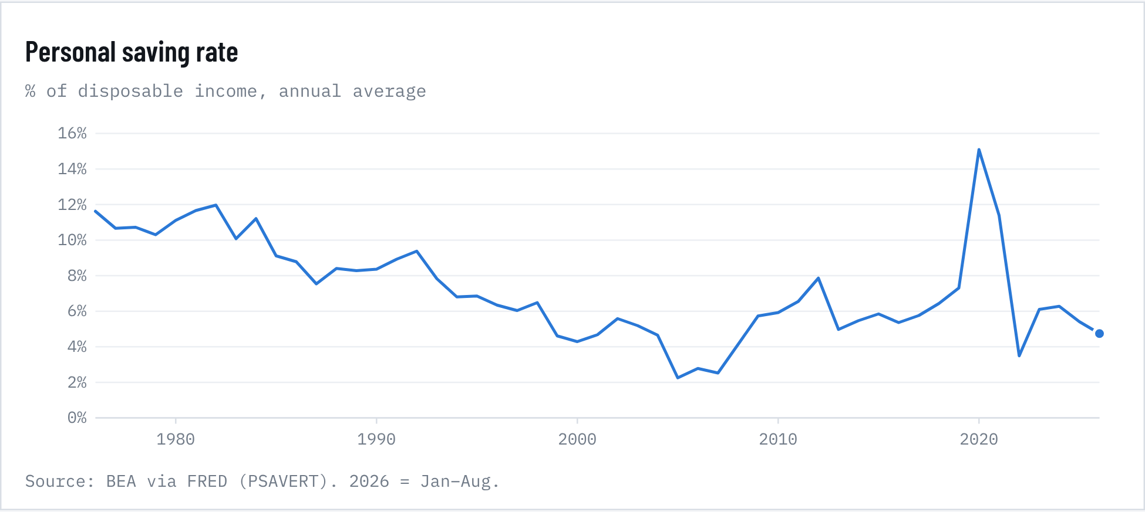
Figure 47. Personal saving rate
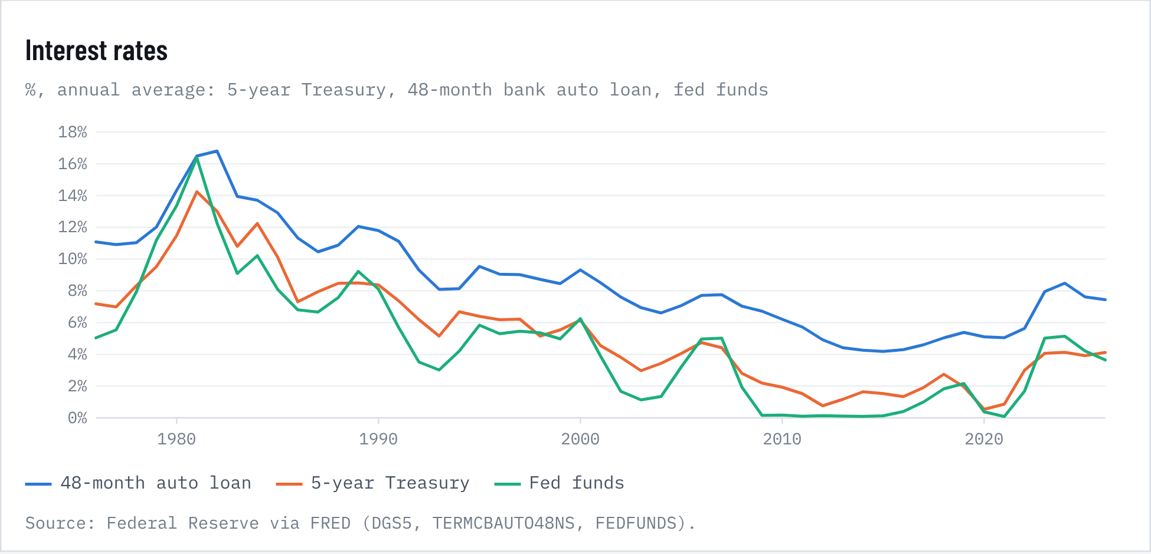
Figure 48. Interest rates
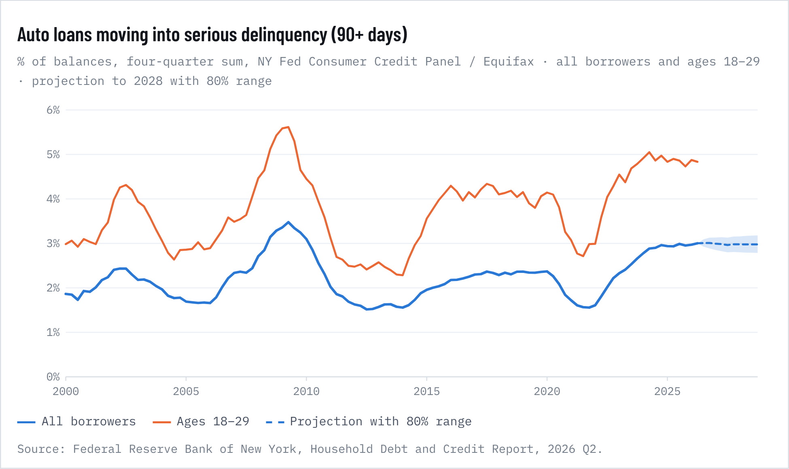
Figure 49. Auto loans moving into serious delinquency (90+ days)
Savings. Households are saving 4.1% of disposable income (August 2026), against 6.1% in 2015–2019 and 7.2% in the 1990s. A thin cushion matters for cars in two ways. Adding the saving rate to our quarterly sales model shows each one-point rise in saving cutting sales about 1.7% (p = 0.07), as households pull back on big purchases. Controlling for saving, sales track income more strongly, with an elasticity of 2.3 (p = 0.005). A low saving rate also means less room to absorb a shock without missing payments.
Debt service. Household debt payments take 11.1% of disposable income (Q2 2026), up from a record low of 9.1% in early 2021 and below the 15.8% peak of late 2007. In the 2006–2026 sample, each extra point of debt service is associated with about 17% lower sales (p < 0.001). It is the single strongest financial predictor of demand we tested.
Defaults. In the year to Q2 2026, 3.0% of auto balances moved into 90+ day delinquency, up from 2.35% in 2019 and approaching the 3.5% peak of 2008–2011. For borrowers aged 18–29 it is 4.8%. The stock of auto debt 90+ days late reached 5.49% of $1.71 trillion, above the 2010 peak of 5.27%. Among subprime securitized loans, Fitch's 60+ day delinquency index hit a record 6.90% in January 2026, with annualized net losses of 9.81%.
A dynamic regression on 2006–2026 quarterly data finds delinquency very persistent (0.90 carry-over per quarter). It rises with loan rates (long-run +0.21 points of annual transition per point of rate, p = 0.01) and with the share of subprime originations two years earlier (p = 0.006). It falls when used-car prices rise, because higher collateral values let borrowers sell out of trouble (p = 0.05). Out of sample (2022–2026, forecasting forward from 2021), it beats a naive forecast (RMSE 0.92 vs 1.13). It still under-predicts the recent surge: it reaches 1.8% against the actual 3.0%. Much of the rise sits in young and subprime borrowers and is not captured by macro variables. The projection holds near 3.0% through 2028 (80% range 2.8–3.2%). Delinquency stays elevated rather than spiking, unless unemployment rises faster than the assumed 4.4%.
Interest rates. The five-year Treasury hit 4.99% on 8 October, up from an August average of 4.38%. Bank auto-loan rates historically move about 0.37 points per point of five-year Treasury change (p < 0.001), implying another ~0.2 points on auto loans. That would add about $5 a month to the typical payment, on Cox's $22-per-point rule of thumb. The 48-month bank rate's spread over Treasuries (3.1 points) is close to its 2010–2019 average (3.3), so credit is not unusually tight for prime borrowers. The squeeze is the level of rates plus thin savings.
HOW THE DEFINITION OF LUXURY HAS CHANGED

Luxury used to mean a price. Now it is mostly a badge.
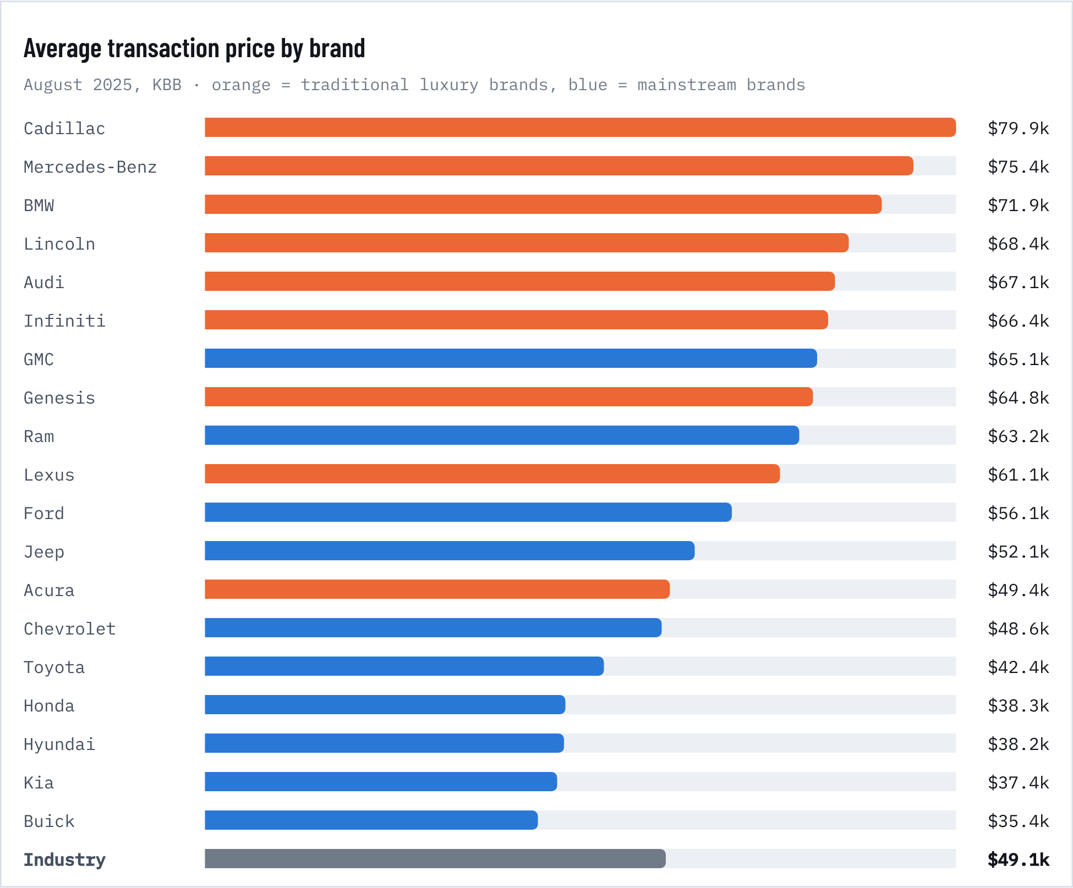
Figure 50. Average transaction price by brand
Table 40. Mainstream vs. luxury segments
Segment | Dec 2022 | Dec 2025 | Change
Full-size SUV (mainstream) | $74,467 | $79,739 | +7.1%
Full-size pickup (mainstream) | $64,532 | $66,386 | +2.9%
Entry-level luxury car | $55,714 | $57,649 | +3.5%
Luxury mid-size SUV | $75,586 | $73,473 | -2.8%
Luxury compact SUV | $58,015 | $52,290 | -9.9%
Mid-size SUV (mainstream) | $47,931 | $49,144 | +2.5%
Compact car (mainstream) | $26,736 | $26,945 | +0.8%
1991 luxury-tax threshold in 2026 $ |  |  | $73,615

The tax code's old definition. In 1991 Congress defined a luxury car as one costing more than $30,000 and taxed the excess at 10%. The threshold was indexed to $40,000 by 2002, and the tax expired after 2002. In today's dollars those lines are $73,615 (1991 line) and $74,306 (2002 line). By that standard the average full-size mainstream SUV ($79,739) is now a luxury car, and the average new vehicle ($50,089) sits at 68% of the line.
Prices crossed over. A full-size pickup now averages $66,386, about $14,000 more than a luxury compact SUV. The luxury compact SUV fell 9.9% from December 2022 while the pickup rose 2.9%. GMC ($65,128) and Ram ($63,212) average more than Lexus ($61,132), and far more than Acura ($49,409). Luxury brands took a historically high 18% of sales in mid-2022 (KBB).
The affordable car is what disappeared. In the first half of 2026, only 4% of new vehicles sold for under $25,000 and 10% for $25,000–$30,000 (Edmunds). Just over a decade ago, most new cars sold for under $30,000. Safety and tech that defined luxury in the 2000s (cameras, automatic braking, large screens, driver assistance) are now standard on most models or required by law. Luxury has become a matter of brand, materials and service rather than price or features.

10. History and long-run trends
HISTORICAL BREAKDOWN, 1976–2026

Fifty years of car prices against everything else
The Bureau of Labor Statistics adjusts the new-vehicle index for quality: when a car gains standard safety or efficiency features, that part of the price increase is not counted as inflation. That is why the index rose only 2.0% a year since 1976 against 3.6% for all items. Used-vehicle prices rose faster (2.8% a year) and swing much more, because used supply is fixed by past new sales.
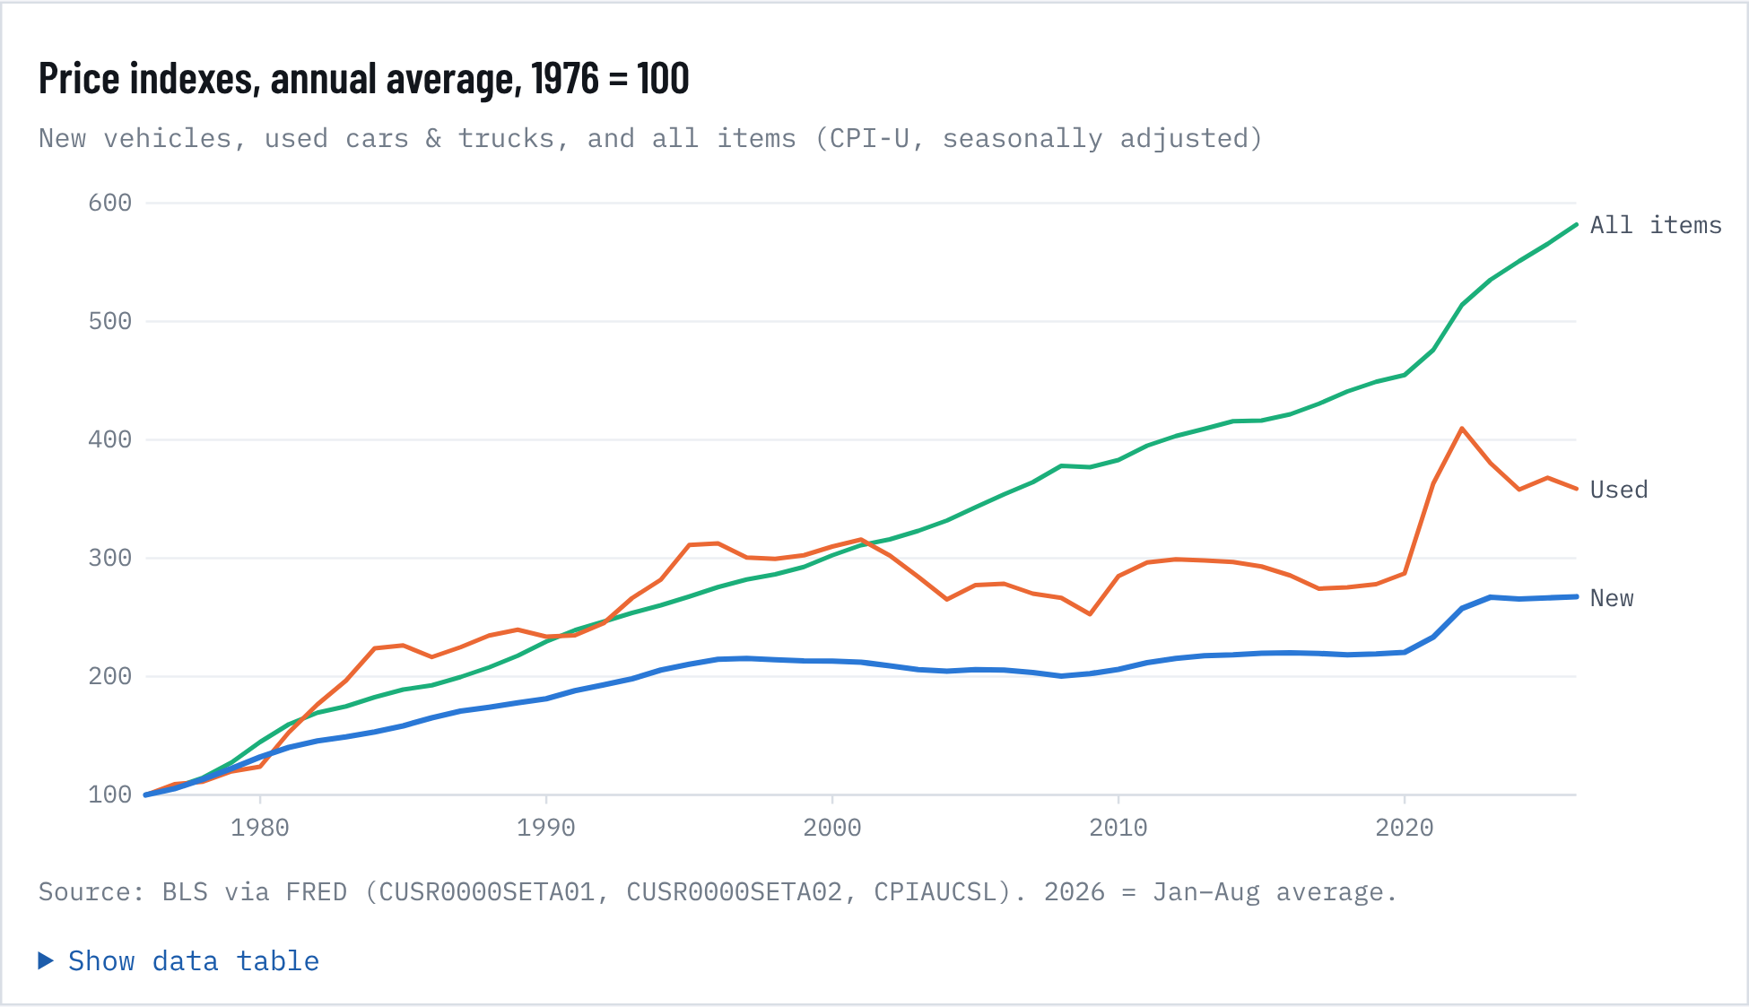
Figure 51. Price indexes, annual average, 1976 = 100

Five eras
Table 41. Five eras
Era | Years | New veh. %/yr | Used %/yr | All CPI %/yr | Real new %/yr | Avg sales (M) | Truck share | Loan rate
Oil shocks & Volcker | 1976–1983 | 5.7 | 11.5 | 7.8 | -2.0 | 12.9 | 23% | 13.3%
Japanese competition, SUV boom begins | 1984–1997 | 2.5 | 2.3 | 3.4 | -0.8 | 14.8 | 35% | 10.5%
Long deflation in quality-adjusted price | 1998–2019 | 0.1 | -0.3 | 2.2 | -2.0 | 16.2 | 54% | 6.4%
Pandemic & chip shortage | 2020–2023 | 5.7 | 10.8 | 4.8 | 0.9 | 15.0 | 78% | 5.6%
Normalization, tariffs, oil shock | 2023–2026 | 0.1 | -2.7 | 3.0 | -2.9 | 16.4 | 82% | 8.0%

Annualized growth between the start and end months. Real = new-vehicle index deflated by all-items CPI. Truck share = light trucks as a share of light-vehicle sales (BEA). Loan = commercial-bank 48-month new-car rate.
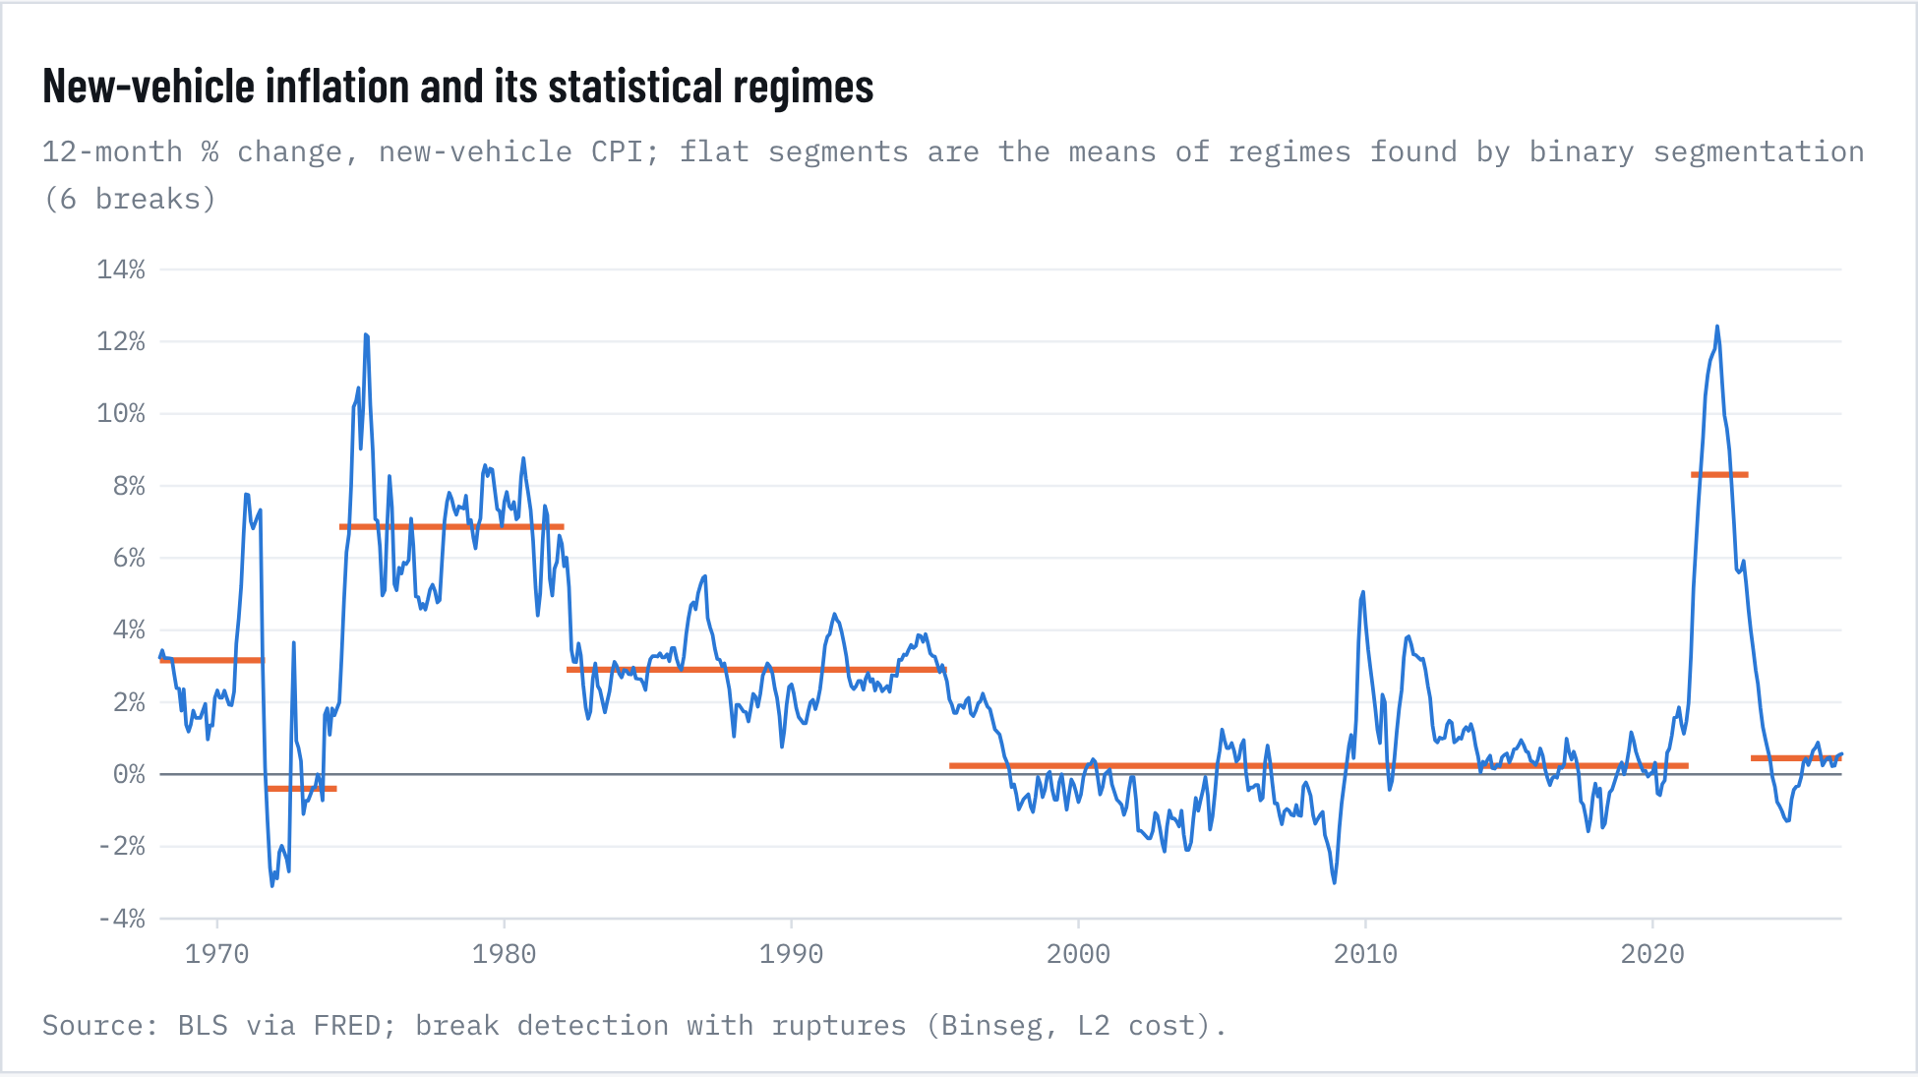
Figure 52. New-vehicle inflation and its statistical regimes
MAJOR CONSUMER AND TECHNOLOGY TRENDS

Bigger, faster, cleaner, and financed for longer
Four long trends explain most of the gap between the quality-adjusted index and the sticker price. Each one adds content a buyer pays for, so the transaction price rises even when the index barely moves.
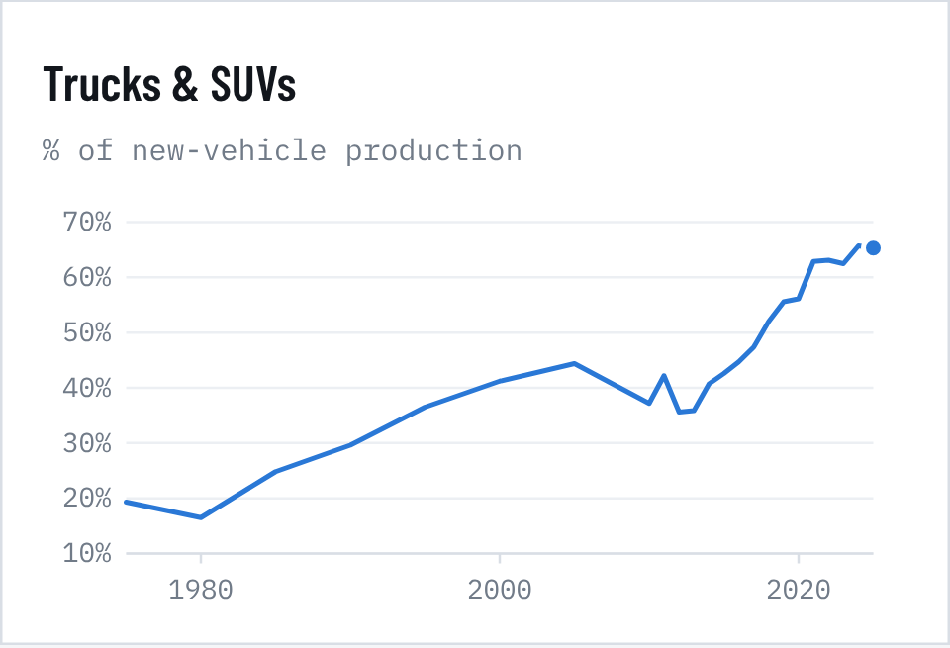  Figure 53. Trucks & SUVs | 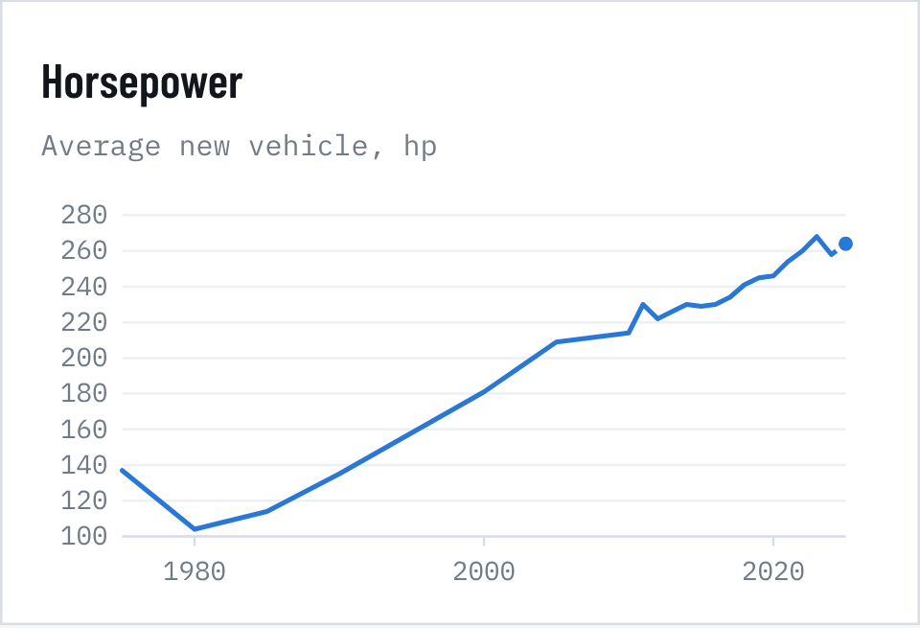  Figure 54. Horsepower

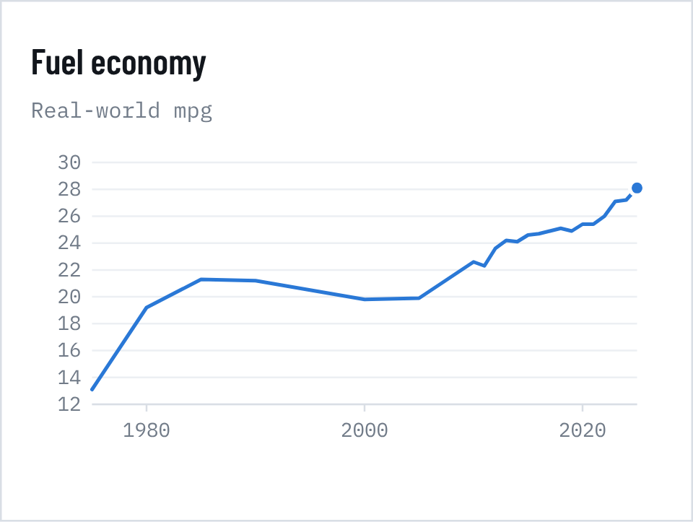  Figure 55. Fuel economy | 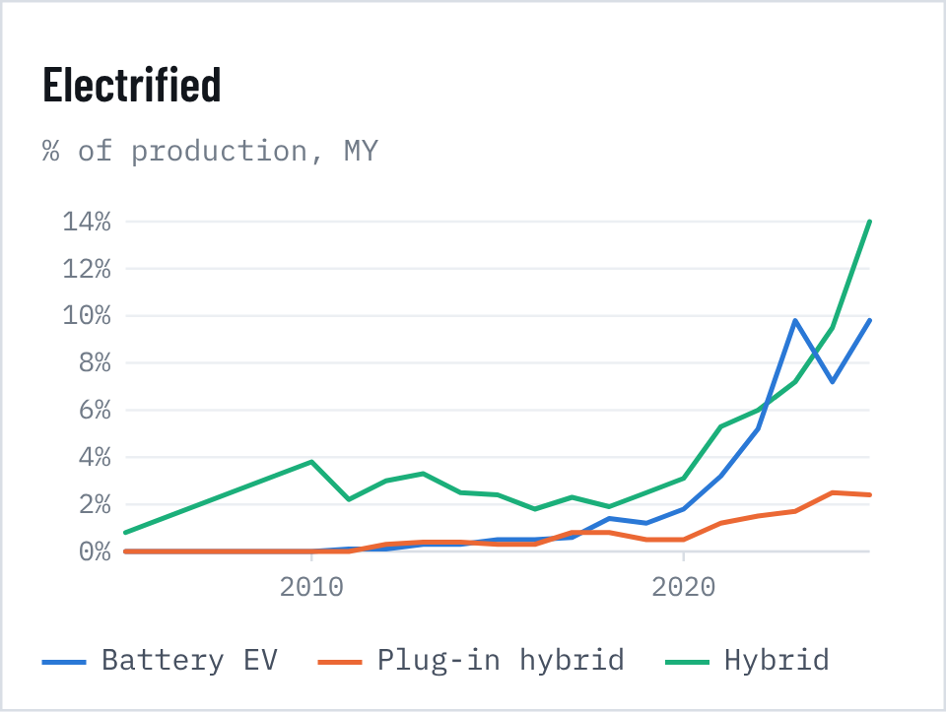  Figure 56. Electrified

Source: EPA Automotive Trends Report (Feb 2026), Tables 3.1 and 4.2. Model years 1975–2024 final; 2025 preliminary.
The SUV takeover. Cars were 81% of production in 1975 and 34% in model year 2024. Truck-based SUVs alone are now half of all production. In the monthly sales data, light trucks reached 84% of sales in August 2026.
More power, more weight, better efficiency. The average new vehicle went from 137 hp to 258 hp, and 0–60 mph times fell from 15.6 seconds (1980) to 7.5. Even so, fuel economy doubled to a record 27.2 mpg (28.1 preliminary for MY2025), helped by turbocharging, direct injection (now in about 80% of new vehicles) and hybrids.
Electrification, then a reset. Battery-electric vehicles reached 9.8% of MY2023 production. Battery packs fell from $732/kWh in 2013 (in 2022 dollars) to $108 in 2025 (EV packs $99). The federal EV tax credit ended on 30 September 2025, and EV sales share dropped to about 6% in 2026. Hybrids took the gap and reached a record 16.3% of sales in Q2 2026. The EV price premium over gasoline vehicles narrowed to 9.4% in August 2026, from more than 16% a year earlier.
Financing stretched to the limit. In Q2 2026 the average new-car loan ran 70.4 months, 23.9% of buyers took terms of 84 months or more, and 20.3% paid $1,000 a month or more, tying the record. The average payment was $777. Incentives are only 6.5% of the price, against 10–11% before COVID, so automakers are protecting margins rather than chasing volume.
Owners are keeping cars longer. The average light vehicle on the road is a record 12.8 years old (2025), which supports used prices and future replacement demand.
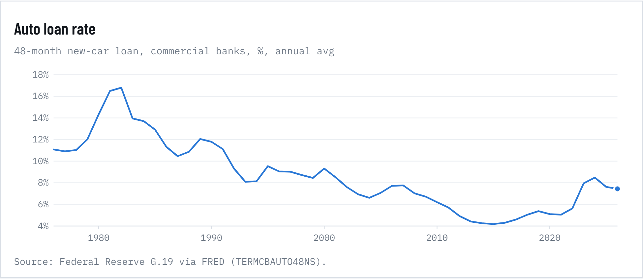
Figure 57. Auto loan rate
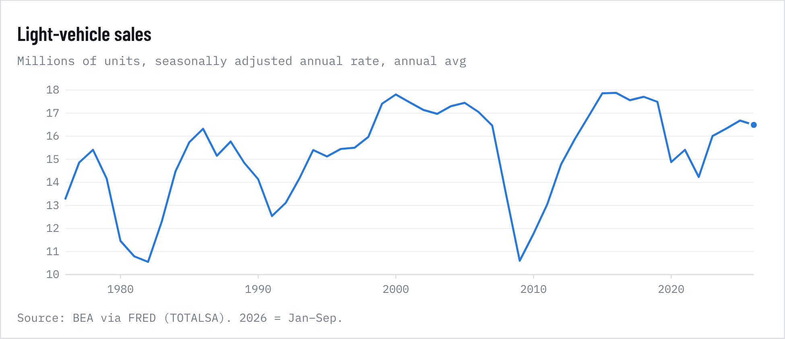
Figure 58. Light-vehicle sales

11. Statistical appendix and model card
STATISTICAL APPENDIX

Methods, tests and diagnostics

A1. Stationarity (1984–2026)
Table 42. A1. Stationarity (1984–2026)
Series | Form | ADF stat | ADF p | KPSS stat | KPSS p | n | Verdict
log_cpi_new | level | -2.37 | 0.395 | 0.396 | 0.010 | 512 | unit root
log_cpi_new | diff | -3.57 | 0.006 | 0.385 | 0.084 | 512 | stationary
log_cpi_used | level | -2.71 | 0.231 | 0.287 | 0.010 | 512 | unit root
log_cpi_used | diff | -6.08 | <0.001 | 0.077 | 0.100 | 512 | stationary
log_ppi_veh | level | -2.22 | 0.480 | 0.429 | 0.010 | 512 | unit root
log_ppi_veh | diff | -3.52 | 0.007 | 0.187 | 0.100 | 512 | stationary
log_ppi_steel | level | -3.66 | 0.025 | 0.241 | 0.010 | 512 | mixed
log_ppi_steel | diff | -8.63 | <0.001 | 0.056 | 0.100 | 512 | stationary
log_imp_auto | level | -3.03 | 0.124 | 0.470 | 0.010 | 471 | unit root
log_imp_auto | diff | -3.89 | 0.002 | 0.290 | 0.100 | 450 | stationary
log_cpi_core | level | -2.42 | 0.368 | 0.589 | 0.010 | 511 | unit root
log_cpi_core | diff | -3.03 | 0.032 | 1.058 | 0.010 | 510 | mixed
inv_sales | level | -3.85 | 0.014 | 0.394 | 0.010 | 404 | mixed
inv_sales | diff | -16.20 | <0.001 | 0.034 | 0.100 | 403 | stationary
loan48 | level | -2.40 | 0.380 | 0.451 | 0.010 | 512 | unit root
loan48 | diff | -4.18 | <0.001 | 0.296 | 0.100 | 512 | stationary
unrate | level | -3.02 | 0.125 | 0.216 | 0.010 | 512 | unit root
unrate | diff | -13.30 | <0.001 | 0.034 | 0.100 | 511 | stationary
log_saar | level | -3.63 | 0.027 | 0.104 | 0.100 | 513 | stationary
log_saar | diff | -12.10 | <0.001 | 0.037 | 0.100 | 513 | stationary

ADF (H0: unit root; trend in levels) and KPSS (H0: stationary). KPSS p-values are bounded at 0.01–0.10 by the lookup table. Verdict "stationary" requires ADF p < 0.05 and KPSS p > 0.05. Conclusion: price levels are I(1), so the models use changes.

A2. Cointegration and error correction
We tested whether consumer new-vehicle prices share a long-run path with producer prices (vehicle PPI) and auto import prices. Engle-Granger: τ = -2.84, p = 0.31. Johansen trace statistic for rank 0: 14.6 against a 5% critical value of 29.8. No cointegration: quality adjustment in the CPI means retail and factory price levels drift apart over decades. An error-correction term is still significant month to month (α = −0.020, p < 0.001; half-life about 34 months), so large gaps between retail and factory prices close slowly. Because standard t critical values do not apply to this term without cointegration, we treat it as suggestive and leave it out of the forecast.

A3. Driver regression diagnostics
Table 43. A3. Driver regression diagnostics
Test | Statistic / p | Reading
Breusch-Pagan heteroskedasticity | p <0.001 | Heteroskedastic: use robust errors
Ljung-Box (12 lags) | p <0.001 | Autocorrelated (overlapping y/y): use HAC
Durbin-Watson | 0.14 | Strong positive autocorrelation, as expected
Jarque-Bera normality | p <0.001 | Fat tails (2021–22)
Ramsey RESET | p <0.001 | Some nonlinearity: the pandemic regime
Chow break at Mar 2020 | F 27.4, p <0.001 | Coefficients not stable across 2020
Max VIF | 3.81 | No harmful multicollinearity (< 5)

Residual autocorrelation is expected with overlapping 12-month changes and is why inference uses HAC errors. As a check, a quarterly ARDL with two lags of the dependent variable (n = 131, R² = 0.55) gives the long-run effects below. Used prices and core inflation stay significant, chips and imports weaken, and the inventory ratio is borderline (p = 0.08).
Table 44. Short- and long-run effects (ARDL)
Input | Short-run coef. | p | Long-run effect
Core inflation | 1.704 | <0.001 | 2.048
Used-vehicle prices (lag 1q) | 0.092 | 0.001 | 0.111
Semiconductor PPI (lag 2q) | 0.065 | 0.151 | 0.079
Auto import prices (lag 1q) | -0.041 | 0.694 | -0.049
Steel PPI (lag 2q) | -0.003 | 0.758 | -0.004
Inventory/sales ratio (lag 1q) | 0.926 | 0.076 | 1.113
Δ loan rate | -0.366 | 0.636 | -0.439
Δ unemployment | 0.137 | 0.489 | 0.165

A4. Forecast backtest: new-vehicle CPI
Rolling-origin evaluation: 36 origins every 6 months from January 2006 to August 2023, each model re-estimated (and the ARIMA order re-selected) using only data available at that origin. Errors are in percent of the index level (log-difference × 100).
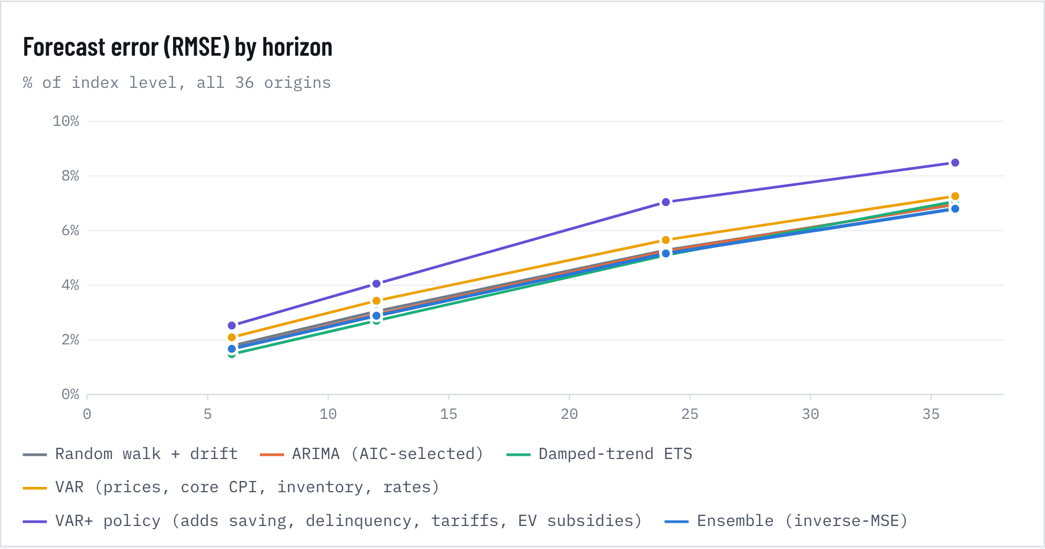
Figure 59. Forecast error (RMSE) by horizon
Table 45. Forecast backtest: new-vehicle CPI
Model | Horizon (mo) | RMSE % | MAE % | Bias % | Theil U | n
Random walk + drift | 12 | 3.05 | 1.90 | 0.99 | 1.000 | 36
Random walk + drift | 24 | 5.28 | 3.54 | 2.05 | 1.000 | 36
Random walk + drift | 36 | 6.95 | 5.05 | 3.17 | 1.000 | 36
ARIMA (AIC-selected) | 12 | 2.93 | 1.71 | 0.89 | 0.963 | 36
ARIMA (AIC-selected) | 24 | 5.24 | 3.20 | 2.00 | 0.992 | 36
ARIMA (AIC-selected) | 36 | 6.97 | 4.55 | 3.20 | 1.003 | 36
Damped-trend ETS | 12 | 2.70 | 1.62 | 0.97 | 0.886 | 36
Damped-trend ETS | 24 | 5.10 | 3.07 | 2.37 | 0.965 | 36
Damped-trend ETS | 36 | 7.07 | 4.43 | 3.90 | 1.016 | 36
VAR (prices, core CPI, inventory, rates) | 12 | 3.43 | 2.04 | 1.08 | 1.127 | 36
VAR (prices, core CPI, inventory, rates) | 24 | 5.65 | 3.52 | 2.31 | 1.070 | 36
VAR (prices, core CPI, inventory, rates) | 36 | 7.26 | 4.98 | 3.60 | 1.045 | 36
VAR+ policy (adds saving, delinquency, tariffs, EV subsidies) | 12 | 4.06 | 2.34 | 0.19 | 1.332 | 25
VAR+ policy (adds saving, delinquency, tariffs, EV subsidies) | 24 | 7.04 | 4.39 | 0.85 | 1.333 | 25
VAR+ policy (adds saving, delinquency, tariffs, EV subsidies) | 36 | 8.49 | 5.34 | 1.73 | 1.221 | 25
Ensemble (inverse-MSE) | 12 | 2.88 | 1.73 | 0.87 | 0.946 | 36
Ensemble (inverse-MSE) | 24 | 5.16 | 3.15 | 1.98 | 0.978 | 36
Ensemble (inverse-MSE) | 36 | 6.80 | 4.45 | 3.18 | 0.978 | 36

Theil U = RMSE relative to the random walk (below 1 beats the benchmark). Bias = mean error; positive means the model under-predicted.

A5. Diebold-Mariano tests vs. random walk
Table 46. A5. Diebold-Mariano tests vs. random walk
Model | Horizon | DM (new) | p (new) | DM (used) | p (used)
ARIMA (AIC-selected) | 12 | -0.93 | 0.350 | -1.43 | 0.152
ARIMA (AIC-selected) | 24 | -0.16 | 0.871 | -1.70 | 0.090
ARIMA (AIC-selected) | 36 | 0.03 | 0.973 | -1.40 | 0.161
Damped-trend ETS | 12 | -1.29 | 0.198 | -0.79 | 0.428
Damped-trend ETS | 24 | -0.68 | 0.495 | -2.11 | 0.035
Damped-trend ETS | 36 | 0.17 | 0.861 | -1.71 | 0.087
VAR (prices, core CPI, inventory, rates) | 12 | 0.89 | 0.371 | -0.75 | 0.451
VAR (prices, core CPI, inventory, rates) | 24 | 0.65 | 0.514 | -1.22 | 0.221
VAR (prices, core CPI, inventory, rates) | 36 | 0.39 | 0.694 | -1.20 | 0.232
VAR+ policy (adds saving, delinquency, tariffs, EV subsidies) | 12 | 1.19 | 0.235 | 0.58 | 0.562
VAR+ policy (adds saving, delinquency, tariffs, EV subsidies) | 24 | 1.98 | 0.048 | 1.36 | 0.175
VAR+ policy (adds saving, delinquency, tariffs, EV subsidies) | 36 | 1.08 | 0.279 | 1.75 | 0.080

Squared-error loss, HAC variance. Negative DM = model more accurate. New vehicles left, used vehicles right.
No model significantly beats a random walk with drift on new-vehicle prices across the full 2006–2023 test window. The pandemic surprise dominates every model's error. Excluding origins whose forecast windows overlap March 2020–June 2023, the release 2.1 ensemble cuts 12-month error from 1.75% to 1.36% and 36-month error from 4.33% to 3.01%. For used vehicles the damped-trend model beats the random walk at 24 months (p = 0.035). Treat the central path as a reasonable anchor, not a precise call. The ranges carry the information.

A6. Excluding the pandemic
Table 47. A6. Excluding the pandemic
Model | Horizon (mo) | RMSE % | MAE % | Bias % | Theil U | n
Random walk + drift | 12 | 1.74 | 1.26 | 0.19 | 1.000 | 28
Random walk + drift | 24 | 2.91 | 2.28 | 0.68 | 1.000 | 26
Random walk + drift | 36 | 4.33 | 3.40 | 1.44 | 1.000 | 24
ARIMA (AIC-selected) | 12 | 1.50 | 1.08 | 0.13 | 0.859 | 28
ARIMA (AIC-selected) | 24 | 2.30 | 1.78 | 0.47 | 0.792 | 26
ARIMA (AIC-selected) | 36 | 3.27 | 2.48 | 1.02 | 0.756 | 24
Damped-trend ETS | 12 | 1.50 | 1.04 | 0.21 | 0.861 | 28
Damped-trend ETS | 24 | 2.17 | 1.65 | 0.73 | 0.746 | 26
Damped-trend ETS | 36 | 3.17 | 2.26 | 1.49 | 0.733 | 24
VAR (prices, core CPI, inventory, rates) | 12 | 1.51 | 1.14 | 0.01 | 0.868 | 28
VAR (prices, core CPI, inventory, rates) | 24 | 2.29 | 1.78 | 0.35 | 0.787 | 26
VAR (prices, core CPI, inventory, rates) | 36 | 3.15 | 2.65 | 0.98 | 0.729 | 24
VAR+ policy (adds saving, delinquency, tariffs, EV subsidies) | 12 | 2.42 | 1.26 | -0.70 | 1.388 | 17
VAR+ policy (adds saving, delinquency, tariffs, EV subsidies) | 24 | 1.62 | 1.10 | -0.52 | 0.559 | 15
VAR+ policy (adds saving, delinquency, tariffs, EV subsidies) | 36 | 2.06 | 1.48 | -0.78 | 0.476 | 13
Ensemble (inverse-MSE) | 12 | 1.36 | 1.02 | 0.07 | 0.780 | 28
Ensemble (inverse-MSE) | 24 | 2.08 | 1.65 | 0.46 | 0.714 | 26
Ensemble (inverse-MSE) | 36 | 3.01 | 2.40 | 1.03 | 0.697 | 24

A7. Mix and content drift (ATP vs. CPI)
Table 48. A7. Mix and content drift (ATP vs. CPI)
Span | ATP growth %/yr | CPI growth %/yr | Mix drift %/yr
2013-2014 | 2.48 | 0.58 | 1.90
2014-2015 | 1.22 | 0.26 | 0.96
2015-2016 | 1.49 | 0.28 | 1.21
2016-2017 | 2.25 | -0.61 | 2.86
2018-2019 | 1.70 | 0.02 | 1.67
2019-2020 | 5.95 | 1.86 | 4.08
2020-2021 | 13.01 | 11.08 | 1.93
2021-2022 | 5.03 | 5.69 | -0.66
2022-2024 | 0.23 | 0.28 | -0.04
2024-2025 | 1.17 | 0.25 | 0.92
Weighted mean (all spans) |  |  | 1.34
Mean 2013–2020 |  |  | 2.11

December KBB ATP vs. December new-vehicle CPI. 2017–2018 is excluded because KBB changed methodology and restated history. 2022–2024 is a two-year span because KBB did not publish a comparable December 2023 figure. Version 2.0 replaces version 1's single assumed drift with the bridge in the 2.0 section (implied average 0.55%/yr through 2030; residual content drift SD 1.09%/yr).

A8. EV adoption model
Table 49. A8. EV adoption model
Quantity | Estimate | s.e. | Note
BEV log-odds growth 2011–2018 | 0.352 | 0.044 | odds ×1.42/yr, n=8
BEV log-odds growth 2018–2023 | 0.408 | 0.060 | odds ×1.50/yr, n=6
BEV log-odds growth 2023–2025 | 0.014 | 0.032 | not different from zero
Hybrid log-odds growth 2019–2025 | 0.295 | 0.020 | trend → 39.9% in 2030 (upper bound)
Battery price change 2013–2025 | -15.1%/yr | 0.016 | log-linear, R² 0.96
Battery price change 2021–2025 | -7.7%/yr | 0.024 | recent slowdown
Credit-expiry Δ log-odds (2024→2026) | -0.323 | – | shock = 15.0% of ICE+ price
Price semi-elasticity (log-odds per pp premium) | -0.021 | – | calibrated; magnitude is an upper bound

Log-odds slopes estimated by OLS on annual shares. Battery learning: OLS of log $/kWh on year. Policy calibration: Δlogit(share) from 2024 (8.1%) to 2026 (6.0%) divided by the credit's value as % of ICE+ ATP ($7,500 / $49,907). Monte Carlo: 2026 start ~ N(6.0%, 0.3pp); premium path from battery decline U(4%,12%) and pass-through U(50%,90%); scenario trend draws as in the EV section.

A9. Demand with savings and debt service
Table 50. A9. Demand with savings and debt service
Variable | (1) coef. | (1) p | (2) coef. | (2) p
Real new-vehicle price | 0.952 | 0.206 | -0.575 | 0.668
Real disposable income | 2.347 | 0.005 | 1.223 | 0.488
Auto loan rate (pp) | -0.011 | 0.307 | 0.090 | 0.003
Unemployment (pp) | -0.019 | 0.069 | -0.028 | 0.027
Sentiment (pt) | 0.003 | 0.004 | 0.001 | 0.483
Saving rate (pp) | -0.017 | 0.069 | -0.037 | 0.014
Debt-service ratio (pp) | – | – | -0.175 | <0.001
Real gasoline price | 0.100 | 0.360 | -0.050 | 0.755
Chip-shortage dummy | -0.103 | 0.345 | -0.229 | 0.071
COVID dummy | -0.055 | 0.627 | 0.070 | 0.538
R² / n | 0.51 | 175 | 0.67 | 82

Dependent: 4-quarter change in log light-vehicle sales. HAC (4 lags). Column 1: 1983–2026 with Δ saving rate. Column 2: 2006–2026 adding Δ household debt-service ratio; with it, the loan-rate coefficient turns positive because debt service already carries the rate effect, so read the two together.

A10. Auto-loan delinquency model
Table 51. A10. Auto-loan delinquency model
Variable | Dynamic coef. | p | Long-run effect | Static coef. | Static p
Lagged delinquency (persistence) | 0.897 | <0.001 | – | – | –
Unemployment rate (lag 1q) | -0.035 | <0.001 | -0.342 | -0.046 | 0.258
Auto loan rate (lag 4q) | 0.022 | 0.014 | 0.210 | 0.222 | <0.001
Subprime share of originations (lag 8q) | 0.009 | 0.006 | 0.083 | 0.034 | 0.100
Used-vehicle prices, y/y % (collateral) | -0.003 | 0.054 | -0.030 | -0.018 | 0.007
Saving rate (lag 2q) | -0.003 | 0.398 | -0.029 | 0.026 | 0.315
Forbearance dummy 2020Q2–2021Q4 | -0.034 | 0.305 | -0.327 | -0.188 | 0.450
Constant | 0.169 | 0.121 | – | 0.391 | 0.528
R² / n / Ljung-Box p (4) | 0.981 | n 81 | LB p <0.001 | 0.569
Out-of-sample RMSE 2022–26 (model vs naive) | 0.92 |  | 1.13 | 2026Q2 predicted 1.77 | actual 3.00

Dependent: NY Fed share of auto balances transitioning into 90+ day delinquency (four-quarter sum, %). Quarterly 2006Q2–2026Q2. HAC (4 lags). Long-run effect = coefficient / (1 − persistence). Unemployment enters with a negative sign once lagged delinquency is included, because transitions peaked in 2009 before joblessness did; we do not interpret it. Out-of-sample test: fit through 2021Q4, dynamic forecast 2022Q1–2026Q2. Projection assumptions: unemployment 4.2% (2026), 4.4% (2027–28); auto rates on the payment path; used prices +0.5%/yr; saving rate 4.1%.

A11. Vehicle-class tests
Table 52. A11. Vehicle-class tests
Test | Estimate | s.e. | p | Note
Light-truck minus car PPI growth, 1994–2026 (pp/yr) | 0.72 | 0.35 | 0.036 | HAC mean of monthly gap, n=391
Segment homogeneity, Dec 2022–Dec 2025 (χ²) | 5.69 | df 16 | 0.991 | cannot reject equal trends
Truck share response to real gas, 1977–2026 (pp per 1%) | -0.050 | 0.014 | <0.001 | 12-month changes, HAC, R² 0.13
Same, 2010–2026 | -0.015 | 0.017 | 0.367 | sensitivity has faded
Car PPI forecast Dec 2030 (index) | 145.7 |  |  | 80% 141.7–149.1
Light-truck PPI forecast Dec 2030 (index) | 230.6 |  |  | 80% 216.2–242.2

A12. EV credit assumptions (subsidy intensity)
Table 53. A12. EV credit assumptions (subsidy intensity)
From | Avg credit per new EV | Basis
2010-12 | $7,500 | Sec. 30D up to $7,500; all makers under 200k cap
2019-01 | $4,200 | Tesla (~70% of EVs) phased to $3,750 then $1,875; GM phase-down from Apr 2019
2020-01 | $2,300 | Tesla and GM at $0; other makers $7,500
2022-08 | $1,500 | IRA: North American final assembly required immediately
2023-01 | $5,000 | IRA rules: cap removed, price/income limits; $7,500 lease credit (45W) widely passed through
2025-10 | $0 | Credits ended 30 Sep 2025 (One Big Beautiful Bill Act)

Average federal credit per new EV sold, in effect from the month shown. Built from CRS (IN11996) and IRS rules: 200,000-vehicle manufacturer phase-outs (Tesla and GM ineligible by 2020–2022), IRA North American assembly (Aug 2022), IRA rules and $7,500 lease credit pass-through (2023), expiry 30 Sep 2025. Values between full and zero are our estimates of the sales-weighted average and are the main uncertainty in this variable.

A13. Buy-signal tests
Table 54. A13. Buy-signal tests
Model | Horizon | OOS R² | Clark-West p | Direction hit rate | OOS R² ex-pandemic | n
All 7 indicators | 3 months | -0.039 | 0.13 | 58% | -0.219 | 244
 | 6 months | -0.128 | 0.50 | 58% | -0.198 | 241
 | 12 months | -0.242 | 0.48 | 61% | -0.083 | 236
Used-car prices only | 3 months | 0.146 | 0.02 | 60% | -0.063 | 245
 | 6 months | 0.157 | 0.05 | 61% | -0.108 | 242
 | 12 months | 0.222 | 0.06 | 65% | -0.030 | 236
Used prices + inventory | 3 months | 0.125 | 0.03 | 51% | -0.073 | 245
 | 6 months | 0.088 | 0.04 | 56% | 0.060 | 242
 | 12 months | 0.123 | 0.00 | 62% | 0.249 | 236

Expanding-window OLS from 1994, re-estimated each month using only data available at the time; forecasts January 2006 onward. OOS R² is relative to the historical average change (Campbell–Thompson). Clark-West tests whether the model beats that average. Direction = share of months where the model correctly called above- vs below-average price change. The 12-month logistic model for "prices up more than 2%" has AUC 0.38 (0.5 = coin flip). Across all 127 combinations of the seven indicators, 41 beat the average at 3, 6 and 12 months over the full sample, and 0 do so with the pandemic months (Mar 2019–Jun 2023 forecast origins) excluded. With that many tries, a few good-looking combinations are expected by chance, so the pre-specified used-only model is the one to trust.

A14. Ownership-cost assumptions
Table 55. A14. Ownership-cost assumptions
Input | Gas | Hybrid | Battery EV | Monte Carlo range | Source
Purchase price | $37,722 | $40,222 | $41,381 | hybrid premium $1,500–$3,500 | KBB compact SUV ATP Aug 2026; Cox EV premium 9.7%
Energy use | 30 mpg | 40 mpg | 0.32 kWh/mi | — | Real-world compact SUV assumptions; EV includes ~10% charging loss
Energy price | $4.35/gal | $4.35/gal | 19.6¢ home, $0.49 public | paths at 1991–2026 volatility (gas 16%/yr, power 4%/yr, ρ 0.31) | EIA/BLS via FRED; public-price trackers
Home charging share | — | — | 86% | 70–95% | J.D. Power 2026 EVX Home Charging Study
5-year depreciation | 45.6% | 40% | 58.8% | sd 4 / 4 / 6 pts | iSeeCars, Mar 2025
Insurance | AAA $1,694/yr scaled by price | same as gas | +18% vs gas | +18% to +42% | AAA 2025; Insurify 2026
Maintenance & repair | 11.04¢/mi | ×0.90 | ×0.60 | EV ×0.60–0.95; hybrid ×0.80–1.00 | AAA 2025; Argonne 2021
Taxes, registration & special fees | AAA $813/yr scaled by price | +$70/yr | +$146/yr | — | AAA 2025; TIAC State EV Fees, Apr 2026
Financing | 10% down, 60 months, 7.54% | same | same | APR ± 0.75 pt (sd) | Fed G.19 60-month new-car rate
Miles per year | 15,000 | 15,000 | 15,000 | 10,000–20,000 | AAA convention

Five years, undiscounted, compact SUV. Insurance scales with the square root of price; taxes and registration scale with price. Hybrid maintenance ratio is an assumption (AAA ranks hybrids lowest on maintenance over five years; Argonne gives no hybrid figure). Federal EV credits ended 30 Sep 2025 and are not included.

A15. Used-car model tests
Table 56. A15. Used-car model tests
Model | Horizon | OOS R² | Clark-West p | OOS R² ex-pandemic | RMSE | RMSE no-change | DM vs no-change p | n
Price · Full (own trend, new prices, inventory, off-lease, jobs, rates) | 3 months | -0.306 | 0.25 | -0.534 | 3.98 | 3.48 | 0.086 | 244
 | 6 months | -0.766 | 0.85 | -1.432 | 6.97 | 5.20 | 0.007 | 241
 | 12 months | -0.840 | 0.76 | -3.093 | 11.89 | 8.62 | 0.042 | 236
Price · Supply only (inventory, off-lease) | 3 months | -0.175 | 0.61 | -0.468 | 3.78 | 3.47 | 0.041 | 245
 | 6 months | -0.373 | 0.89 | -0.861 | 6.14 | 5.20 | 0.047 | 242
 | 12 months | -0.326 | 0.16 | -1.184 | 10.09 | 8.62 | 0.175 | 236
Price · Momentum only (own 12-month change) | 3 months | -0.028 | 0.48 | -0.040 | 3.53 | 3.47 | 0.520 | 245
 | 6 months | -0.080 | 0.77 | -0.088 | 5.45 | 5.20 | 0.244 | 242
 | 12 months | -0.077 | 0.97 | -0.120 | 9.10 | 8.62 | 0.042 | 236
Demand · Full (own trend, relative price, income, jobs, rates, sentiment) | 12 months | -0.335 | 0.17 | 0.119 | 9.31 | 7.62 | 0.264 | 235
Demand · Prices and credit (relative price, rates) | 12 months | -0.131 | 0.78 | -0.225 | 8.57 | 7.62 | 0.519 | 235
Demand · Momentum only (own 12-month change) | 12 months | -0.025 | 0.09 | 0.187 | 8.16 | 7.62 | 0.645 | 235
Price · Plus dealer inventories, vehicle size and fleet age | 12 months | -2.003 | 0.65 | -7.942 | 15.53 | 8.72 | 0.068 | 230
Price · Inventories only (new ratio, dealer ratio, real dealer stock) | 12 months | -0.131 | 0.13 | -0.650 | 9.33 | 8.62 | 0.313 | 236
Demand · Plus dealer inventories, vehicle size and fleet age | 12 months | -0.978 | 0.26 | -0.648 | 11.05 | 7.70 | 0.082 | 230
Price · time-series ensemble (release forecast) | 12 months |  |  |  | 9.67 | 10.34 | 0.056 | 36
 | 24 months |  |  |  | 13.78 | 14.84 | 0.033 | 36
 | 36 months |  |  |  | 16.13 | 17.48 | 0.090 | 36

Expanding-window OLS from 1994, forecasts from January 2006, predictors lagged one month. OOS R² vs the historical average; Clark-West tests whether the model beats that average; DM compares squared errors with the no-change forecast (negative t = model better). Ex-pandemic drops forecast origins March 2019–June 2023. Demand is the 12-month total of real used-dealer sales, 12 months ahead. Ensemble rows use the release forecast's 36 rolling origins.
Table 57. Instrument screen for the used-car price elasticity
Instrument for the used/new relative price | First-stage F
New sales growth 2 years earlier | 1.56
New sales growth 3 years earlier (off-lease) | 0.22
New sales growth 4 years earlier | 0.12
Semiconductor PPI, lag 6 | 0.04
Semiconductor PPI, lag 12 | 0.08
New inventory/sales ratio, lag 6 | 1.98
Steel PPI, lag 6 | 0.12
Auto import prices, lag 6 | 0.90
New-vehicle CPI, lag 6 | 0.08
Pre-specified IV (off-lease supply + semiconductor PPI): elasticity -3.88 (p = 0.28); OLS -0.47; Wu-Hausman p <0.001 | 0.60

Table 58. Granger tests for used-car prices and demand
Granger test (6 monthly lags) | F | p | BH q
Used prices ← New-vehicle CPI | 0.66 | 0.682 | 0.885
Used prices ← Inventory/sales ratio | 5.05 | <0.001 | <0.001
Used prices ← Off-lease supply | 0.60 | 0.730 | 0.885
Used prices ← Unemployment | 5.44 | <0.001 | <0.001
Used prices ← Auto loan rate | 0.56 | 0.759 | 0.885
Used prices ← Real gasoline price | 2.99 | 0.007 | 0.017
Used prices ← Semiconductor PPI | 0.30 | 0.934 | 0.934
Used demand ← Used/new relative price | 5.34 | <0.001 | <0.001
Used demand ← Real income | 9.48 | <0.001 | <0.001
Used demand ← Unemployment | 2.12 | 0.050 | 0.101
Used demand ← Auto loan rate | 0.87 | 0.515 | 0.515
Used demand ← Sentiment | 1.16 | 0.328 | 0.467
Used demand ← Real gasoline price | 1.05 | 0.389 | 0.467

A16. Size and technology: annual data
Table 59. A16. Size and technology: annual data
Span | KBB ATP | New-vehicle CPI | Gap | Weight | Horsepower | Tech index (pp) | Truck share (pp)
2013-2014 | 2.48 | 0.58 | 1.90 | 1.41 | 1.75 | 3.15 | 4.80
2014-2015 | 1.22 | 0.26 | 0.96 | -0.62 | -0.44 | 2.43 | 1.90
2015-2016 | 1.49 | 0.28 | 1.21 | 0.00 | 0.44 | 2.20 | 2.10
2016-2017 | 2.25 | -0.61 | 2.86 | 1.43 | 1.72 | 3.49 | 2.70
2018-2019 | 1.70 | 0.02 | 1.67 | 0.46 | 1.65 | 4.11 | 3.60
2019-2020 | 5.95 | 1.86 | 4.08 | 0.24 | 0.41 | 3.73 | 0.50
2020-2021 | 13.01 | 11.08 | 1.93 | 2.91 | 3.20 | 2.24 | 6.80
2021-2022 | 5.03 | 5.69 | -0.66 | 0.33 | 2.33 | 1.86 | 0.20
2022-2024 | 0.23 | 0.28 | -0.04 | 0.59 | -0.39 | 1.99 | 1.30
2024-2025 | 1.17 | 0.25 | 0.92 | 1.98 | 2.30 | 0.51 | -0.40

Annualized log growth, % (index and truck share: percentage points a year), between December KBB ATP reports and December CPI; EPA model-year attributes for the same years. 2017–18 excluded for the KBB methodology change; 2022–24 is a two-year span (no comparable December 2023 ATP).

A17. Model card
PURPOSE. Medium-term (2026–2030) outlook for US new- and used-vehicle prices for research and planning. Not a trading signal and not personal financial advice.
TARGETS. CPI-U new vehicles (SA) and used cars & trucks (SA), monthly; KBB average transaction price (derived).
TRAINING DATA. Jan 1994 – Aug 2026 for forecasting models; 1967–2026 for history and regime analysis; quarterly 1983–2026 for demand.
MODELS. RW+drift; ARIMA(p,1,q) with trend, order by AIC (final: ARIMA(1,1,2)); damped additive-trend ETS on logs; VAR(4) in monthly changes; VAR+ policy adding saving rate, lagged consumer-loan delinquency, effective tariff rate and EV-subsidy intensity (BIC lags); inverse-MSE ensemble (weights ARIMA 22%, Damped-trend ETS 23%, Random walk + drift 22%, VAR 19%, VAR+ policy 13%).
UNCERTAINTY. Bootstrap of complete 36-month ensemble error paths from the backtest (preserves cross-horizon correlation), extended past 36 months with √h scaling; ATP adds a persistent mix-drift draw and 1%/√yr measurement noise.
KEY ASSUMPTIONS. No new regime like 2021; the Fed follows its September 2026 median path and the 5-year Treasury stays near 5%; truck share follows its 2021–2025 logit trend; Section 232 tariffs stay at current rates in the base case; household income grows 4%/yr nominal for affordability metrics.
RELEASE 2.2 MODELS. Ownership cost: deterministic five-year model plus 20,000-draw Monte Carlo (seed 7) with standardized-regression sensitivity. Used cars: HAC OLS driver models for price and demand with Shapley shares, Chow and Granger tests, 2SLS with an instrument screen, and expanding-window out-of-sample tests. Size/technology: EPA model-year series interpolated to months and tested inside the 2.1 inflation model (Wald, AIC, Shapley over 524,288 subsets) and in annual sticker-price data. None of the 2.2 variables enters the forecast.
KNOWN LIMITS. Full-sample models can't beat a random walk with statistical significance. Driver coefficients changed after 2020 (Chow F = 27.4). The price elasticity of demand is imprecise. KBB ATP has methodology breaks. Scenario shocks are judgment-based, not probability-weighted.
REPLICATION. Python 3 scripts (pandas, statsmodels, linearmodels, ruptures) and all source data ship with this report in the project folder. Random seed 42.

12. Sources
- Release 2.2: AAA, Your Driving Costs 2025 (fact sheet); iSeeCars five-year depreciation study (via F&I Magazine, Mar 2025); Insurify EV insurance analysis (via Carscoops, Jun 2026); Argonne National Laboratory TCO study (via Government Fleet); Transportation Investment Advocacy Center, State EV Fees (Apr 2026); J.D. Power 2026 EVX Home Charging Study; public charging prices, 2026 (Recharged); BLS average electricity price (APU000072610); EIA regular gasoline (GASREGW); Census retail sales, used car dealers (MRTSSM44112USN); used-vehicle CPI, NSA (CUUR0000SETA02); Manheim Used Vehicle Value Index, Sep 2026; Cox Automotive used retail sales, Dec 2025; EPA Automotive Trends Report, Tables 3.1 and 4.2–4.6.
- BLS CPI new vehicles, used cars & trucks, all items, core, gasoline, maintenance (via FRED; series CUSR0000SETA01, CUSR0000SETA02, CPIAUCSL, CPILFESL, CUSR0000SETB01, CUSR0000SETD)
- BLS producer and import prices: light-vehicle PPI, steel, aluminum, semiconductors, auto import prices (PCU336110336110, WPU101, WPU1025, PCU33443344, IR3)
- BEA light-vehicle sales, autos and light trucks (TOTALSA, LAUTOSA, LTRUCKSA); Census auto inventory/sales ratio (AISRSA)
- Federal Reserve G.19 48-month new-car loan rate; fed funds; unemployment; real disposable income; U. Michigan sentiment; EIA retail gasoline; WTI; Census median household income (MEHOINUSA646N)
- EPA, The 2025 EPA Automotive Trends Report (Feb 2026)
- Kelley Blue Book, August 2026 ATP report; December ATP reports for 2025, 2024, 2022, 2021/2020, 2019/2018, 2017, 2016/2015, 2014/2013
- Cox Automotive, Q3 2026 Sales Forecast Update (24 Sep 2026); EV Market Monitor, July 2026; Vehicle Affordability Index, July 2026; Manheim Used Vehicle Value Index, Q3 2026
- Edmunds Q2 2026 financing data (via Carscoops)
- BloombergNEF, battery price survey 2025; BNEF historical pack prices
- S&P Global Mobility, Supreme Court IEEPA ruling: implications for automakers; Anadolu, Section 122 tariffs expiring; Tradlinx, Section 301 replaced the global tariff; Anderson Economic Group, auto tariffs 2025; WardsAuto / Cox tariff cost estimates
- Federal Reserve Bank of New York, Household Debt and Credit Report, 2026 Q2; FRED: personal saving rate (PSAVERT), household debt-service ratio (TDSP), 5-year Treasury (DGS5), finance-company auto rates (RIFLPBCIANM60NM, RIFLPBCIANM72NM), PPI automobiles and light trucks (PCU3361103361101/02), CPI parts (CUSR0000SETC), electricity price (APU000072610), BEA insurance price (DTINRG3A086NBEA)
- Fitch subprime auto ABS indexes (via Auto Remarketing, May 2026)
- BloombergNEF Electric Vehicle Outlook, June 2026 (via Yahoo Finance); Cox Q4 2025 EV sales report; Cox Q1 2026 EV sales; Cox 2023 EV sales
- KBB ATP data tables (Dec 2025, Dec 2024, Dec 2023, Aug 2023)
- J.D. Power 2026 Initial Quality Study; J.D. Power 2026 Vehicle Dependability Study; NHTSA 2025 Annual Recalls Report
- BEA customs duties and imports of goods (effective tariff rate); BLS CPI new vehicles NSA (CUUR0000SETA01)
- CRS, Clean Vehicle Tax Credits in the Inflation Reduction Act of 2022; credit expiry 30 Sep 2025
- NHTSA, Early Estimate of Traffic Fatalities in 2025; IIHS 2026 awards; IIHS front-end height study; backup-camera and AEB mandates
- CRS, Luxury Excise Tax on Passenger Vehicles; KBB luxury share June 2022; KBB brand ATP tables, Aug 2025; Edmunds price bands (via NBC); Cox new-vehicle inventory, Aug 2026
- CCC Crash Course 2026 (summary); CCC Crash Course 2026 webinar recap
- Federal Reserve rate decision, 16 Sep 2026; 2026 Iran war fuel crisis; S&P Global Mobility, average vehicle age 2025
Replication: US_Car_Price_Outlook_Replication.zip rebuilds every figure, table, the web page and this report with run_all.sh. US_Car_Price_Outlook_2_2_Data.xlsx holds the data and a live cost-of-ownership calculator.

